InPlace Partner Services Handbook

Version 1.1
4th July 2024

Contents

Handbook Overview/Aim 3
Step 1 - Logging in to the InPlace System 4
Learning Objectives 4
Logging in to the InPlace System Steps 4
Recovering your Password 5
Step 2 6
SALO/CPC end to end Journey 6
Learning Objectives 6
Attendance Summary 6
Working with the Programme Map 7
Allocations process 8
Transferring Data 9
Primary Process 10
The Secondary Process 10
Uploading your Allocation File to be further processed by DCU staff 11
Daily Timesheets 13
Actual submitted timesheets Grid 14
Absences 14
Processing Timesheets 14
Creating a comment on a Timesheet 16
Step 3 16
SALO/CPC annual tasks 16
Learning Objectives 16
Populating the Clinical Audit Fields 16
Access Scanned versions of Clinical Audit documents 18
DCU Staff Visits 18
Viewing student documentation (PRCN only) 19
NCADs – Future State 20

Handbook Overview/Aim

This Partner Services Handbook will provide InPlace systems steps for the SALO/CPC roles and responsibilities.

Topics Covered

- Logging on to InPlace

- SALO/CPC end to end Journey
- Allocations a
- Timesheets
- Loading allocations files and late changes
- Shared documents

- SALO/CPC annual/Infrequent tasks
- Placement visits
- Clinical Audits
- NCAD management
- Viewing student documentation (PRCN only)

Step 1 - Logging in to the InPlace System

Learning Objectives
- The SALO/CPC will be able to log on to the InPlace System within 5 attempts.
- The SALO/CPC will be able to recall the steps in how to recover their password to 100% Accuracy
- The SALO/CPC will be able to recall the step in how to get their password unlocked to 100% Accuracy

Logging in to the InPlace System Steps

The Placement Provider end-user will receive a welcome email with a link through their work email address from InPlace to welcome to the system.

- Click on this link.
- Create a new password (username is your email address).
- Click ok. The InPlace homepage will appear.

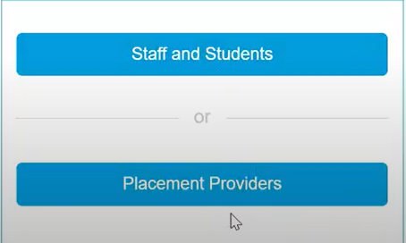

- Click on the Placement Providers button.
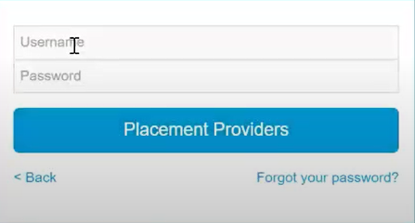

- Enter your email address as your new Username.
The end-user will only have 5 attempts to enter the correct username and password. Failure to do so will result in the password being locked out.
(A user from DCU will need to unlock your password)

- Click on Placement Providers login.
- The In Placement Home Screen will appear

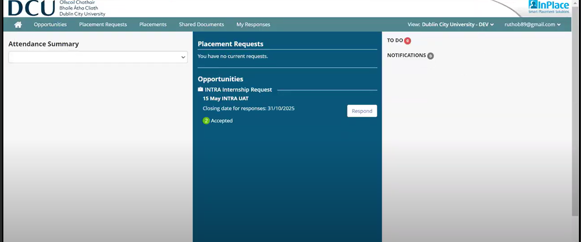

Recovering your Password

- Click on Forgot your password? A Recover your password dialog box will appear.

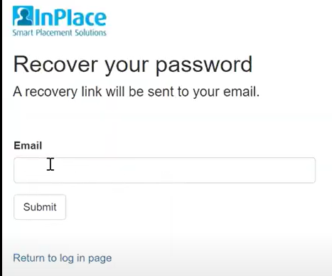

- Enter your email address.
- Click submit.

The end-user will receive an email with instructions on how to get back into the InPlace system.

- Follow the instructions on the email and repeat the above steps where necessary.

Step 2

SALO/CPC end to end Journey

Learning Objectives

The SALO/CPC will be able to execute the InPlace system steps for allocation, timesheets, loading allocations files shared to a 100% accuracy.

Attendance Summary

- Log on to InPlace if not already logged on. In the Home Screen, the attendance summary is divided up with current students who are attending and upcoming students who will be attending.
- Click the down arrow on the right-hand side under Attendance Summary or the white space just below the Attendance Summary to filter by current/upcoming for the next 7 days or the next 14 days. A drop down list will appear.

- To Minimise the Current and Upcoming menus click the Minimise button.

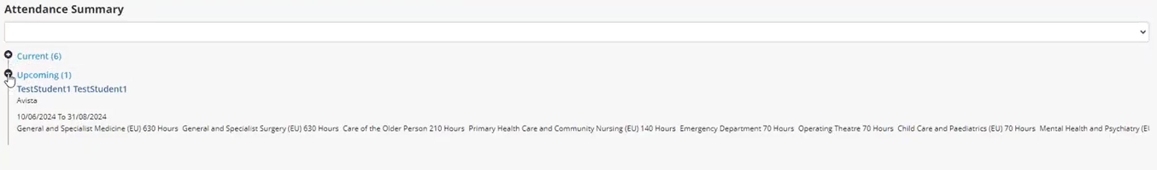

The full homepage view for this Salo/CPC can be viewed:

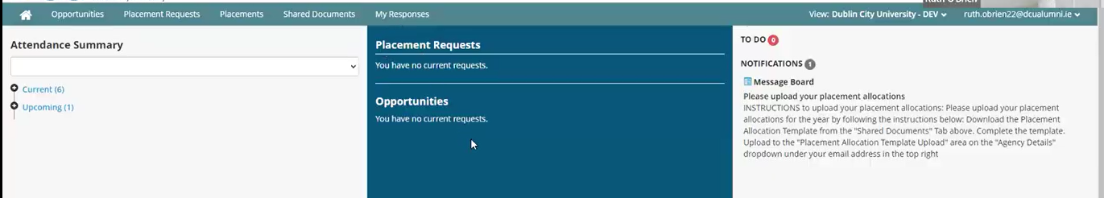

On this Salo/CPC homepage the Shared Documents feature, and the Placement feature will be mostly used.

Click on the Shared Documents to reveal the Following list:

- Programme Map (one of the first documents that is required).
- The Garda Vetting Reports (this will be generated by DCU staff).
- The Agency Codes.
- Any Other Documentation that is deemed necessary.
- Click the download button on the right-hand side across each document to read it.

Working with the Programme Map

- To download the programme map. Click on the Download button.
- Click the programme map file on the drop-down window on the top right corner. The Programme Map file will display and give an indication of when the students are scheduled to go on their placement blocks.

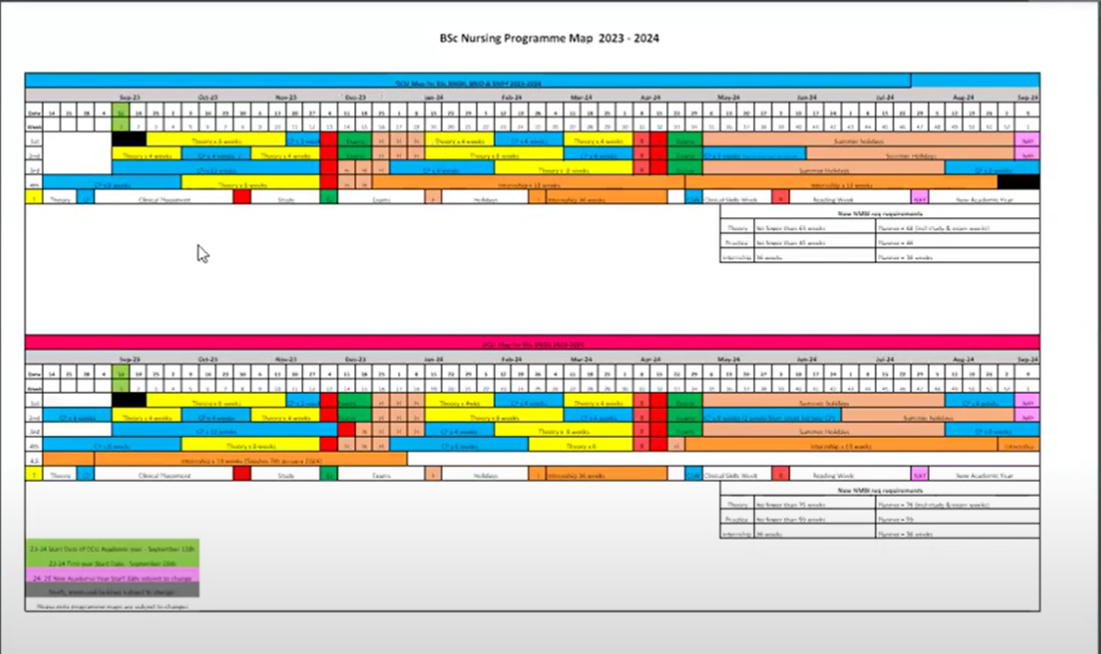

Allocations process

- Click on the Placements header

This will display a list of all the students who have been allocated to a parent hospital.

- Click the Student column down arrow to display a list of all students who are being allocated to the parent hospital.

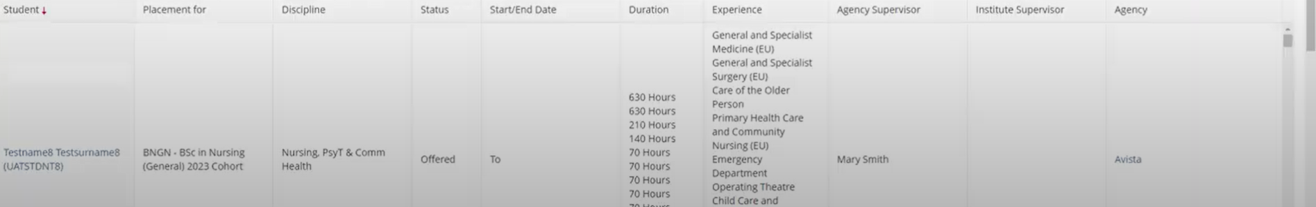

- This display can also have a filter functionality for student name, student code and supervisor status.

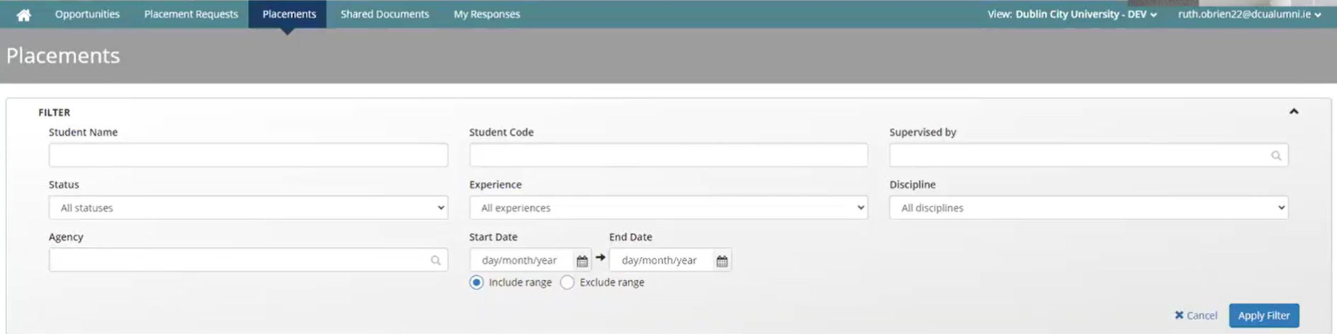

- In the Status drop down select the status type from the list. Select Offered because these are the students who need to be allocated. This discipline will always be nursing.
- In the Agency drop down select Parent Hospital. In this example, the parent hospital is Beaumont and all the wards for Beaumont will be listed underneath.
- To filter a date range, click on the calendar icons within the Start Date and End Date fields.
- Select the required date range.
The grid will now reflect what has been filtered in the previous steps: the names of the students who have been allocated to this partner services and who need to be allocated out further.
- This grid view can also be exported to an Excel file.
- Click the down Arrow to export table.

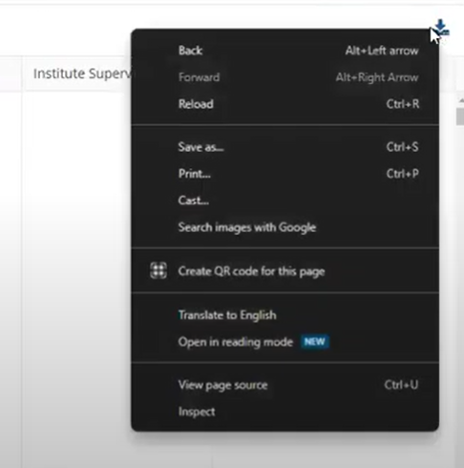

This will download to your local machine.

- Click the placement CSV file on the drop-down window on the top right corner.

This will display all the information that was in the grid in an Excel format that can be used to populate the import file/calendar view file.

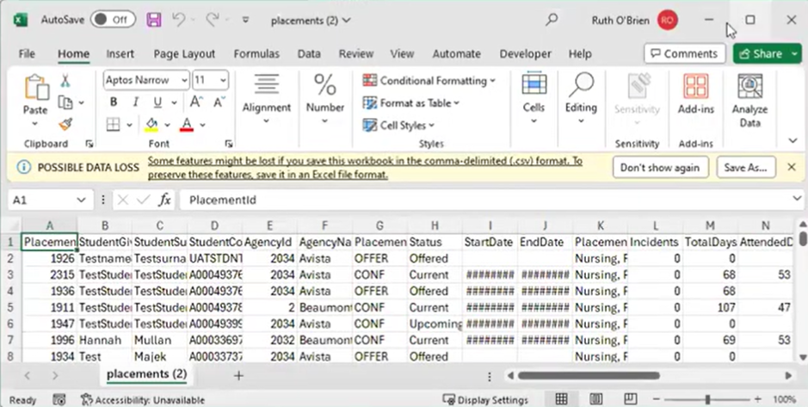

- Click the Maximise button to expand the view of the CSV file (Excel spreadsheet).

Transferring Data
For the final list of the students who need to be allocated, the data needs to be transferred into either one of two files, depending on how big the service is and how many students need to be allocated.

Primary Process
The first and primary process is using the import file. This process requires the following information about the:

- Student Code.
- Student First Name.
- Student Surname.

This information is in the export file that has been downloaded. The Primary process also requires details on:

- Agency code.
- Start and end date.
- Number of hours and the nursing type.
- Supervisor details.

This information can be obtained from the agency code information on the Shared Documents tab.

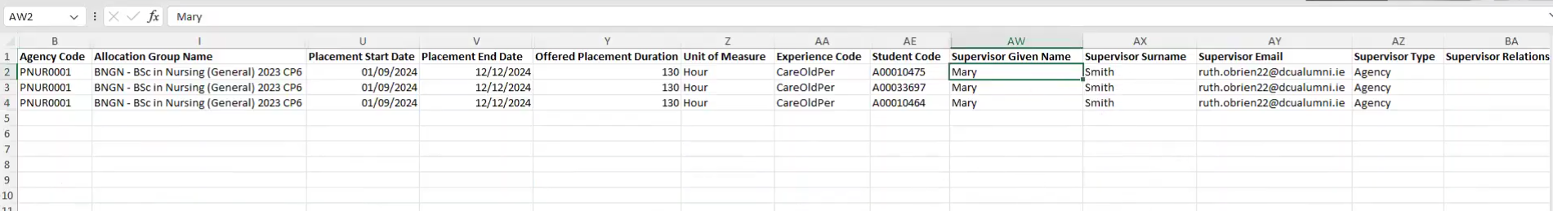

The Secondary Process
If the service is quite large there is an option to use the secondary process. This process requires information on a list of the students in a particular group, so their first name, surname and student code and then
divided by the calendar view.

For each one of these columns, that particular week, this should be colour-coded to reflect the type of nursing. The Agency Code, the Agency Name, number of hours and the type of nursing are required.

This will be completed for each student across this calendar view file. Once the allocations file is completed, it must be saved to the SALO’s desktop.

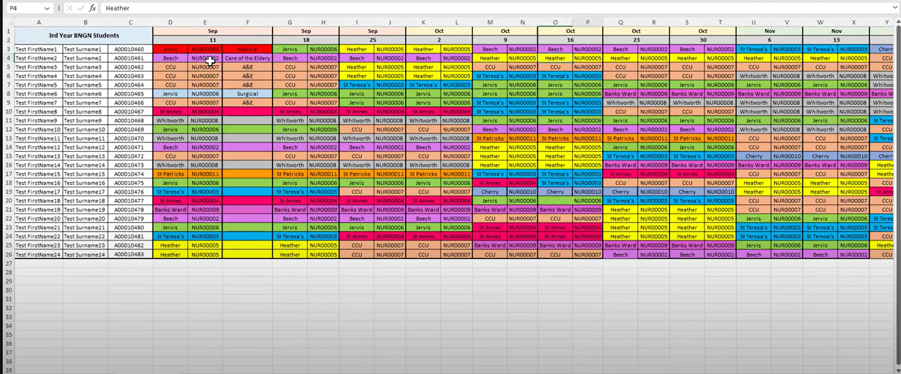

The agency code is required to input into the Allocations file. If using the primary process, which is the import file, or the secondary process, which is the calendar view, the agency codes are required. These will be shared by DCU staff in the form of a report. From shared documents, access them by clicking Download.

This will open an Excel file with all the agency codes of your particular partner service. In the first column, you'll see the agency code, along with the agency name.

Uploading your Allocation File to be further processed by DCU staff
- Return back to the InPlace dashboard.
- To upload the file, follow the instructions on the Message Board on the right-hand side.
- Click the down arrow beside the email address on the right.
- Select Agency Details from the dropdown menu.

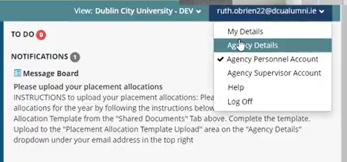

The Agency Details form will appear.

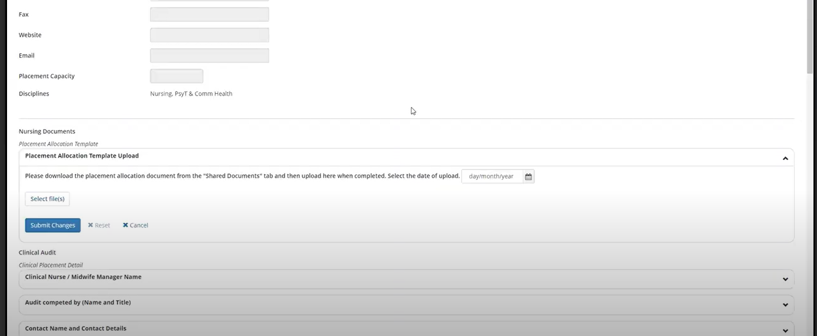

- Scroll halfway down the page to Nursing Documents.
- Click the down arrow or click the white space.
- The Placement Allocation Template dialog box is displayed.

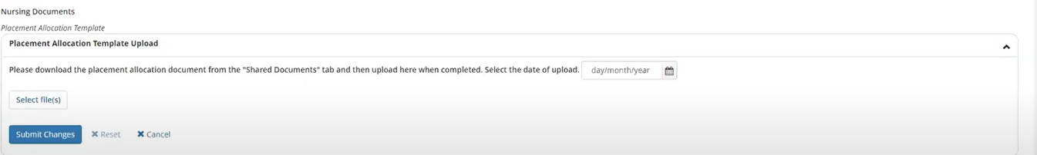

- Select the File button. This will open up the documents in file explorer on your machine.
- Select the required file by double clicking on it.
- Click on the Calendar icon and set the date on which you are submitting the file.This sends the file to the DCU Allocation staff.

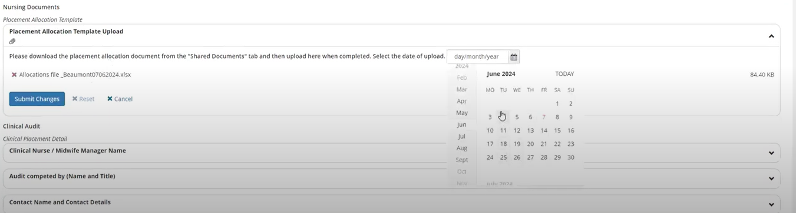

- Click the Submit Change button. A green success message will also appear.

Note: If there are any late changes (e.g.placement provider or location change) these should be highlighted in the import file or calendar view file with the original placement start and end date. The file should be submitted via the same process outlined above (i.e. via agency details screen).

To ensure that DCU staff receive the alert that the file has been updated, remove the previous file by clicking the red “X” and deleting the date. Click “Submit changes”.
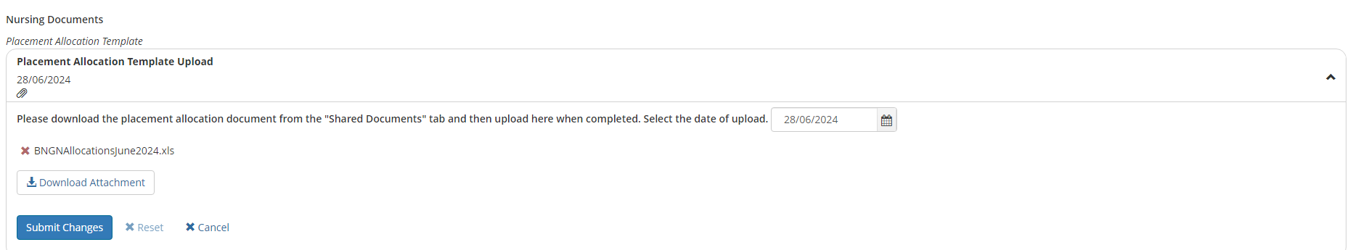
This resets the file upload task and ensures that DCU staff are notified if the late changes file is loaded.

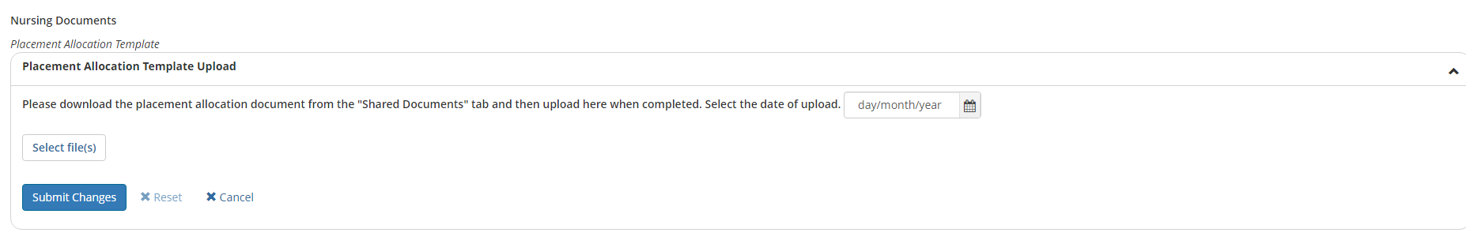

Daily Timesheets

- Once the student has begun their placement, they will begin to submit daily timesheets on InPlace. These will appear in your to-do items per student.
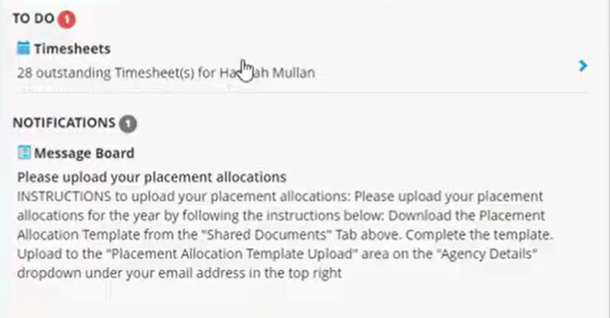
In the screen above, there are 28 outstanding timesheets for i.e. Hannah Mullan.

- Click on the right-facing arrow.
- A screen will appear with the Placement Schedule header selected.

The start and end date of the placement along with the nursing type is displayed at the top. There will most likely be one nursing type and the corresponding number of hours. You can also see the overall progress bar for the attendance summary for that particular placement. In this example, there are 630 hours allocated and 43.5 hours logged.

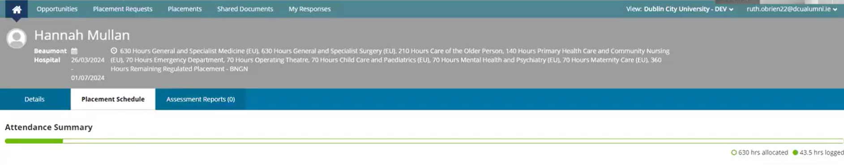
Filters can be created for date to a date and include confirmed timesheets if required.

Actual submitted timesheets Grid
In the Attendance column, the daily timesheet submitted by the student is colour coded. Green means that the timesheet has been submitted without any absences. Red means there has been some absence logged. Each timesheet displays the agency, (e.g Beaumont Hospital), Shift, and the attended hours. The attended hours go towards the NMBI requirements.

Absences
Absences are logged and visible (in red). Reasons for the absences can be revealed when the mouse is hovered over a comment icon (example sick leave) or clicking the Action button and viewing the comment.

Processing Timesheets

All of these timesheets are not yet confirmed as reflected with No in the Confirmed column. You can also click into each one of these timesheets to look in more detail.

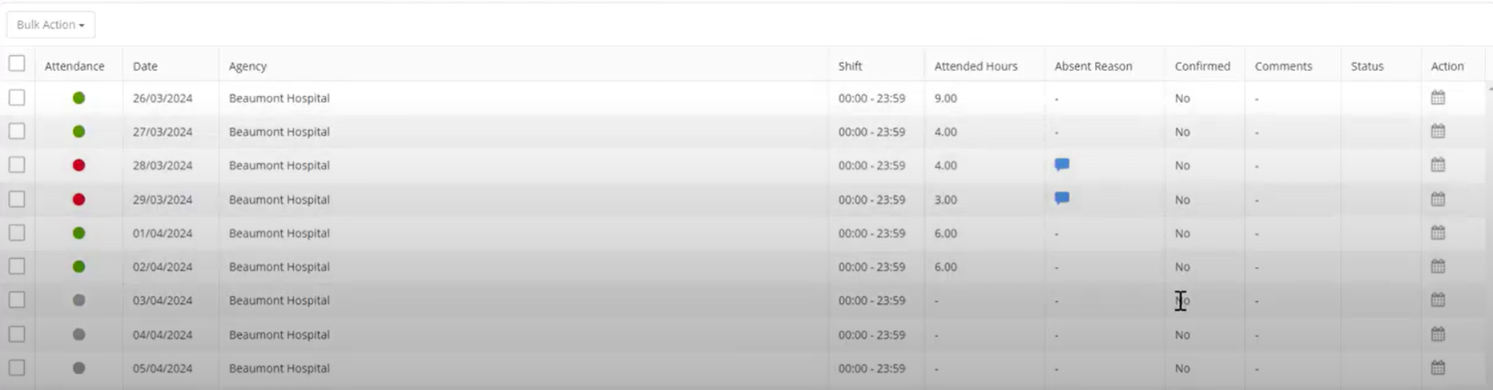

To look at each daily team sheet in more detail, click on the calendar icon in the Action column. For example, if the second of April was open, it would display again the time that was logged, start time, the end time, any break hours, the total attended hours.

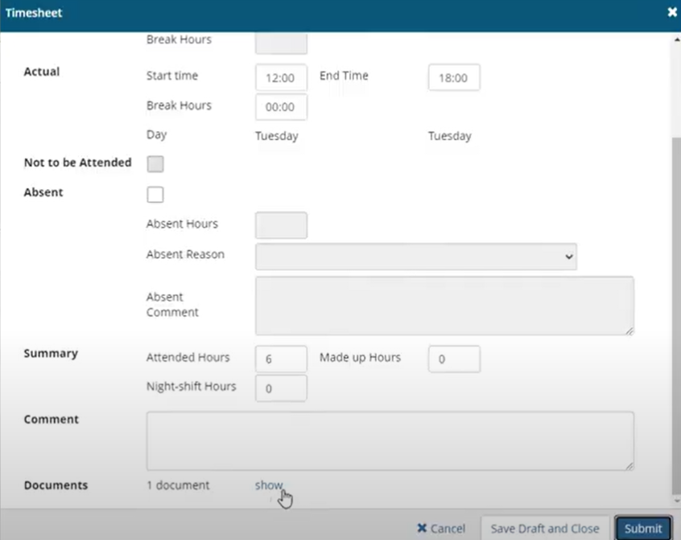

Timesheets can also be in a paper format that has been scanned by the student and the student can add a document. It can be downloaded by clicking Show.

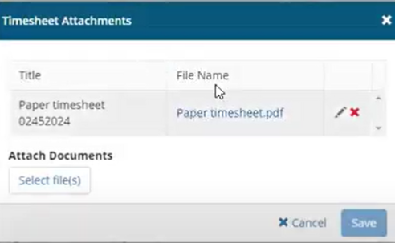

Bulk action all timesheets
- Bulk action timesheets to be confirmed.
- Click the checkboxes under Bulk Action.
- Click the Bulk Action drop down arrow.
- Click Mark Timesheet as Confirmed.

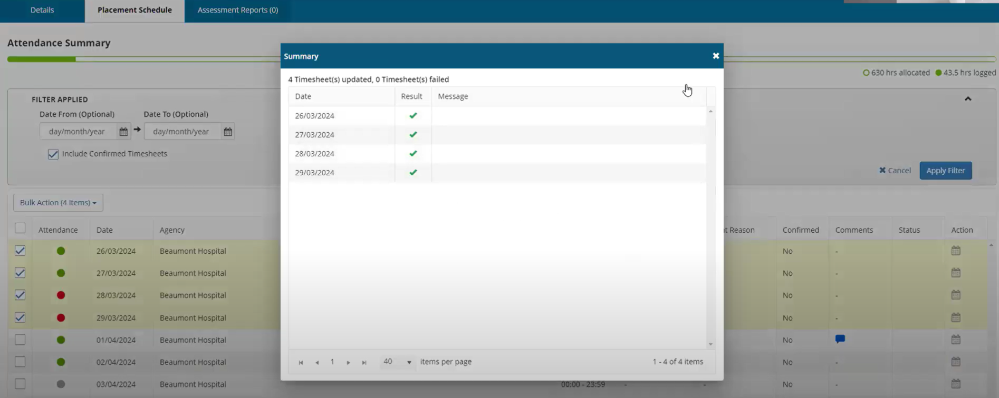

If the CPC/SALO has to confirm/change a daily timesheet this can be changed:

- Click on the Action button.
- The Timesheet dialog box will be displayed.

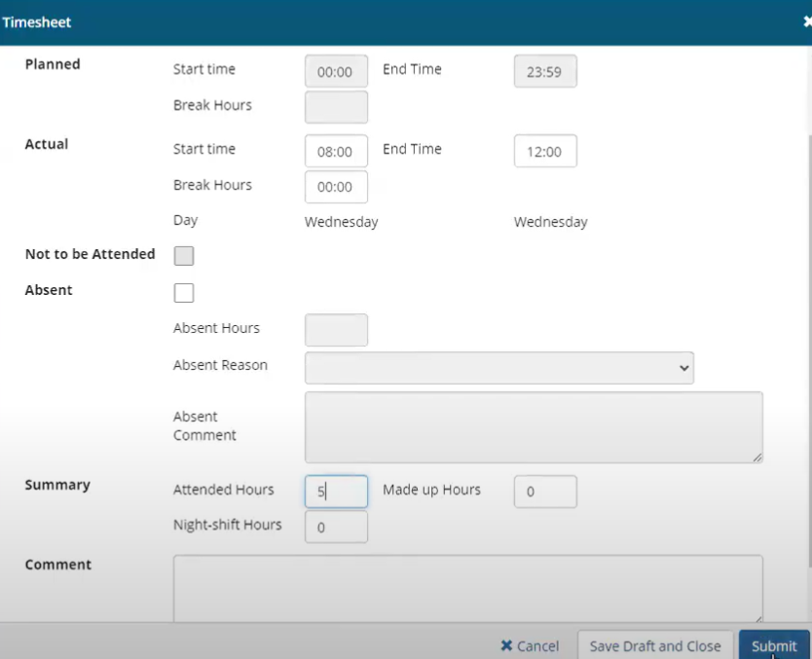

- Change the attended hours from i.e. 4:00 to 5:00.
- Click Submit.

This would also reflect on the student's timesheet in the Attended Hours column in the Placement Schedule along with the DCU staff record. If records are in grey. This means that no time has yet been entered by the student for these particular timesheets.

Creating a comment on a Timesheet
- Click on the relevant Action button in the Action column. A Timesheet dialog box will appear.
- Enter the comment in the comment box.
- Click the save draft and close button. DO NOT CLICK SUBMIT.

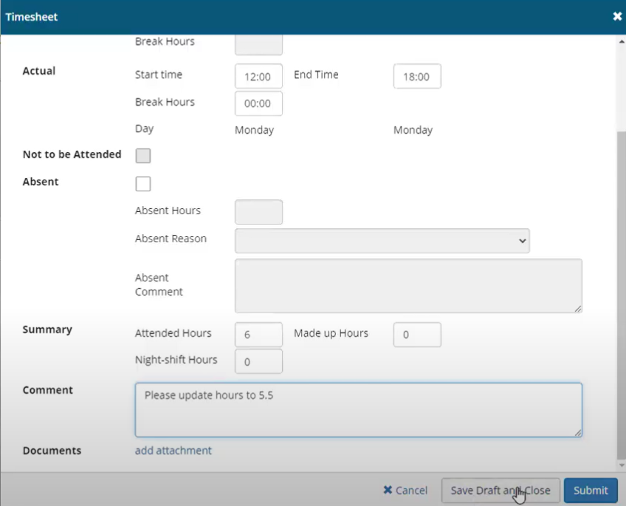

Clicking Submit means that the student can no longer edit it.

Step 3

SALO/CPC annual tasks

Learning Objectives

The SALO/CPC will be able to execute the InPlace systems steps for managing clinical audits, placement visits, NCAD management to an accuracy of 100%

Populating the Clinical Audit Fields

- Log on to the InPlace System.
- From the Placement Provider or Partner Services view, click on the down arrow next your email address.
- Click on Agency Details.

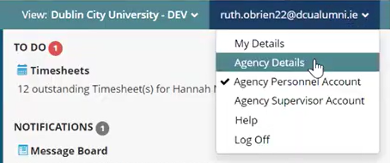

A screen with the Clinical Audit fields will be displayed

- Scroll down to the Clinical Audit fields.
- To enter data in these fields, click in them or use the down arrow.
- Populate the fields with required information. These fields are editable by both Partner Services staff and DCU staff. Anything that is entered in these fields will be visible to both sets of user groups.
- Click Submit Changes
- Observe the green success message in the top right-hand corner

These fields reflect the fields that are there in the NMBI clinical audit requirements. All of the indicators are there as well.

- To view the full indicator, click on the down arrow to review the full name of the indicator.
- Repeat the same for each one of the different standards.

Once each field has been populated, the expiry date will automatically trigger if it's three to five years, depending on what date has been set. This is the fully digital way to manage the audit. It's also possible to scan a paper copy of the audit and for DCU staff to upload it to InPlace.

Access Scanned versions of Clinical Audit documents
- Click on Shared Document Tab
- The Shared Document screen will be displayed

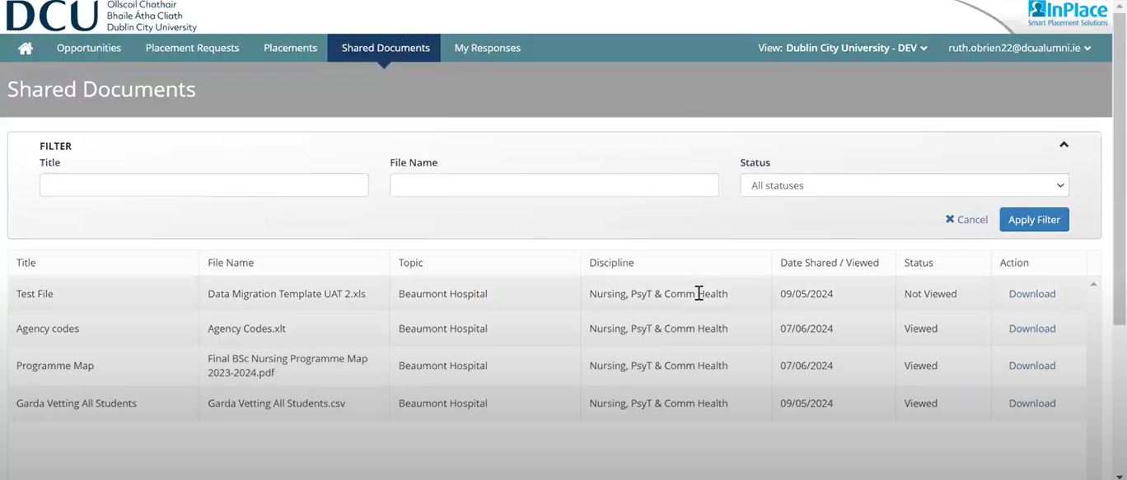

DCU Staff Visits

The DCU staff may come on site to visit the partner services if something is happening on placement that requires a visit. The DCU staff will be responsible for logging this visit.

- Under the agency record, (example Beaumont Hospital)
- Click on Site Visits

This will display the purpose of the visit, the type of visit, the categorization, the date and time, who raised the action, and the status are all logged. This is completed after consultation with partner services.

Viewing student documentation (PRCN only)

The SALO/CPC for PRCN students can access the student’s previous undergraduate transcript and declaration of undergraduate hours completion by clicking on the student’s name on the homepage

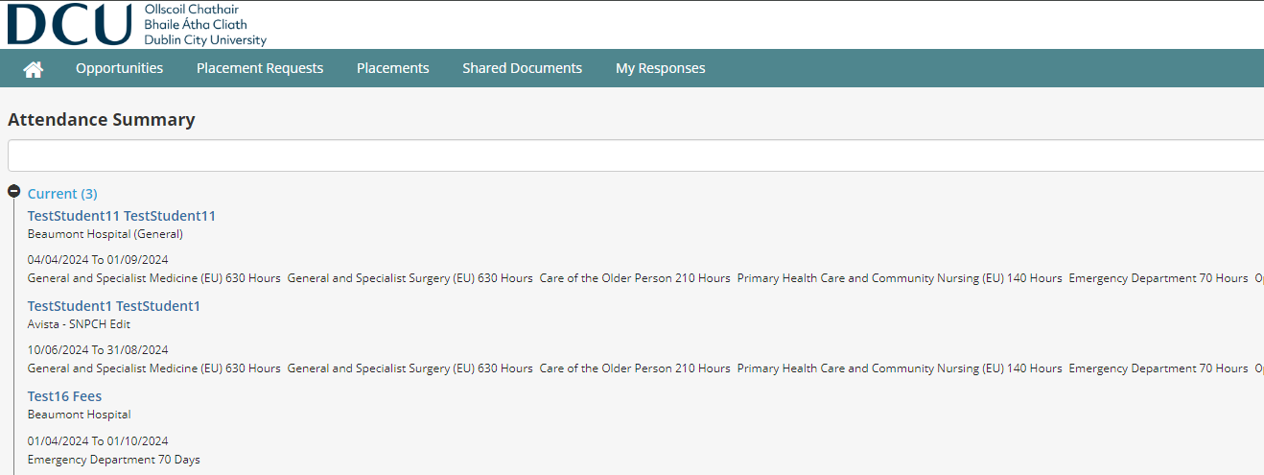

This will display the student details. Scroll down the page to download the documents the student added

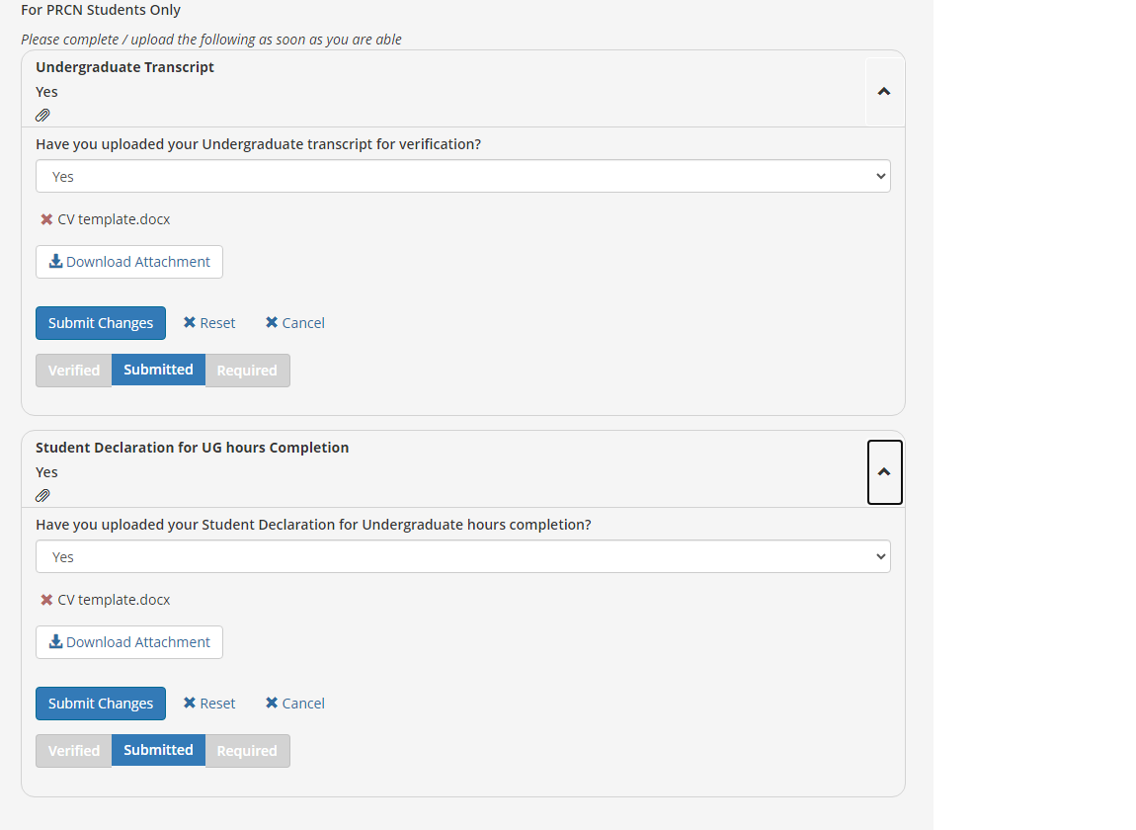

NCADs – Future State

In the short term whilst using InPlace, preceptor accounts will not be added to the system due to limitations with preceptor email addresses. In the first instance, the student will sit down with their preceptor and fill the paper form and get it signed off by the preceptor.

They will then scan the paper form and upload it to their In Place account. SALOs and CPCs do not have access to this currently, but this may change when the whole process becomes fully digital and the preceptor accounts are all added to InPlace. In that case then, the student and the preceptor will log the NCAD completely online, with both filling the relevant field. It is important to note it is planned that students will not be able to edit any of the preceptor fields once the fully digital NCAD is implemented. When either the paper scanned NCAD is uploaded to the student's InPlace account or the fully digital version, they are submitted to the Practice Module Coordinator who will then grade the NCAD.

END.

