Submit to ISGEI@dcu.ie by August 29th
For further information contact
Fiona.regan@dcu.ie

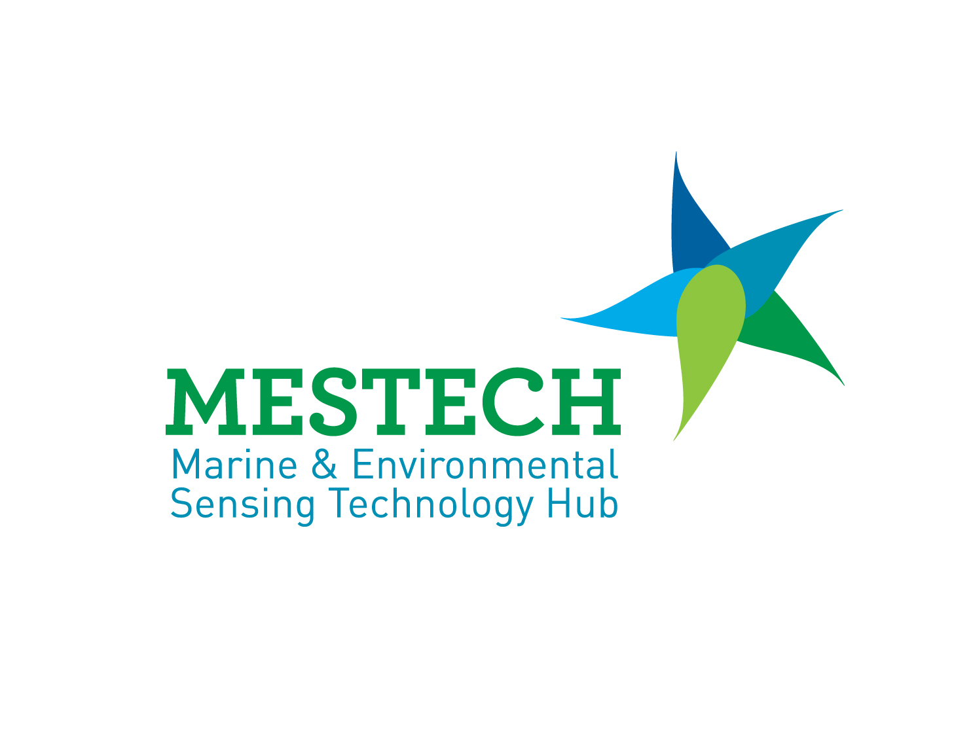

International SmartOcean Graduate Enterprise Initiative (ISGEI)

2011

PROJECT PROPOSAL FORM

Project Title:

ISGEI Institution
Thematic area:
Project Supervisor:
Description of suitability / track record (1000 characters, no spaces only). Include website details.
Contact Details:

Project description: . 1500 characters

Related Research elsewhere: 1000 characters

How does this research differ from competing approaches: 500 characters

Potential benefits to the Marine ICT industry sector (be quantitative): 1000 characters

Who would be the beneficiary in the marine ICT industry sector and what are the potential applications? 500 characters

Timetable:

Deliverable(s):

Milestones:

Maximum 2 pages

