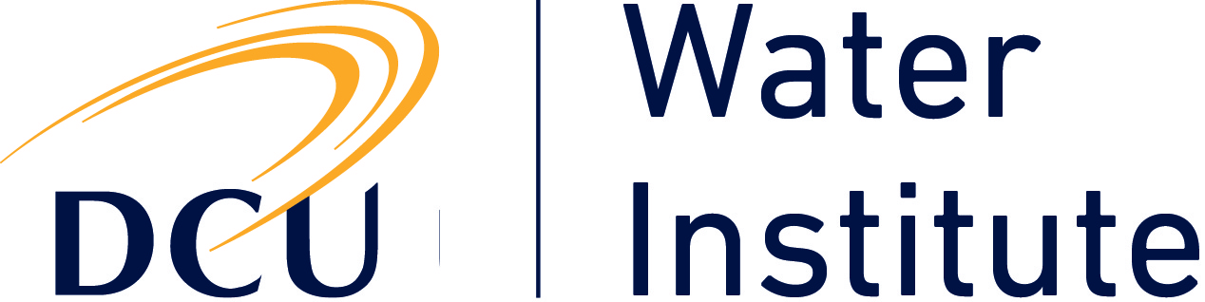 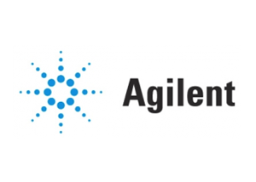

**DCU Water Institute / Agilent Symposium**

**28th January, DCU S206**

**Advanced Analytical Methods for Environmental Analysis of Water**

**09.30**     **Registration, Tea & Coffee,**

10.00 Introduction, Prof. Fiona Regan, DCU Water Institute

**Keynote speaker:**

10.10 Prof. Sandra Perez, CSIC, Spain

“Applying suspect screening based on LC-HRMS for the determination of transformation products of emerging pollutants in the aquatic environment”

**Session 1 Emerging contaminants; pesticides and pharmaceuticals**

10.40 Dr Lisa Jones, DCU

“Determination of pesticide occurrence in Irish catchments”

11.10 Chris Sandy, GC/MS Product Specialist, Agilent

“Screening for Pesticides, EOPs and POPs in Surface Water Samples using a GC/MS based analyzer and MassHunter Target Deconvolution”

11.40 Dr. Leon Barron, Kings College London

“Suspect screening of emerging contaminants using liquid chromatography-high resolution mass spectrometry and in-silico methods”

12.10 Dr Tony Sullivan, Agilent

“Overview of the analysis of trace pharmaceuticals and consumer products in water by LC/MS/MS”

**12.40** **Lunch & student posters**

**13.40** **Invited Student Speaker**

Jaume Aceña, CSIC, Spain

“Screening of pharmaceuticals and their metabolites in biota samples: from the lab to the field”

**Session 2 Forensic & Trace Analysis**

14.10 Prof. Hilairy Hartnett, Arizona State University

“3D-fluorescence spectroscopy as a tool for tracing organic carbon dynamics in aquatic systems.”

14.40 Dr Ruth Morgan, University College London

“Forensic evidence as intelligence? Detection of explosives throughout the wastewater system”

15.10 Dr. Maria Nevin, Complete Laboratory Solutions

"A new technological approach to the analysis and forensic interpretation of TPHCWG in soils and waters using 2D Gas Chromatography method (GCxGC)"

15.40 Dr Raimund Wahlen, Agilent

“The Use of Novel plasma-based techniques for analysis of trace materials,for analysis of trace metals, major elements and metal species in water samples.”

16.10 Dr Mercedes Vasques, NCSR, DCU

“Solid-phase Micro-extraction Centrifugal Microfluidic Discs for Preconcentration of Water Pollutants”

16.40 Poster session and laboratory tours