Research Ireland Overview of 2025 - Planned Programme Calls
Details are provided below for programmatic calls with a launch, deadline or decision in 2025. The timelines provided are for planning purposes only, and while correct as of the date of this update, are subject to change.

1. Programmes launched during 2024 or earlier with a 2025 funding decision

Deadline prior to 2025, applications currently under review.

Programme | 2025 Award Decision Timeframe
Research Ireland Pathway Programme 2024 | January
Research Ireland Frontiers for the Future Projects 2024 | April
Research Infrastructure 2023 | Reserve List open until end of Q1 2025
ERDF ARC Hubs 2024 call | Early Q2 2025
Government of Ireland 2025 Programme | April
COALESCE 2025 | May
Fulbright Scholars Program 2025-2026 | March – May 2025
Research Ireland Centres Programme | See call page Q4
National Challenge Fund
Teams are evaluated as they progress through the National Challenge Fund various stages gates. The schematic below shows the overarching progress under the National Challenge Fund and status of different cohorts.
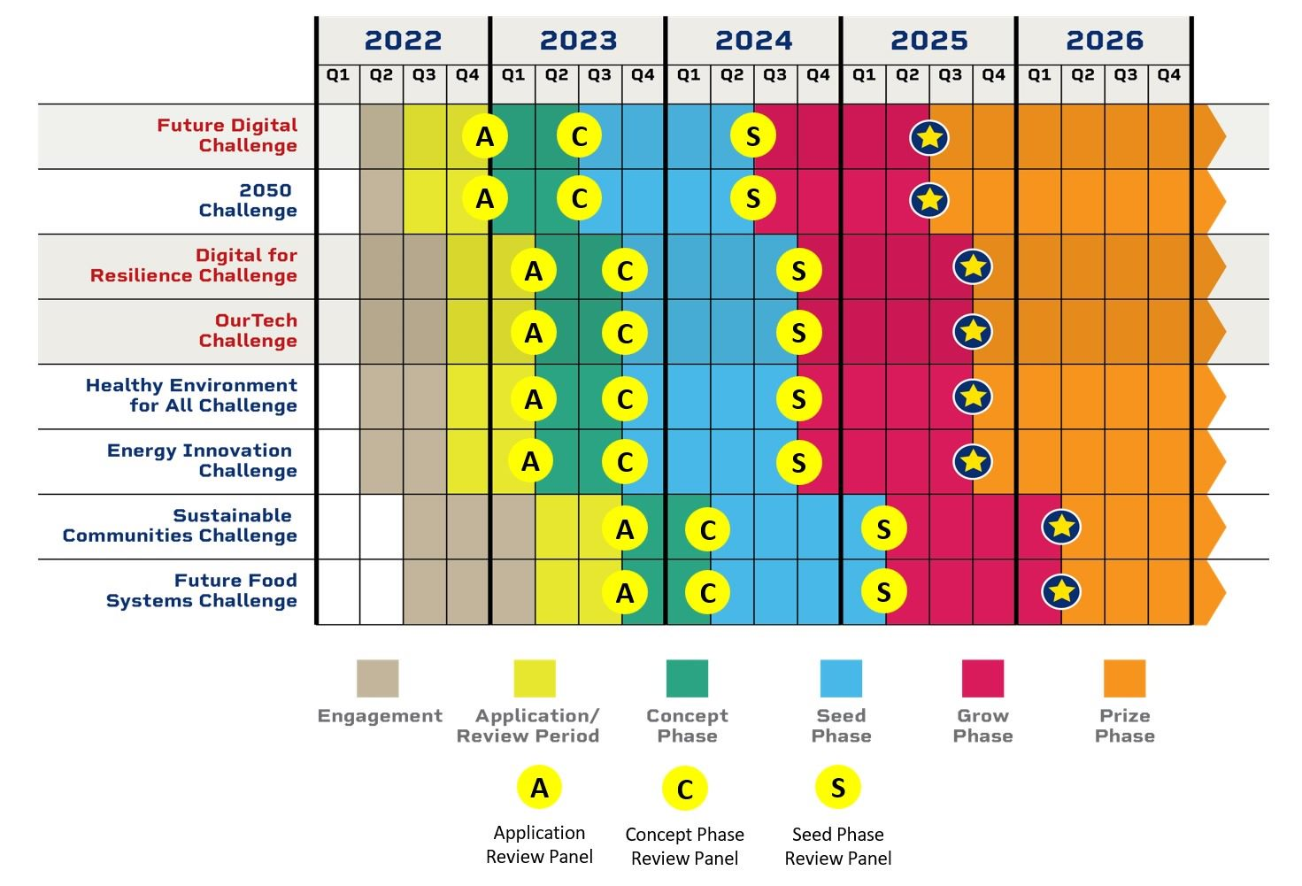

Programmes launched during 2024 or earlier with a Deadline in 2025

Programme | Call Deadline 2025 | Award Decision Timeframe
Research Alliance Award - Wales | Jan | March

2. Fixed Deadline Calls to Open in 2025

Programme | Call Launch 2025 | Call Deadline | Award  Decision Timeframe
Research Ireland Investigator (FFP Projects and Laureate combined) | March 2025 | TBC | Q2 2026
Research Ireland Pathway 2025 | Q3 2025 | Q1 2026 | Q1 2027
Research Infrastructure 2025 | March 2025 | June 2025 | Dec 2025
Innovate for Ireland | January | March 2025 | Q3 2025
Research Ireland Discover Programme  Annual Call | April | June | November
Industry RD&I Fellowship and Enterprise Partnership Postdoctoral Fellowship calls (run in parallel) | Q2 2025 | Q3 2025 | Q4 2025
Research Ireland Science Week Call | March | April | June
Research Ireland Fellowship | April | May | July
Research Ireland - Defence Organisation Innovation Challenge 2024 (Prize Phase only) | Teams commenced the first phase of the Challenge on January 2025, and will be evaluated for subsequent phases in March 2025 and November 2025 the Prize in November 2025 Q2 2024 | Q3/4 2024 October (report/Prize Phase application submission deadline) | December Q4 2024
Research Ireland-Irish Aid SDG Challenge | Teams will commence the first phase of the Challenge on February 2025, and will be evaluated for subsequent phases in June 2025 and June 2026 Q2 2024 | Q4 2024 | Q1 2025
Research Ireland – Gas Networks Ireland Innovation Challenge | Q1/Q2 | Q3 | Q4
Government of Ireland 2026 | August/September 2025 | October 2025 | Q2, April 2026
Lindau Nobel Laureate Meeting Awards | September 2025 | October/November 2025 | April 2026
Research Ireland Enterprise Partnership Programme (Postgraduate) | February 2025 | April 2025 | June 2025
New Enterprise Fellowship Programme call merging IRDIF and EPSPD (will cover faculty) | Q3 2025 (TBD) | Q4, 2025 (TBD) | (TBD)
Ulysses | 20th February | 1st May 2025 | October 2025 (TBD)
New Foundations | May 2025 | June 2025 | October 2025
COALESCE 2026 | September 2025 | December 2025 | May 2026

3. Rolling Calls Open during 2025 *

Programme
Sesearch Ireland Strategic Partnerships
Frontiers for the Future (Awards)
Maternity/Adoptive Leave Allowance
ERC Support Programme
Disability Supplement (TBC)

*Note: Research Professorship remains closed

4. International Partnerships Open in 2025. Deadlines as scheduled by Lead Agency

Programme
US-Ireland R&D Partnership Programme
Royal Society University Research Fellowship; results expected June 2025
EPSRC-Research Ireland Standard Research Grants
Research Ireland-/NSF I-Corps@Research Ireland Entrepreneurial Training Programme
European co-funding initiatives
Research Ireland European Southern Observatory Studentship Programme
CHISTERA Call 2025

