Introduction & Guidance Document for the New On-Line Application Form 2025:

Promotion to the Grade of Associate Professor

Table of Contents
What’s Changed? 2
1. Removal of amendments to fonts, margins, deletion of lines from tables etc 2
2. Introduction of Character Count 3
3. Removal of 20 pages requirement 3
4. Removal of Bold & Underline 3
5. Removal of Hyperlinks 3
6. Amendments to Questions 4
7. Publication Requirements 4
8. Checklist Location 4
9. On-Line Application Form Template 4
10. Preparing your application 4
How to Guide 4
1. How to Add Bullet Points 4
2. How to Expand Text Boxes to View or Enter Data 5
3. How to Expand Fields in Tables (if required) 6
4. How to Add Symbols or Special Characters 6
5. How to Enter Links to Websites 7
6. Entering Totals on Questions (if required) 8
Help & Support 8

What’s Changed?

Following feedback from previous applicants, APC members and all stakeholders. A new on-line Application Form has been designed on Qualtrics. The on-line form is a pre-set format of questions and is based on the pre-existing form with some amendments. Below are a summary of the changes outlined with further details provided:-
- Removal of amendments to fonts, margins, deletion of lines from tables etc
The application form has been designed in a pre-set format of questions. Therefore, the ability for applicants to amend fonts, margins and delete questions or lines on tables etc has been removed. Additional lines have been added to the tables.
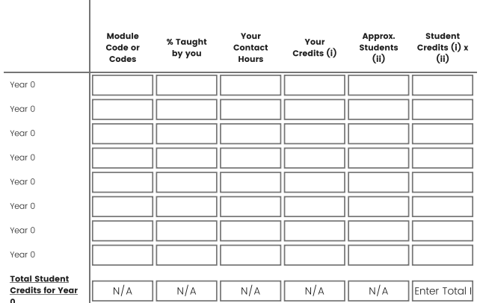

In addition, text boxes are expandable where required for applicants. Further details are outlined in the ‘How to Guide’ Section.
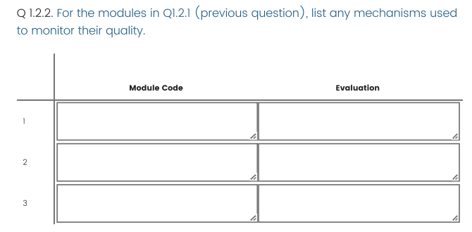

- Introduction of Character Count
A character count has been introduced on questions. Questions where bullet points are required displays a maximum character count ie. (Max. characters 3,250) at the top of the text box. As the applicant enters the text the remaining characters are displayed at the bottom of the text box (see example below).
Please note the character count will vary per question depending on the information requirements. The reference to the 'no. of bullet points' required has been removed from the questions and the max. character counts have been included consistently throughout the form. It is advisable to use bullet points to best highlight your application and for ease of review.
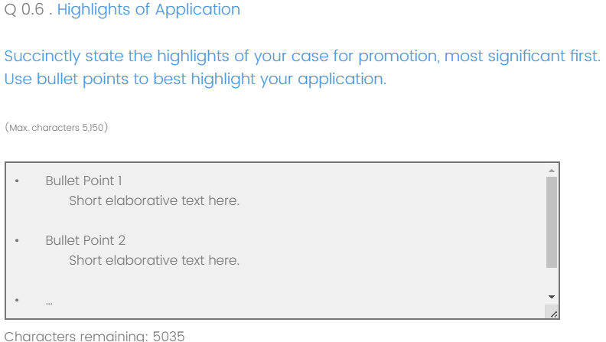

- Removal of 20 pages requirement
The 20 page requirement is no longer valid on the on-line application form as a character count has been introduced to manage the quantity of information per question.

Removal of Bold & Underline
There is no facility on the on-line application for applicants to use the bold or underline on text. Bullet points will be used in these sections to best highlight your application. There is no requirement for bold or underline in the tables as they are clear to view.

Removal of Hyperlinks
There is no facility for applicants to add hyperlinks in the text boxes however, applicants can provide the full web address in the text box and these will automatically become clickable links in the final PDF document once the application has been submitted.

Amendments to Questions
Some amendments have been made to text in questions and tables have been updated. Including the inclusion of extra lines on tables.

Publication Requirements
For publications, applicants are required to include the link to the publications tab in their full DCU profile. Applicants will need to ensure they update their publications in Research Engine and publish accordingly in-line with the instructions on the form and to reflect their application details provided.

Checklist Location
The checklist which was on the first page of the pre-existing form is now moved to the end of the application form along with the signature.

On-Line Application Form Template
A PDF template of the on-line application form has been provided as a reference guide only. No applications will be accepted on this template or by email. Applications will only be accepted using the on-line application form.

10. Preparing your application
Due to the time it takes to complete an application it is advisable to prepare the bullet points on a blank Word document and then copy and paste them to the on-line application form.

How to Guide
Below are some helpful points which should be considered when completing the on-line application form:-.

How to Add Bullet Points
Bullet points are required in sections of the on-line application form. Applicants may type the bullet points directly on the form however, it is advised to draft all your bullet points in Word and Copy & Paste all the sections to the Form when it’s convenient.
Ctrl C = Copy
Ctrl V = Paste

How to Expand Text Boxes to View or Enter Data
It is possible to expand the text boxes on the application form to view your data if it makes it easier for you to view. The amount of characters will remain the same, it just displays the data in a larger view if you require. For example: in this question if you click on the which is located at the bottom right of the text box, the arrow will change and the field can be expanded to view all the data by clicking and drag the box. There is no requirement to amend the field in the table, it’s an option for entering data and for your convenience. When the data is submitted it will display all the data regardless if the field is expanded or not.
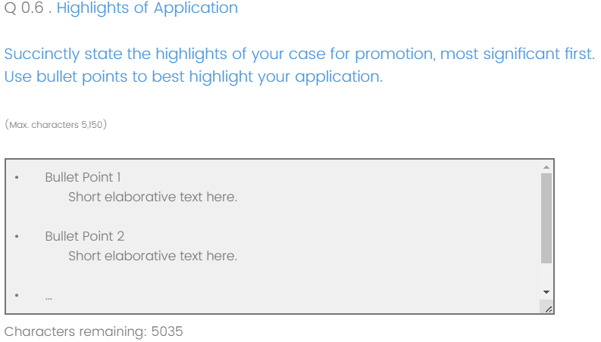
It will then display as follows:-
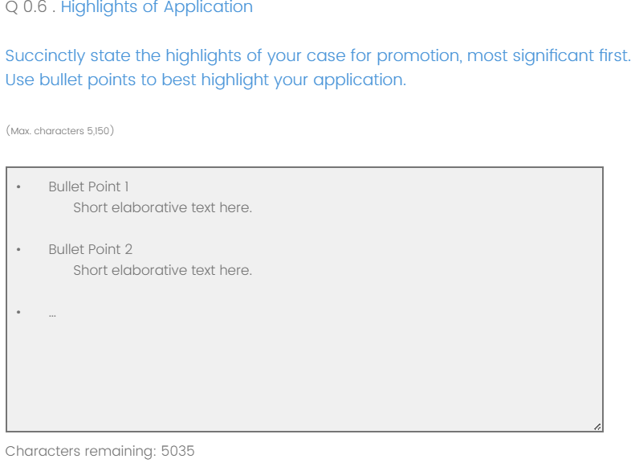

How to Expand Fields in Tables (if required)
Similar to the point above, it is possible to expand text boxes in tables where the appears for example in Q 1.2.2. Move the mouse to and click and hold down & drag the mouse to expand the field. Release the mouse and enter data in the field. There is no requirement to amend the field in the table, it’s an option for entering data and for your convenience. When the data is submitted it will display all the data regardless if the field is expanded or not.

How to Add Symbols or Special Characters
It’s possible to add symbols into the on-line application form for example: degrees°, Supercript ^{2 ,} Bullet point symbol etc
  - To add special characters ie. Superscript, degrees, bullet point character etc.
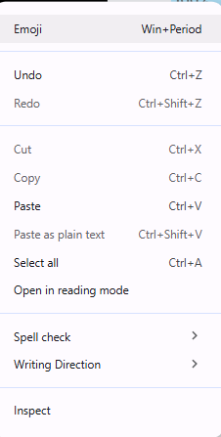
  - In a field on the form, right click the mouse and select Emoji.


  - The following will appear:-

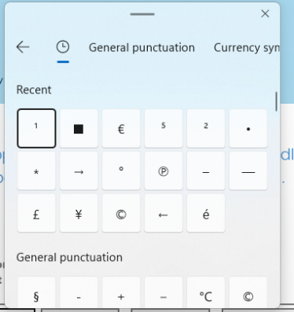
  - Select which will display

  - Select the relevant section across the top for example if you wish to use the superscript, use the arrow to move to the right and select Math Symbols the following will appear, click on the symbol required.
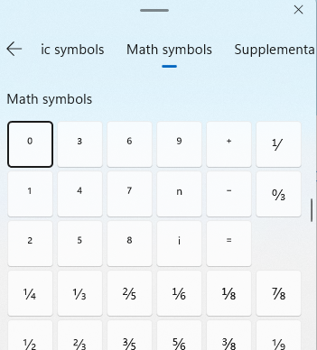
  - If it’s a symbol you use regularly it will appear in the Recent section and this can be clicked the next time you wish to use the symbol.

How to Enter Links to Websites
There is no facility to add Hyperlinks in the text boxes however, applicants can provide the full web address in the text box ie. https://www.dcu.ie/. The link will then be clickable links in the final pdf document which is issued to the applicant, FRP & APC members. It is also possible to use short links.
If you wish to test a link, add the link to the text box and right click on the text box and the following will appear:-
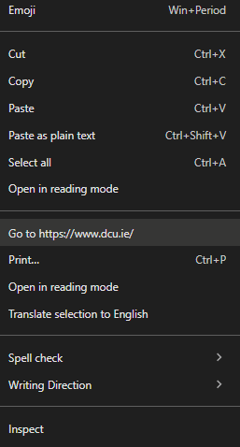
- The option Go to https://www.dcu.ie (if you click on this it will test the link and open the page in another tab on the browser)

Entering Totals on Questions (if required)
The form does not automatically calculate totals in the tables on the form. Applicants will need to include totals where required as part of their application ie. Q2.1.1


Help & Support
Please refer to https://www.dcu.ie/people/promotion-associate-professor-2025 and for further queries please contact apc.dcupeople@dcu.ie

