**Accessing the Core Portal Pension Self-Service – Instructions for Single Scheme (SPSS)**

Members of the SPSS can view the annual pension and lump sum referable (money) amounts that have accrued in DCU (as at date of running calculation). As it is not possible at the moment to calculate future projections under the Single Scheme from the Pensions Portal, members should refer to the Department of Public Expenditure and Reform’s website to do this <https://singlepensionscheme.gov.ie/for-members/scheme-information/single-scheme-estimator-tool/> .

**Log in Details:**

Log on to Core Portal Site by using your normal username and password. Ensure you are in ‘employee dashboard’ mode. Scroll down left hand side and select ‘My Pension’ from list of icons.

1. Click ‘Open’ on Pensions Landing Page
2. On the main Core Pension screen you will see Personal Details, outlining:

* Date of Birth
* Date Joined Pension Scheme (in DCU only)
* Date of Retirement
* Date of Calculation

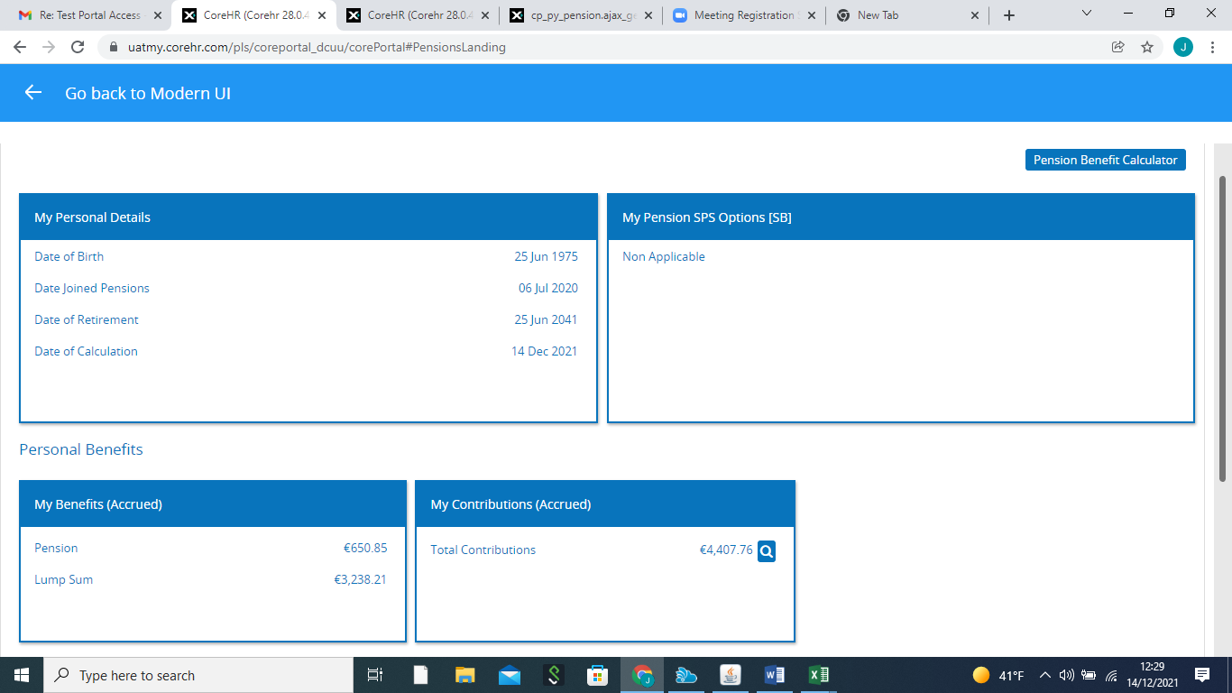

1. This shows the value of annual pension and lump sum referable amounts accrued since joining the Single Scheme in DCU.
2. This shows the total value of contributions paid since joining the Single Scheme in DCU.
3. Click here and it shows the breakdown of contributions paid in each year since joining the Single Scheme in DCU.
4. At present it is not possible to calculate future projections from the Pensions Portal. However, you can do so from the Department of Public Expenditure and Reform’s website at <https://singlepensionscheme.gov.ie/for-members/scheme-information/single-scheme-estimator-tool/> . You can also purchase additional referable amounts for Pension and Lump sum and a calculation tool which provides an estimate of the cost to purchase additional amounts is available at <https://singlepensionscheme.gov.ie/for-members/scheme-information/single-scheme-member-purchase-transfer-calculation-tool/> .
5. Select ‘Pension Benefit Calculator’.
6. Read disclaimer and select ‘Agree’ before proceeding.
7. Select ‘Generate Benefits’

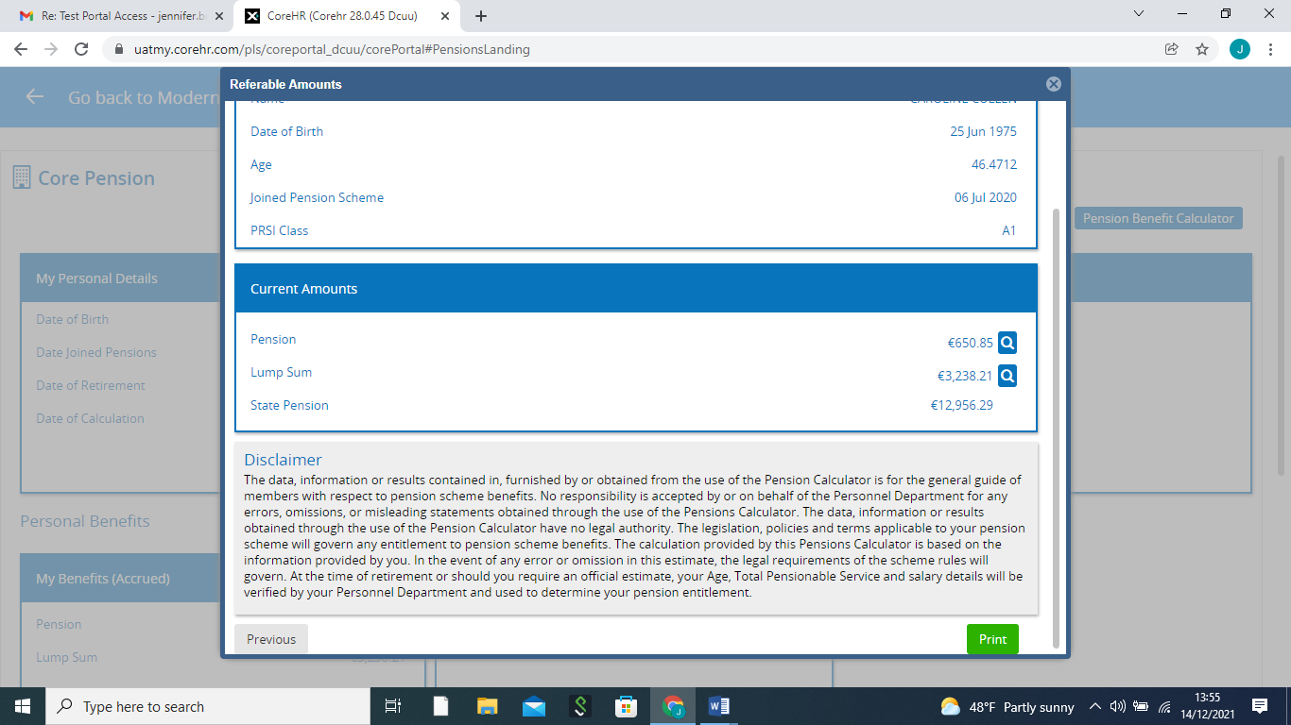

1. Click here to see the referable amounts accrued for each year of your membership of the scheme.

**Important to Note:**

If you are an A rate PRSI contributor your benefits are co-ordinated with the State. This means that you will receive a pension from DCU and if eligible, the State Pension Contributory or part thereof.

As benefit details are available in real-time and as ESS is available on a 24/7 basis hard copy annual member benefit statements will no longer be issued unless requested from [pensions@dcu.ie](mailto:pensions@dcu.ie).

**It is important to note that the results obtained through the use of the ESS have no legal standing, and are designed to provide guidance only.  In the event of any error or omission in estimates, the legal requirements of the scheme rules will govern. Estimates are not suitable for use in Family Law cases or if you are considering retirement. In either event, contact should be made with the HR Pensions Team at**[**pensions@dcu.ie**](mailto:pensions@dcu.ie)**.**