

DCU Nursing Staff Placement Handbook

Version 1.1
03 July 2024

Contents

Pre-requisites (Staff)
Pre-requisite review……………………………………………………….4
Pre-requisite approval/rejection………………………………………….5

NCAD Management
How to set up NCADs……………………………………………………..7
How to allocate NCADs and set deadlines……………………………...8-10
How to review NCADs……………………………………………………..11
How to grade NCADs and map to the final result……………………..12

Preferences (Staff)
How to set up preferences………………………………………………..13-16
How to manage preferences……………………………………………..15-17

Allocation groups
How to set up allocation groups/requirements groups…………………18-19
How to manage allocation groups/requirements groups………………19-21

Timesheet Management
How to view timesheet progress………………………………………….22-23
How to edit timesheets…………………………………………………….24-25
How to report on timesheets and absences…………………………….26-27

Failed Placements
How to manage failed placements where hours don't count………….28-29
How to delete timesheets…………………………………………………29
How to report on failed placements……………………………………...29

Allocations
How to manage allocations process…………………………………….30-31
How to publish placements………………………………………………31
How to handle placeholder placements………………………………...31
How to handle late changes……………………………………………..32-34
How to provide necessary information for SALOs/CPCs……………..34-36

Placement Visits
How to log a placement visit…………………………………………….37-38

Clinical Audits
How to log a clinical audit………………………………………………….39-40
How to report on clinical audits…………………………………………....40-41

Reports
How to create new reports……………………………………………………42
How to edit/filter reports………………………………………………………33
How to share reports………………………………………………………43-45

Feedback
How to create feedback forms……………………………………………..45
How to trigger feedback…………………………………………………… 45
Feedback reporting………………………………………………………….46

Checklist for creating placements………………………………………………………..……….47

Pre-requisites
Objective - At the end of this guide, you will be able to download, view, reject and verify prerequisite documents uploaded by students. You can view them by student, by document type or by date submitted chronological order.

Students upload all of their necessary certifications by clicking on My Details. Scrolling down the page will bring them to the pre-requisite section. Here they can add their NMBI pin number, any self-declaration, all people handling certifications, and any certifications that they need to show from HSeLanD in order to be able to go on placement.

Step 1
Go to the Attribute Verification Widget on your homepage and click on Manage Attribute Verification.

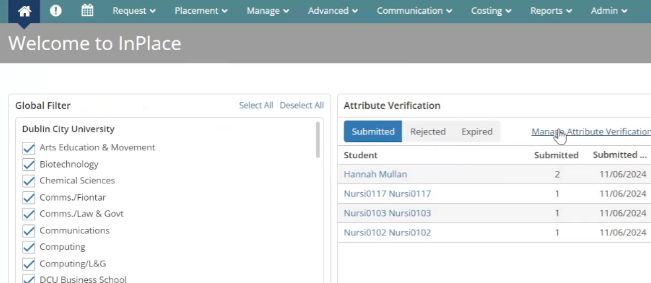

Step 2
Under view mode click student.

Step 3
Clicking the down arrow on the right-hand side of the screen on each student, you can see for each different attribute what they have uploaded.
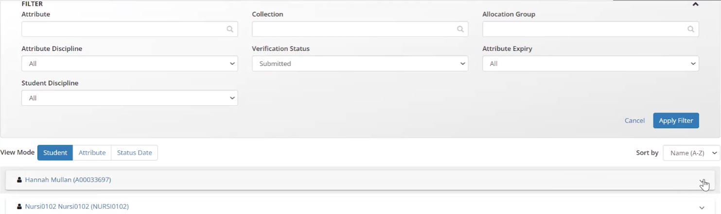
Step 4
Click on the attachment icon to download the file uploaded by the student. This downloads it for you and you can view it.
Step 5
If satisfied with the document click verified and add a comment if you wish, which is visible to the student. Click rejected if not, and this prompts the student to re-submit.
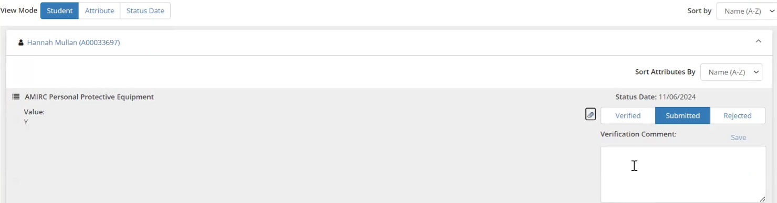

Step 6
In view mode click attribute for a view of pre-requisites uploaded by the type of document. This shows students who have uploaded each pre-requisite type, e.g. personal protective equipment certs.

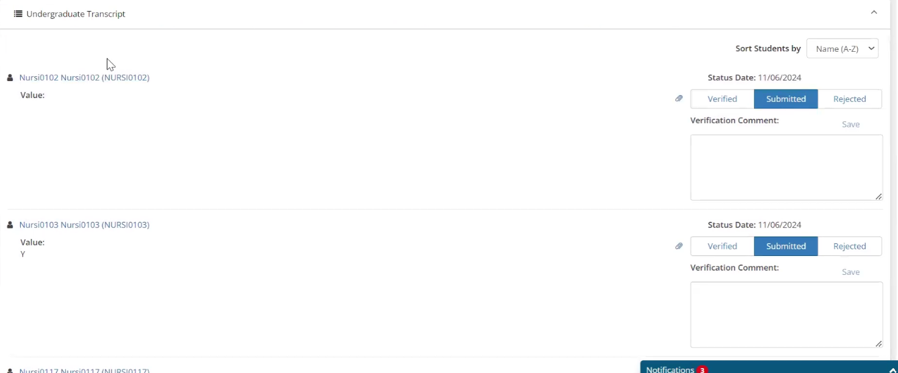
Step 7
Click on view mode and status date and on the right hand side sort by earliest or latest submission to view prerequisite documents submitted in chronological order.

NCAD Management
Objective - At the end of this guide, you will be able to manage uploaded NCADS within the InPlace system. Note: When all preceptors have email accounts, students can fill each individual NCAD section directly in InPlace.

Step 1
Click on advanced and survey and assessments, referred to as InSight Plus. Surveys are detailed here along with their corresponding campaigns (this is what triggers the to-do item for the student). Click on one of the surveys on the left ie. National Competency Assessment Document. Note: where a student has filled the same NCAD for multiple placements, they will need to upload that NCAD for each to-do item. e.g 2 to-do items that one NCAD applies to.
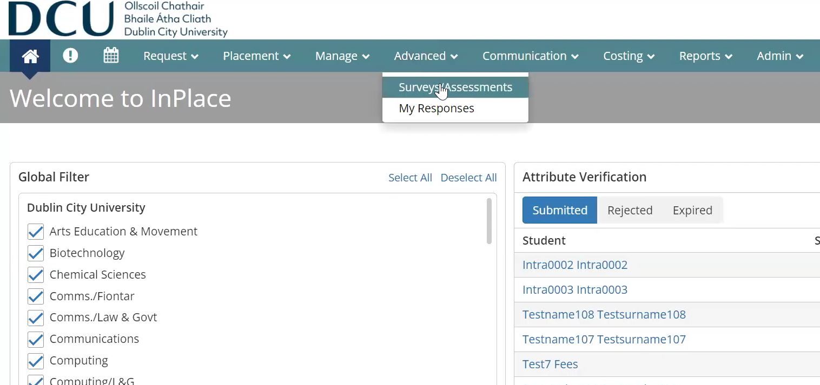
In the screen build above you will see the submission screen for students, their sign off requirement and scrolling down the section for Practice Module Coordinators (PMCs) to review and enter comments for students if required and to confirm competency (pass or fail).
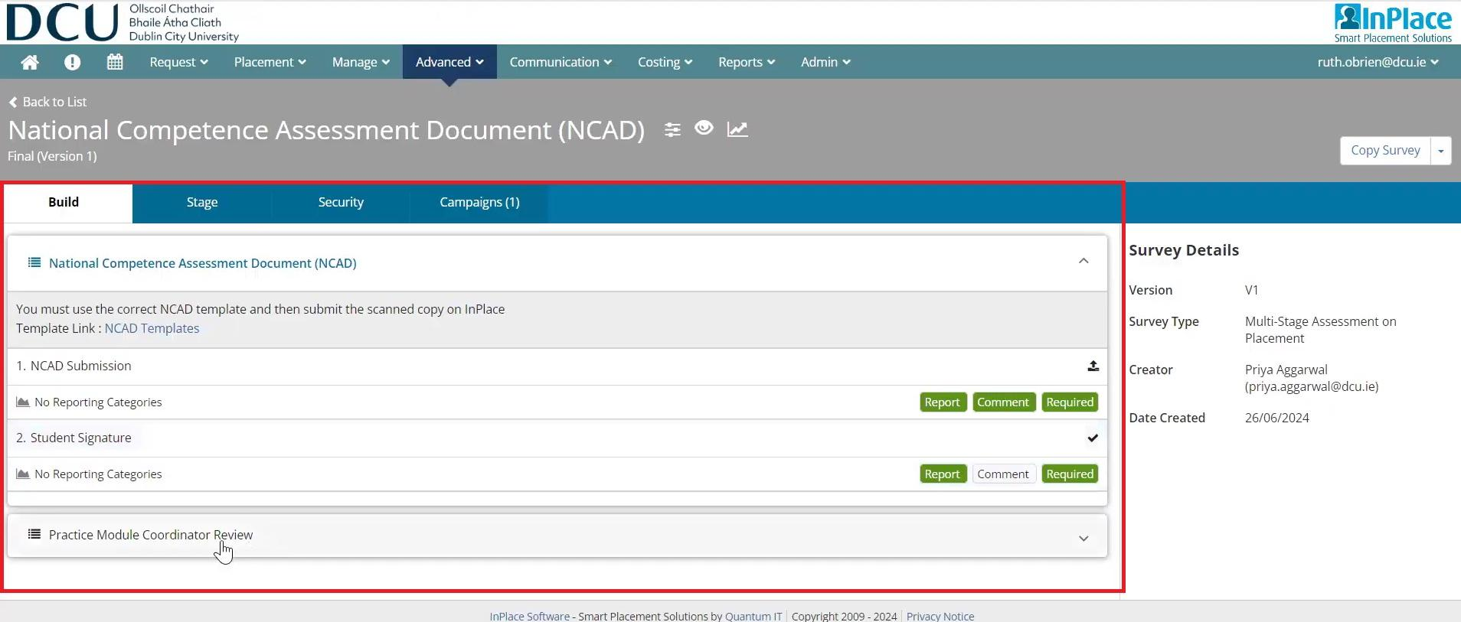

Step 2
In the stage screen, this details which part of the process is applicable to which user and you can set submission window and deadlines for NCAD submission as per below:
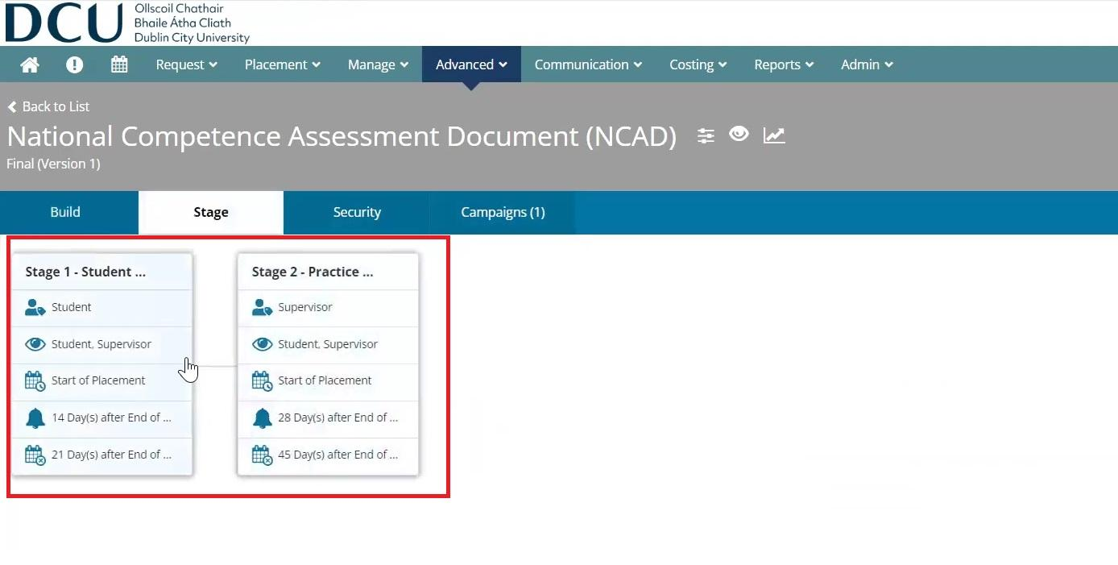
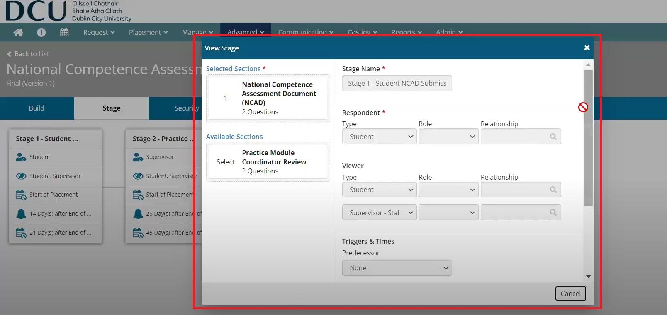
The security screen shows the access permissions that users have.
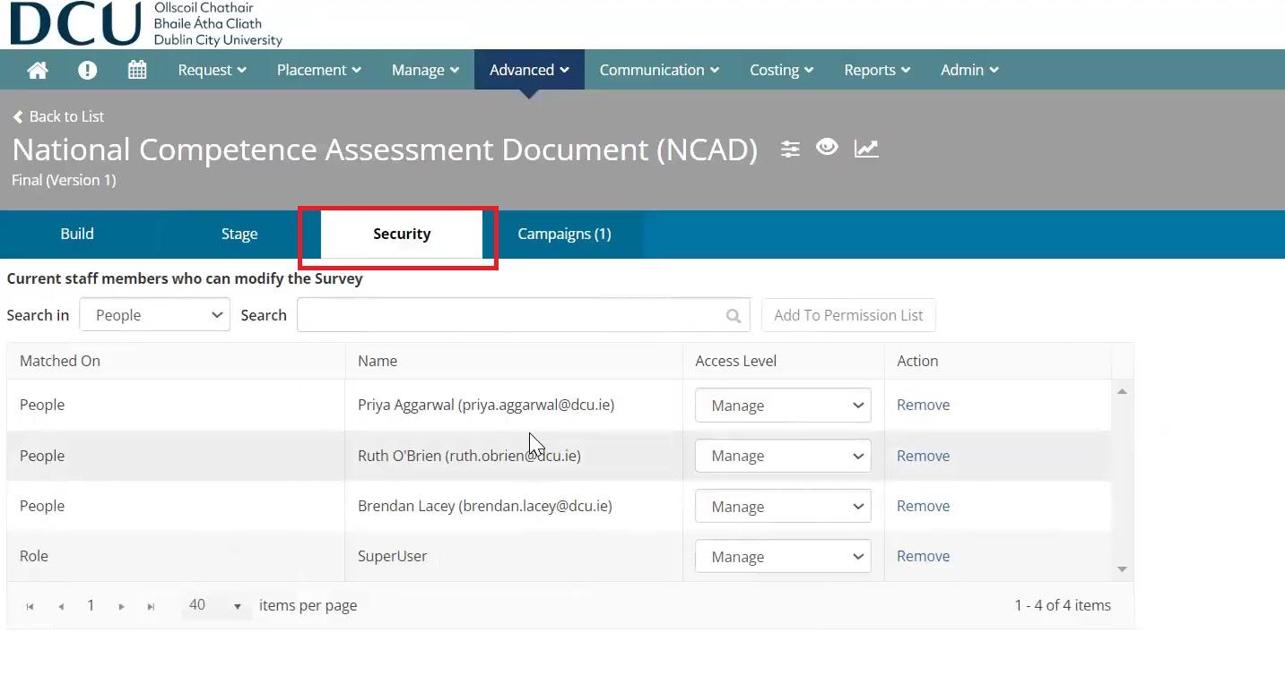
In the campaigns screen below you click into each campaign, see how many placements are attached to each campaign, the campaign creator, dates and options to run reports. When you click on the campaign name field in blue, you can see further information on settings, dates and reports.
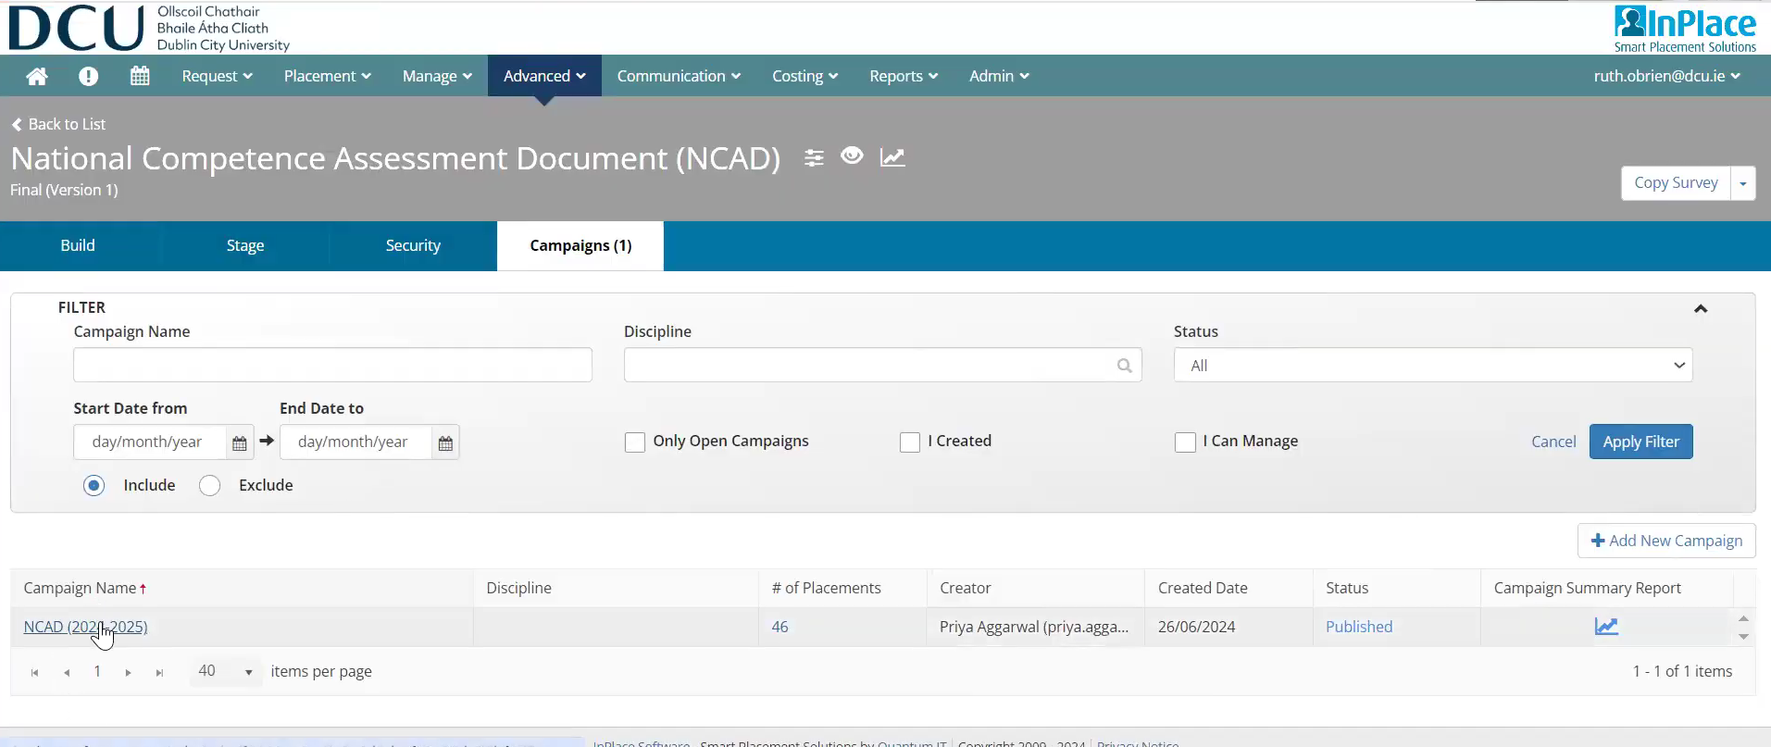
Step 3
Click into placements and use the filters as required. Under status you will see the different stages of the NCAD submission. 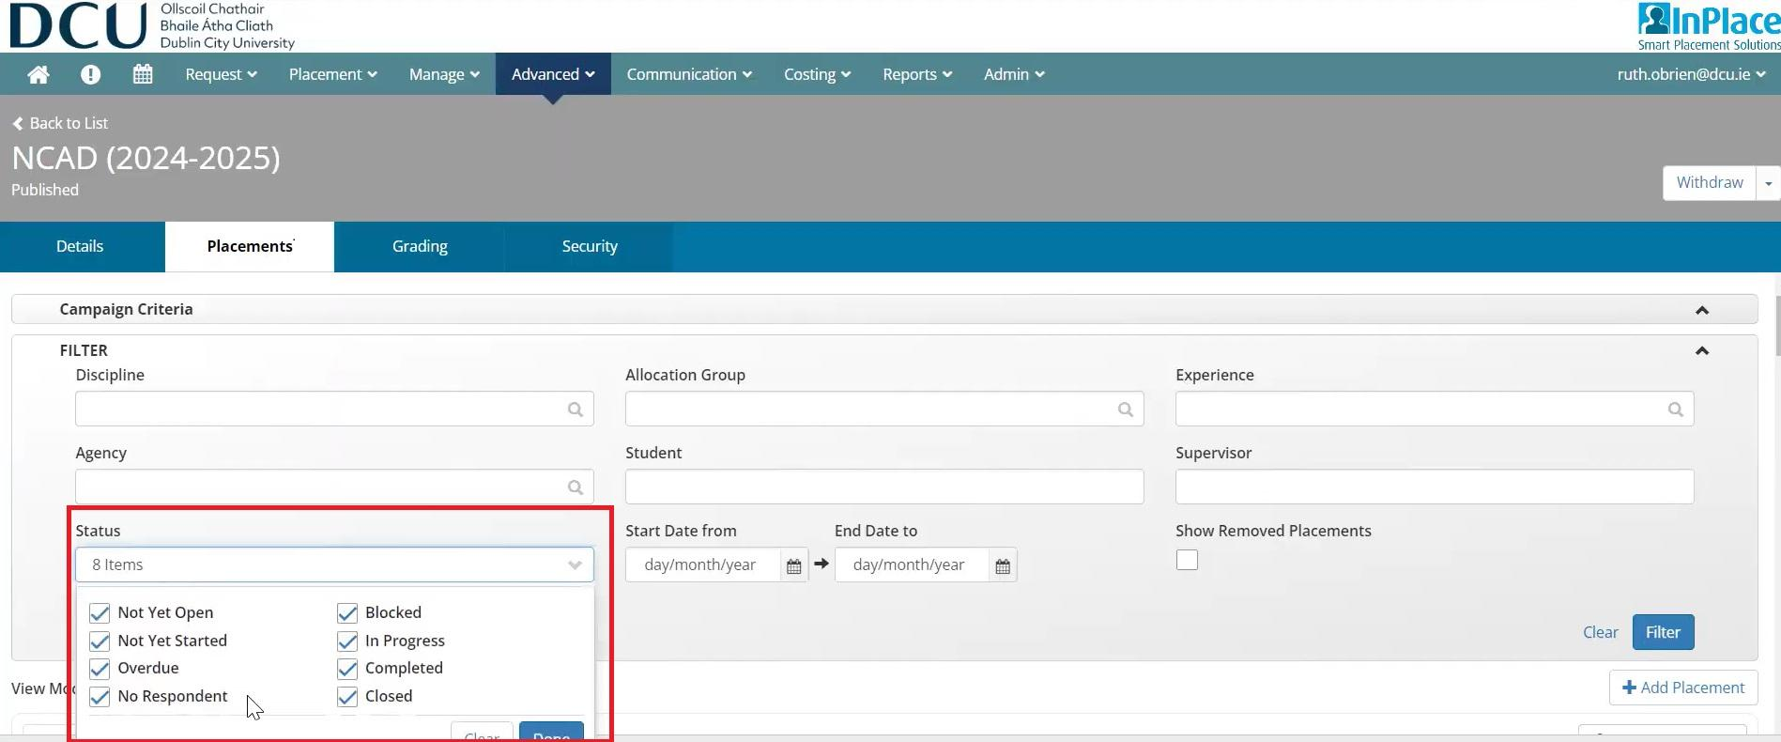
Note in the view mode you can change it to stage, if required to see how many NCADs are at student submission stage and PMC stage. To the right, you can add more placements under + add placement to add recently added placement since the placement campaign began. Scrolling down you can see the supervisor for each placement (SALO and PMC).
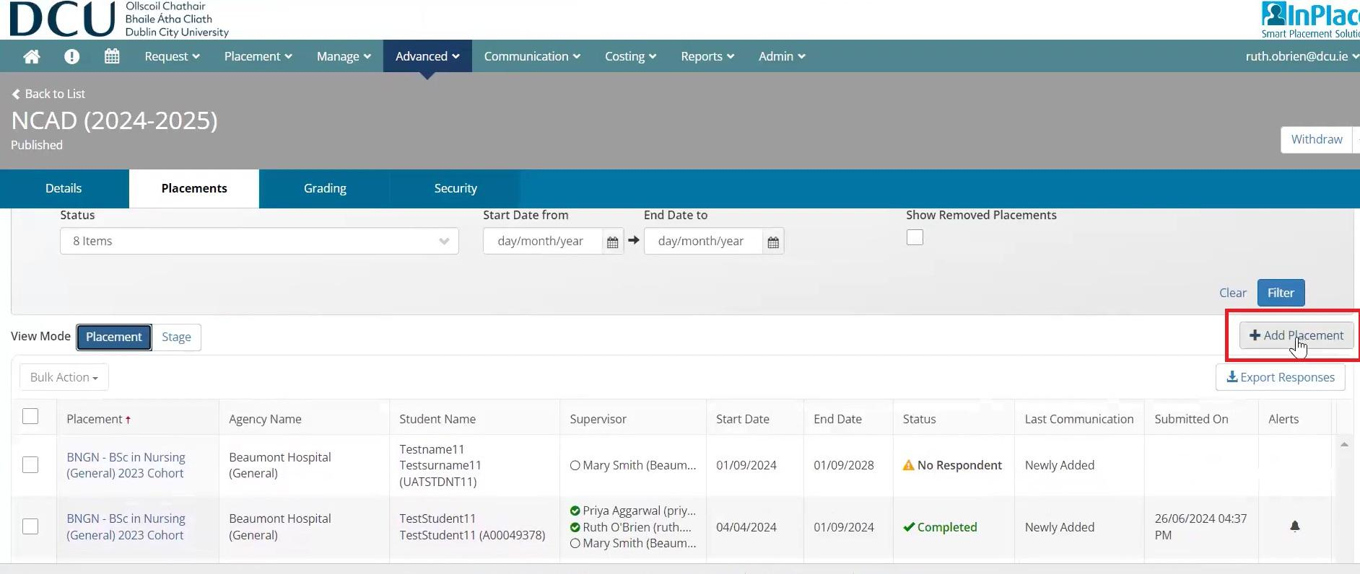
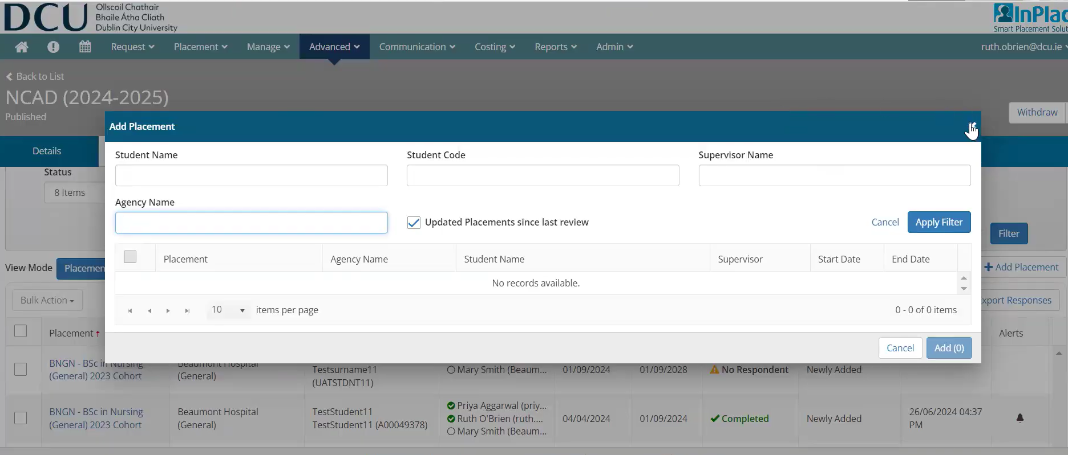
Under the placement column on the left each link brings you to various details of the actual placement including options to export this information to an excel file. Clicking into a placement you will see this below:
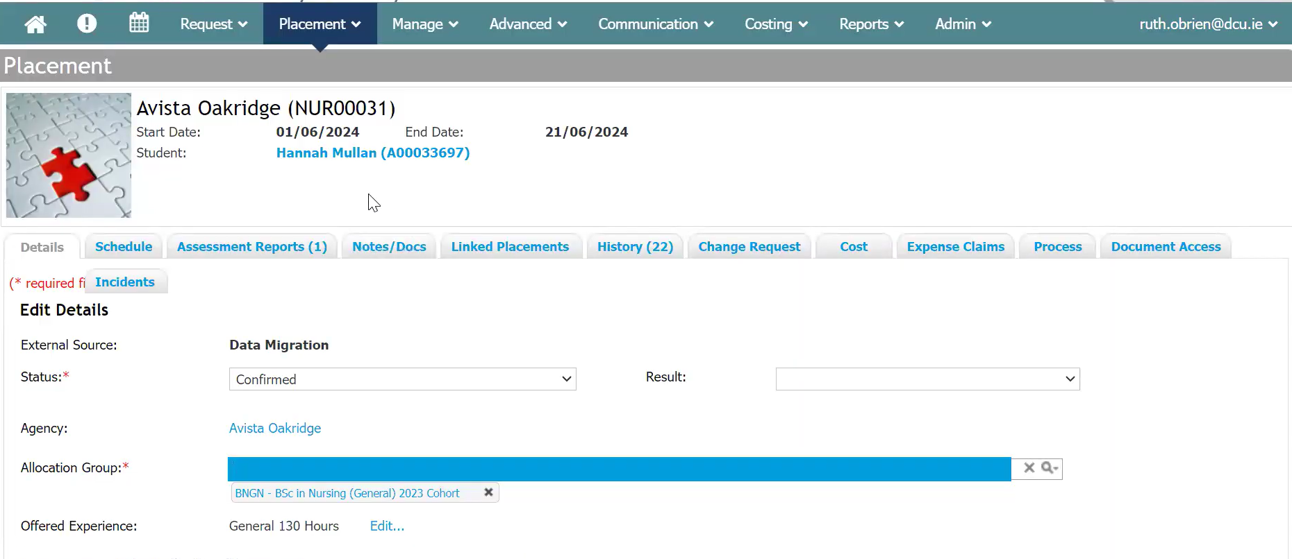

Step 4
To impersonate the student and see the NCAD from their point of view click into the name. Scroll down the page and click login as student. In here you can see the prompt on the student’s to-do list, the NCAD task assigned as well as the NCAD template available and the option to download, leave a comment and submit it.
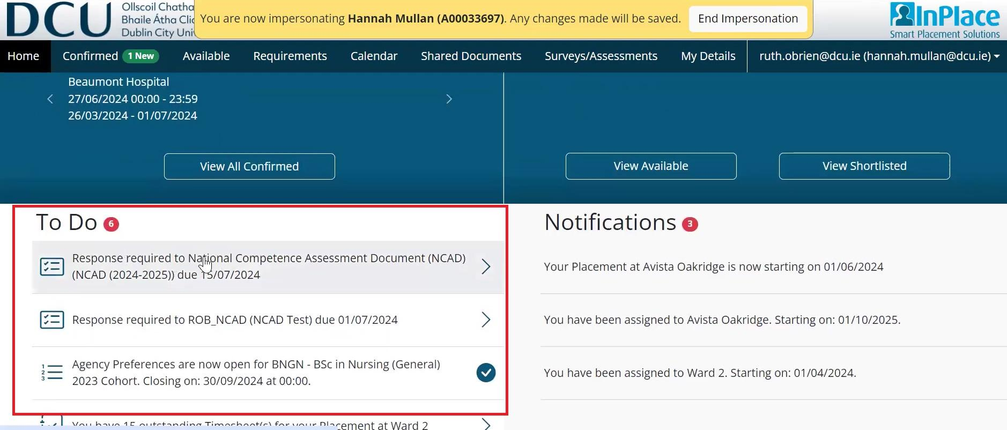
There is an option to save the submission as draft and to leave a comment for the practice module coordinator. The student must click the acknowledgement box on the left before submitting.
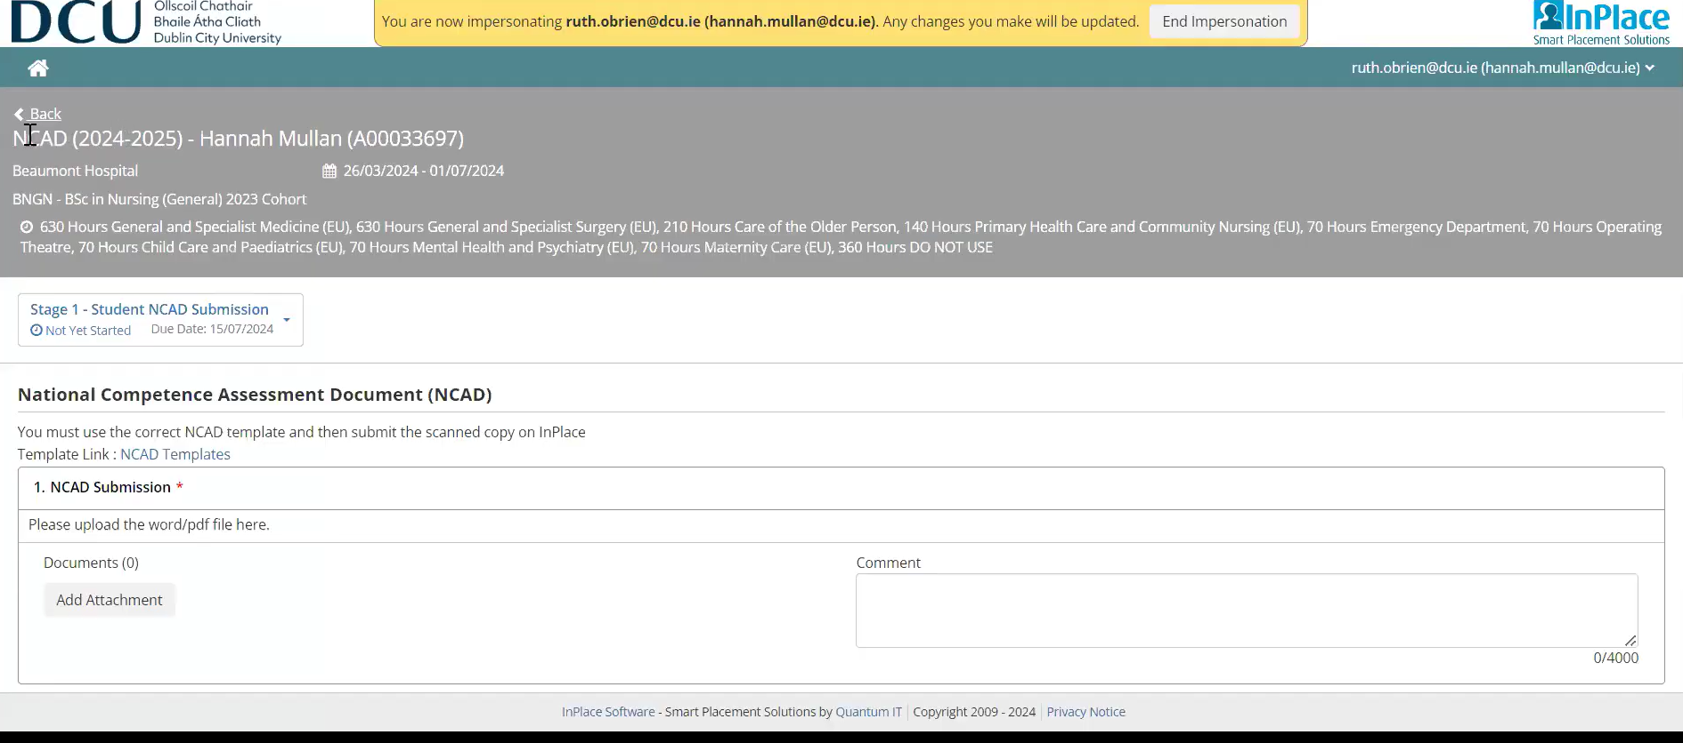
Step 5
For the practice module coordinator that is linked to a student as a supervisor they can view a submitted NCAD. Click advanced and my responses.
You can filter for the student or the status. Note: the stage is now stage 2 Practice Module Coordinator review. The campaign can be i.e. an academic year. To see the NCAD, Click respond.
General information on the placement is in the top left hand corner and you can also see each stage below. Click on stage 1 NCAD submission and download the submitted document. To grade the NCAD, click on Stage 2.
Enter review comments if required. Under competencies click on competent (pass) or non-competent (fail). Save as a draft or submit if happy it is completed and ready to submit.
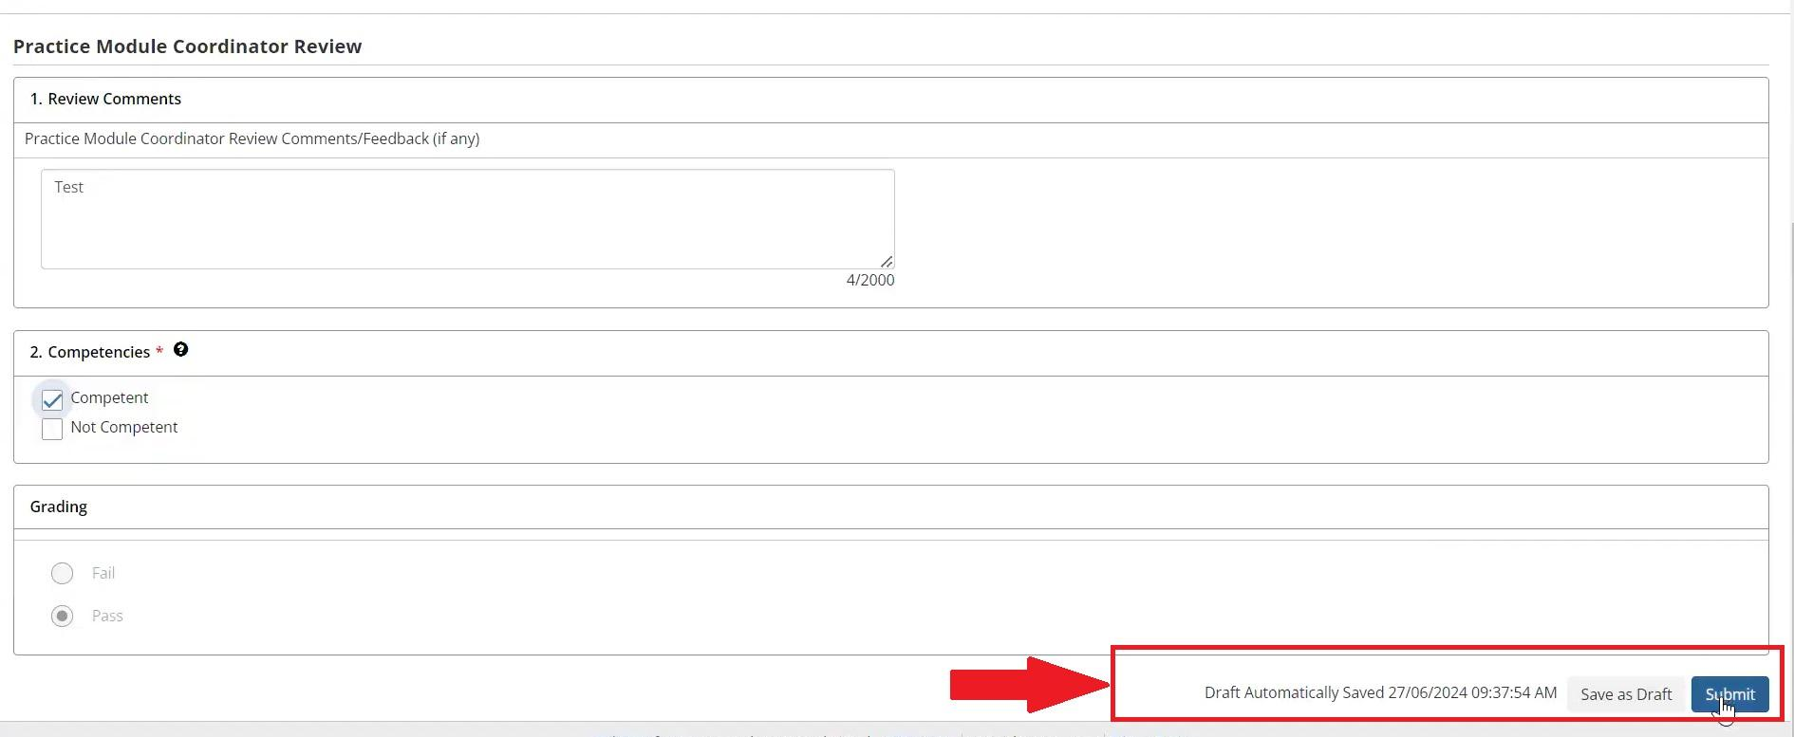
NOTE: If a student fails the NCAD their submitted hours for that placement must be removed from their total hours.

Preferences (Staff)

Objective - Using this guide, you will be able to select student groups and set up Agency Preferences for an allocation group in InPlace.

Step 1 - Selecting Allocation Group
Once you are ready to set up Agency Preferences for an Allocation Group on InPlace, you can start this process by following these steps
- Clicking on the Placement button, located in the tab at the top of your dashboard.
- Select Allocation Groups.
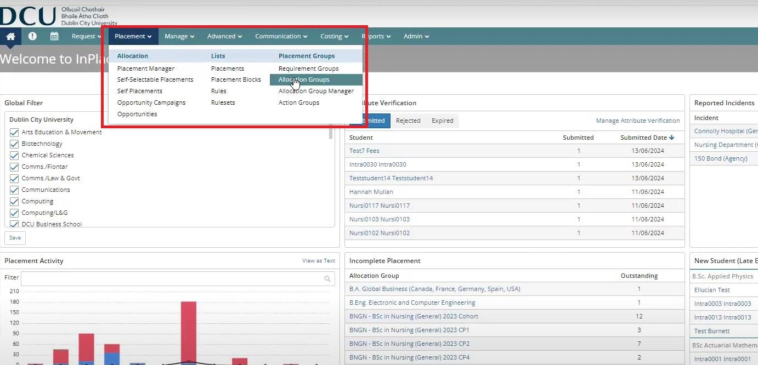
This will bring you to a list of Allocations Groups. Here, you will be able to find the Allocation Group for which you wish to set up Agency preferences. You can start this process by clicking on the relevant Allocation Group:
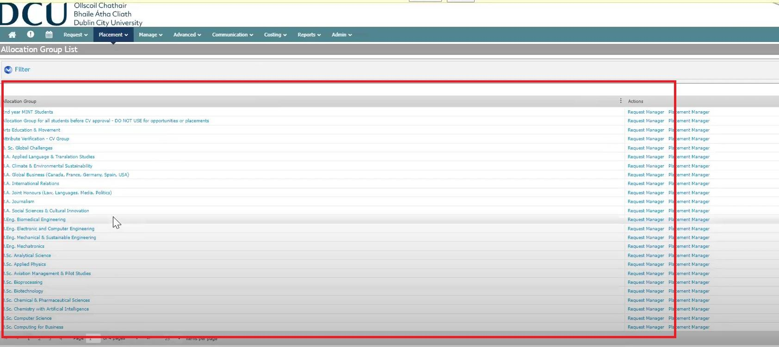
Step 2 - Setting Up Agency Preferences
Once you have selected your Allocation Group, you will be brought to the following page:
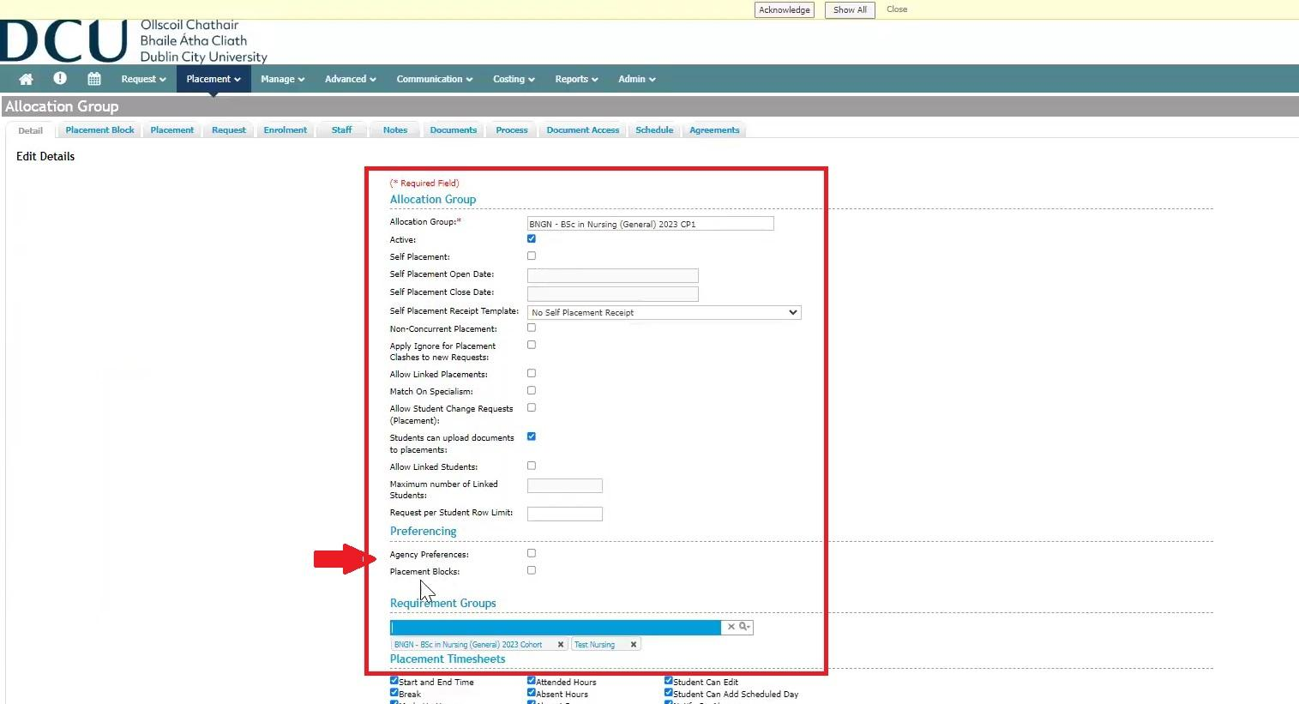
Here, you will be able to view a list of details regarding this particular allocation group. If there are no agency preferences associated with this group, the agency preferences box will be unmarked. Click on the box to select agency preferences, then click save. This will only apply to first year modules.
You will now see agency preferences as an option in the tab, at the top of the page.
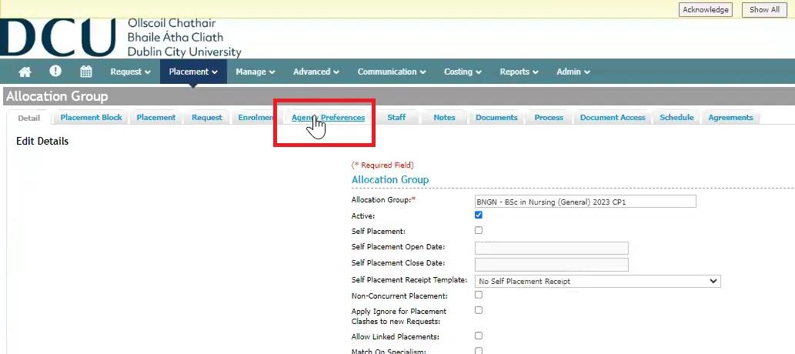
Step 3 - Preference Set
After clicking save, you can now set up agency preferences using the agency preference tab.
You can set up the start and end dates of the preferences, under the edit details tab. This affects when students can submit their preferences.
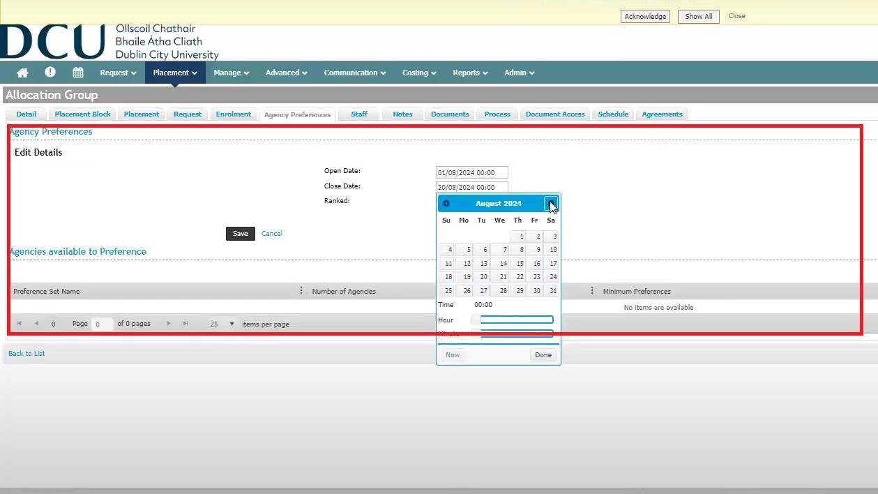
To add a preference set, click the add Preference Set option, on the right-hand of the screen.
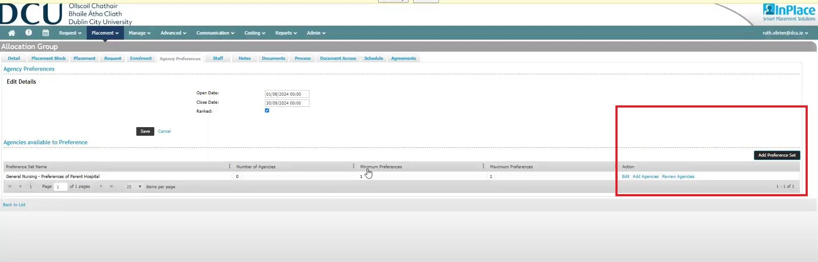
*Please note that you can also select Review and Edit options here.*
A pop-up box will appear and you will be required to complete some information to add a preference set. You will be required to fill out:
- Preference Set Name
- Minimum/Maximum Preferences
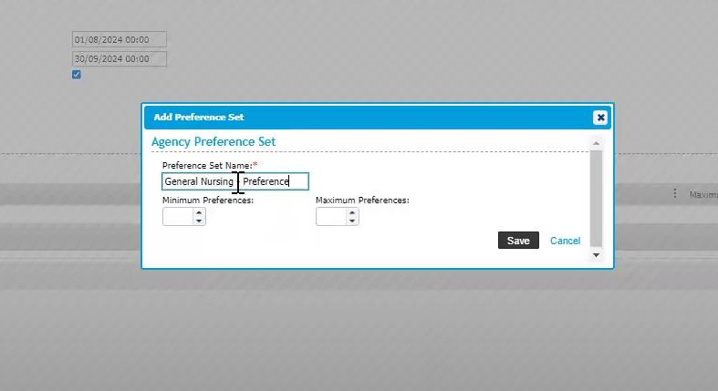
Once Preference Set is added, options for Preference Set Name and Maximum/Minimum Preferences appear.
Step 4: Adding Agency to Preference Set
You can now add Agencies to this set. To start this process you will click on the Add Agencies option, located on the right of the screen.
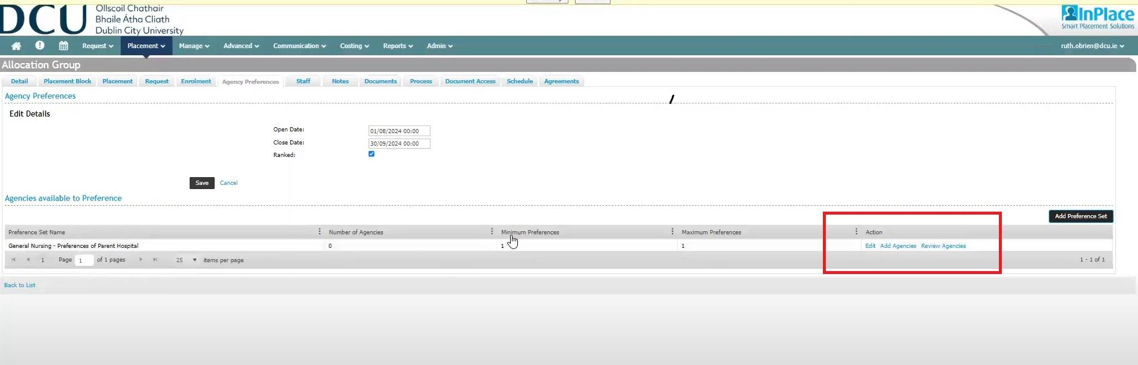
Once this option has been selected, a pop-up screen will appear with a list of Agencies that you can add to the Preference Set that you are setting up. Select the agencies you wish to add to this preference set and select save.
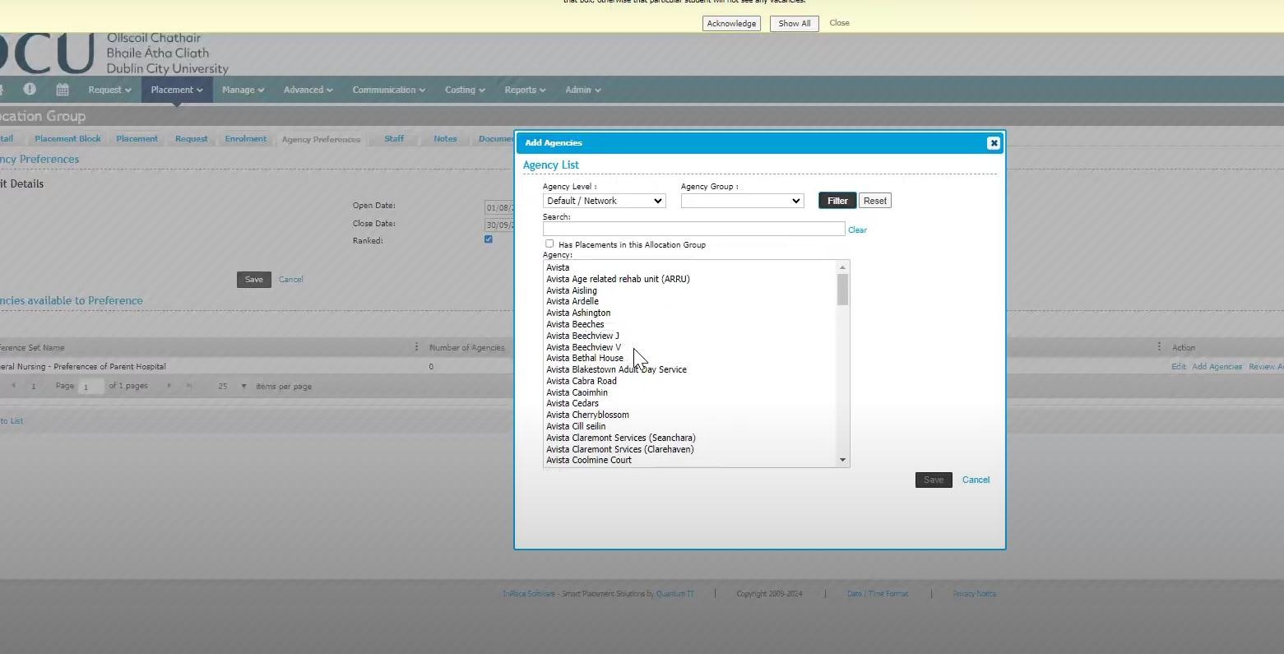
Once you are satisfied that all of the information you have added is correct, you can then select save, to finish setting up the agency preferences process. Once you have selected save, this will generate the agency preferences for the Student to choose from.
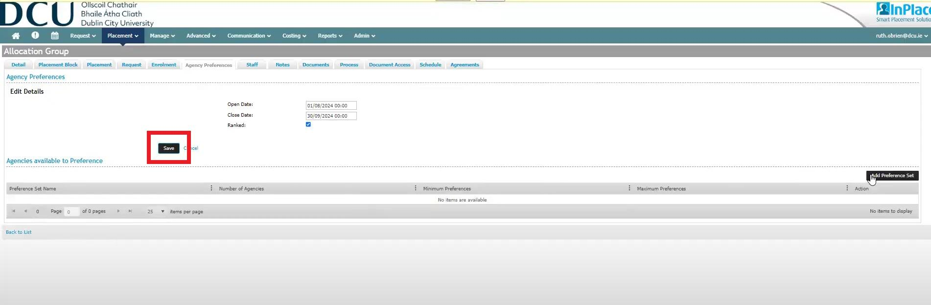

Allocation Groups
Objective - At the end of this guide, you will be able to set up and manage different allocation groups (grouping placements) and requirement groups (grouping students to their NMBI requirements) in the InPlace system.

Step 1
Click on Placement and then allocation groups. Underneath Allocation Groups on the left-hand side you should see only Nursing Allocation Groups. Use the filter as shown below noting that the discipline will always be Nursing.
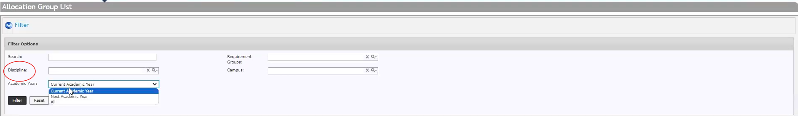

Step 2
Click into one of the allocation groups to view the details. Complete the mandatory fields as shown below:
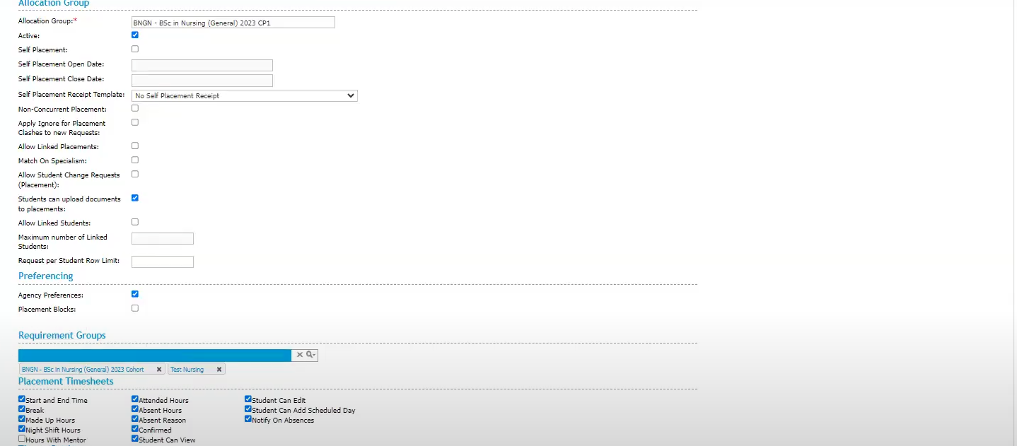
Scroll down to the section entitled Preferencing to gather the preferences* of a student grouping.
*Preference for a particular parent partner service i.e. Beaumont Hospital. Scroll further down and tick all of the boxes in the Placement Timesheets section and click save.
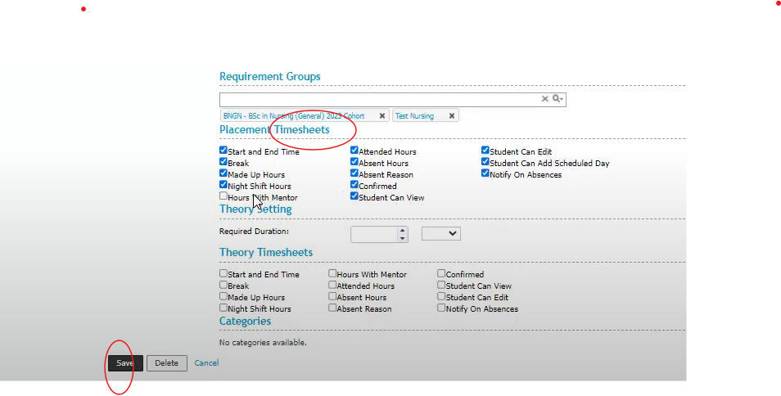
Under Allocation Group, click on the placement tab, three tabs from the left, to view the placements set up for students in this allocation groups. Click the enrolment tab to see the students within each allocation group. The staff tab shows nursing staff linked to a particular group of placed students. The documents tab shows documents already shared with this group.
Step 3
Navigate back to your Allocation group and click + add new item in order to create your own new allocation group. Complete the mandatory fields marked with a red asterisk. Tick the box labelled active and agency preferences if setting up a first year allocation group. Select a requirement group and tick all of the boxes as shown in Step 2. Click Save. Check into the tabs as shown in Step 2 i.e. enrolment to see which students are in the group, they will automatically be added to the allocation group according to the requirement group criteria (e.g. registering for a module).
Step 4
To set up and manage a requirement group click into Placement and from the drop down menu of placement groups, select requirement groups.
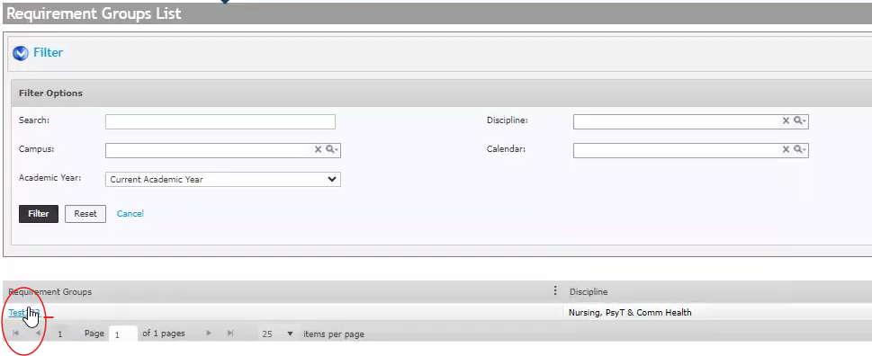
The group(s) will be shown under Requirement Groups on the left-hand side in blue as shown above. Click onto the relevant group and you will be in the edit screen. Fill in the mandatory fields, again noting the discipline will always be Nursing. Scroll down the page and fill in the requirements as shown below for example, NMBI requirements. Select the experience required under Experiences and click add. you can select more than one. Choose an Allocation group from the drop-down list and then click save.

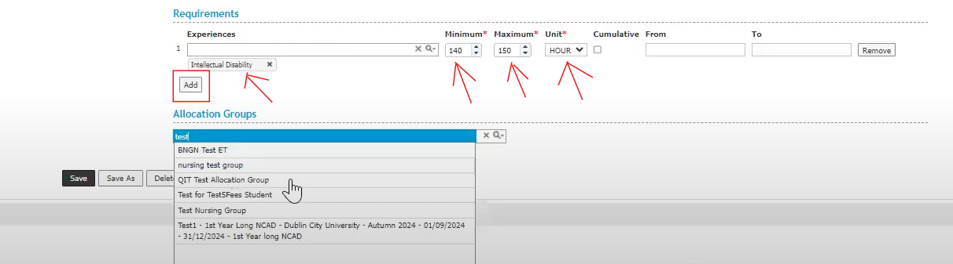

Now click on the enrolment tab above to add your enrolment criteria. Click add enrolment criteria. As below, the field Unit in InPlace = Module. Select your module from the list to the right of this. (You can manually add and remove a student from your requirement group in this screen as well under the enrolment tab).

You can fill in advanced criteria and click Generate Student Enrolment when happy with your criteria.
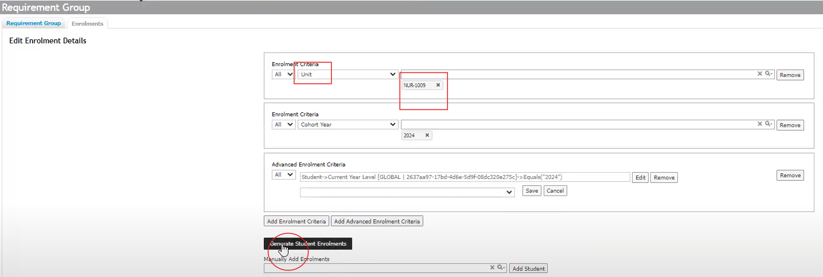

This will enrol all students registered in Banner for that particular module as Banner integrates with InPlace. The following academic year, a new copy of the requirement group can be created by clicking “Save as”. This allows you to save the same criteria and rename the requirement group to the next academic year.

Timesheet Management
Objective - At the end of this guide, you will be able to manage attendance, absences and related documentation. You will also be able to filter for students, student cohorts and supervisor staff details.

Step 1
Using the Absence Notification Widget, check the submitted absences by clicking on the entries under submitted by and acknowledge these by clicking acknowledge to the right. Filter as needed under Absent Notification.
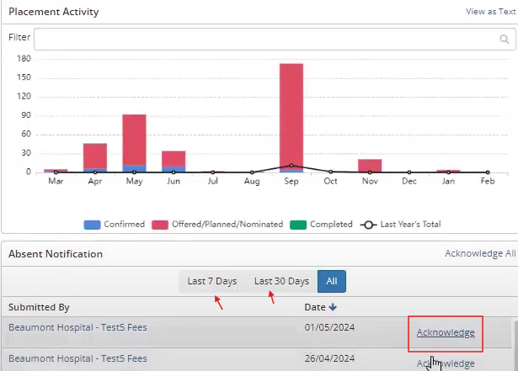

Step 2
On your home screen click into Manage and click on Timesheets from the drop-down list. Click on the filter arrow below to see all of your filtering options.
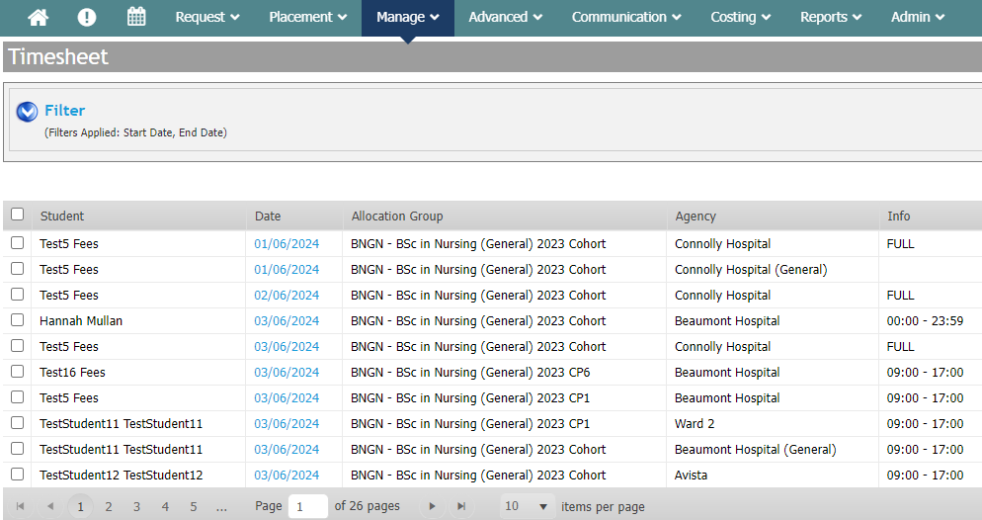
Note: In the Discipline field you will always choose nursing. Scroll to the bottom of the page and you can also choose how many records per page you wish to see displayed as below, under items per page.
Step 3
Key Columns and what they mean:
Date - Day in question for a student’s timesheet. Daily timesheet is submitted by the student
Attended Hours - This feeds into NMBI requirements for transcript of training
Made up hours - Hour the student may have logged to compensate for any hours missed while sick/on leave
Confirmed- yes/no- These hours have been confirmed by the SALO (or not)
Comments: Hover over this to view comments left on the timesheet by the student, SALO or DCU.
Note: All of the columns can be sorted by clicking on the heading in grey and then on the arrows to view in ascending order or descending order
You can multi-select records and select an action in bulk as shown here below in the bottom left-hand corner below:
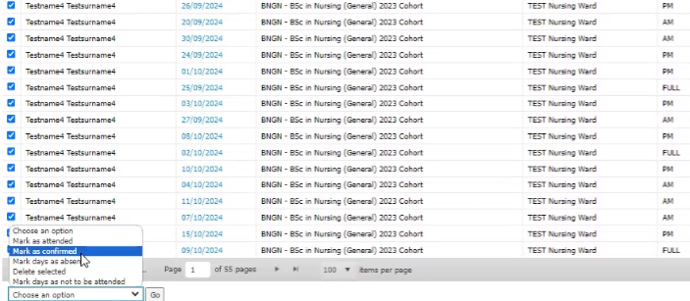
Select an option and click go to the right.
Step 4
You can bulk add absences to a student cohort by scrolling back to the top as shown here:
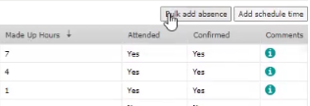
Choose a specific date and enter your details as below. In this example we’re adding 1 hour of annual leave to a specific cohort of students (allocation group).
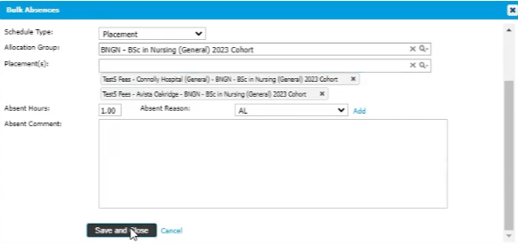

To change an already-confirmed timesheet
Return to your filtering option screen as per Step 2. Select the student whose timesheet you wish to amend and click filter. Scroll through the timesheets to find the one to be changed. To change it, click on the date. Unclick the confirmed box. Edit the times. Click the confirmed box and hit save/close.
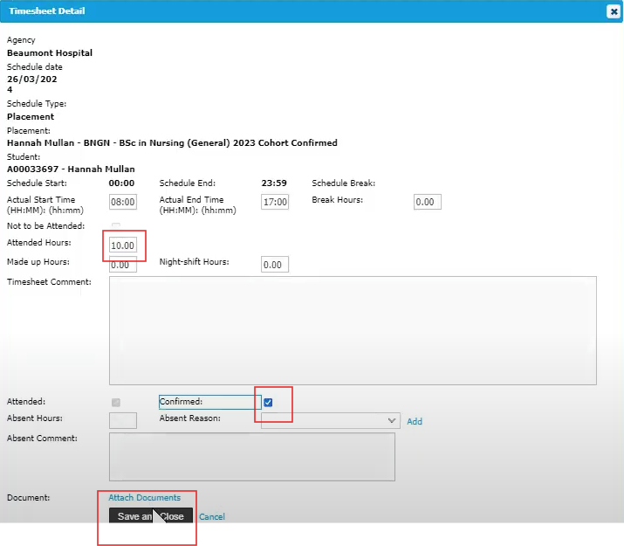
Check that your edit has been made by viewing attended hours on that student’s list of timesheets and that the status is confirmed. This will also reflect in the student/SALO view of the attendance summary.
Step 5
To add schedule time here for a student, click Add schedule time in the box to the right.
Add the date and other details such as those below (note schedule type is always placement):
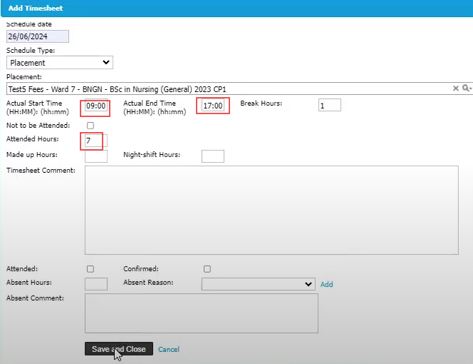
Click save and close.
Step 6
To generate a report on timesheets, on your main top-screen menu click Reports.
Beside the subject section, click to choose the theme of your report i.e. student and placement. Choose the appropriate base query from the drop- down list, in this case “Schedule”. Under columns, select required details from the available columns list by clicking add columns. You will see these listed to the right -hand box as you select. When ready, click run in the top-right corner.
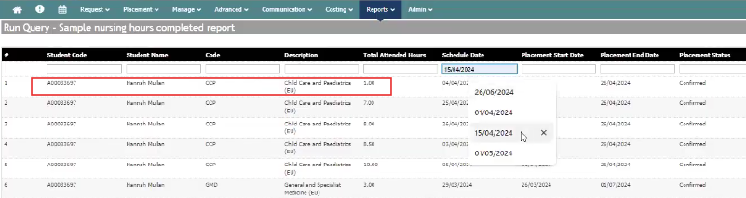
Above shows a sample report.
In the sample above, the student has logged one hour in Childcare and Paediatrics on the fourth of April. Her placement block was from the 1st to the 26th of April. You can see that the timesheet has been confirmed. You can filter by a specific nursing code, student name, description or a specific schedule date. This sample is filtered for the 2nd of May. You can see on the 2nd of May, there are two entries for two different students and two different types of nursing. You can also run a report on absences and apply filters such as covid leave among others before running in the same way as the report above.

Failed Placements
Objective - At the end of this guide, you will be able to remove a student’s hours on a failed placement and create a new placement for that student.

Step 1
After the Practice Module Coordinator has marked the NCAD as failed and mapped it to the placement result, go to Reports/Query Tool on your main menu. Navigate to the failed placements report and click run as shown below:
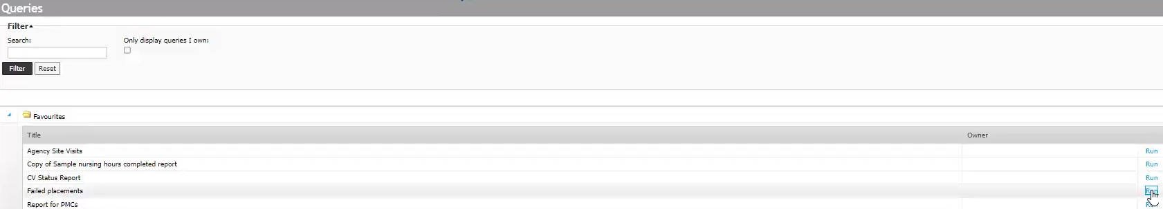
Step 2
Your report below will show a number of students who have failed their placement and who need a new placement created and their failed placement hours removed.
Click on Manage and Timesheets
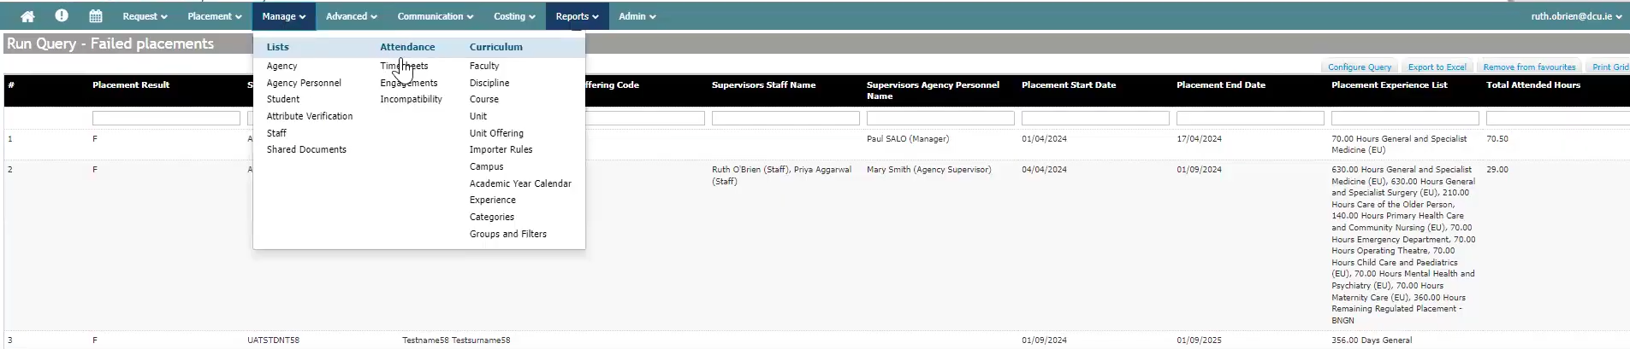
Use the filter options to filter for a particular student. Click on the tick boxes on the left-hand side to select the hours that need be removed as below:
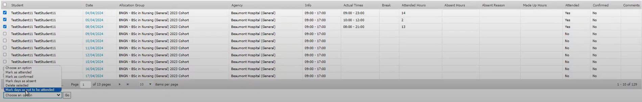
As above, Under choose an option bottom left, choose delete selected and click go. You will see those hours removed from the students placement record.

Step 3
To create a new repeat placement for the student, go to your main menu and click placement and placements under lists. Scroll down and to your right click on + add a new item as in 1 or as part of a list of new placements as per 2 below:
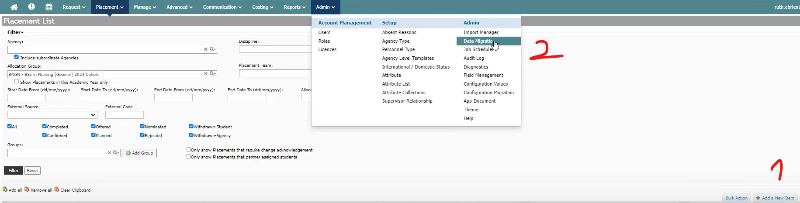
Once the details have been filled and schedule generated, this will trigger a new timesheet for the student on their InPlace dashboard. When they repeat the hours and pass the placements, these hours will go towards their NMBI requirements.

Allocations
Objective - At the end of this guide, you will be able to manage the allocations process, facilitate placeholder placements, handle late changes and publish placements to include information relevant to SALOs/CPCs.
Bulk share information (document) with partner services

Step 1
On the main menu click communication and choose communication templates from the drop-down list. Filter for Template Type from the drop-down list on the left-hand side and select agency personnel notification. Click the filter button. Note in the name column the different types of information available. Select one of the templates i.e. programme map by clicking detail of template in blue on the left-hand side and you can populate the information for sharing as shown below, on the next page:
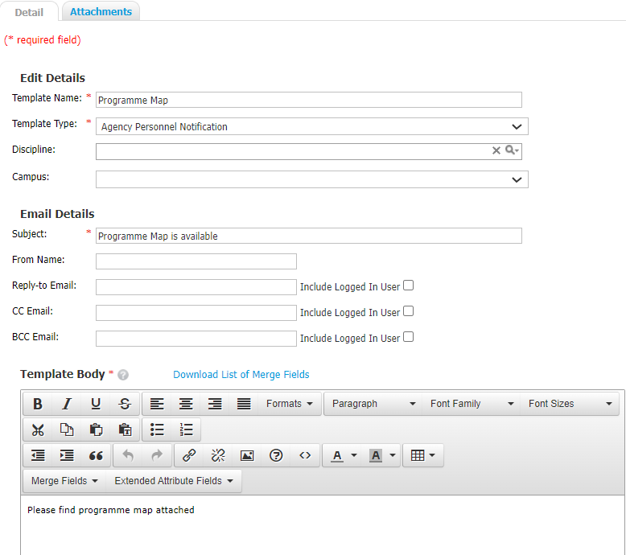
Scroll down and click save when happy with the information you’re prepared to share. Scroll back up and click on the attachments tab. Select your file from your device under standard attachment in the normal way and click on save in InPlace. Click on back to list in the bottom left-hand corner.
Step 2 - Share document with multiple SALOs at once
To create a new template, click the button on the right-hand side + add a new item. Use a template name of import file as this is what you’ll be asking the agency to download and fill in. Complete the mandatory fields, type your message for the agency. Click save when happy with content. Click on attachments and then add a standard attachment. Select the import file template from your device as in step 1. Save and click back to list and you will see your new template on the list. Once you see it, click Manage on the top menu and agency personnel from the drop down list.
In the filter section under under agency level select Default/Network to reach the highest level of network i.e. SALOs in the parent partner service.
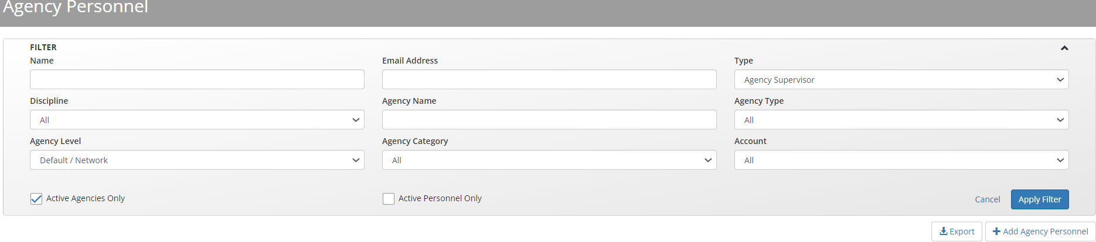
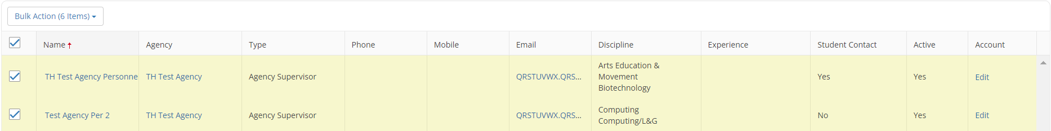
Click on the bulk action items button and then send email from the drop-down list. Click yes to confirm and choose the template you wish to send from the list ie. ‘Programme Map’. You preview the document, message and click send.
Sharing information with individual partner services

Step 3 - Share document with one agency at a time
Click Manage on the top menu and agency from the drop down list. Click on your chosen agency from the list on the left. Navigate to documents. Click + add new document. Give it a title and choose a file from your device as in Step 2. Click the box share with agency personnel. Choose nursing for the field discipline and save. You’ve now shared this information with the relevant SALO.
When students choose a preferred parent partner service
Step 4
On the top menu click Placement and from the drop-down list click placements. Click + add a new item to bulk create the parent hospital placements to start matching the student with the parent hospital. Choose your parent provider from the agency section and your cohort from the allocation group section along with start date and end date (e.g. 4 year programme will be 1/9/24 to 31/08/28). Fill the correct number according to parent hospital capacity under “Number of Placements per Agency”. When completed, click generate.
Click Placement from the top and then placement manager. Using the filters at the top choose an academic year and under group type, choose allocation group. Click refresh. Scroll down and click best fit. Below under rule set click on Nursing Base Hospital. Click on run trial match to the right. Once finished running, Click close when the Trial Match Progress Report dialog box appears.
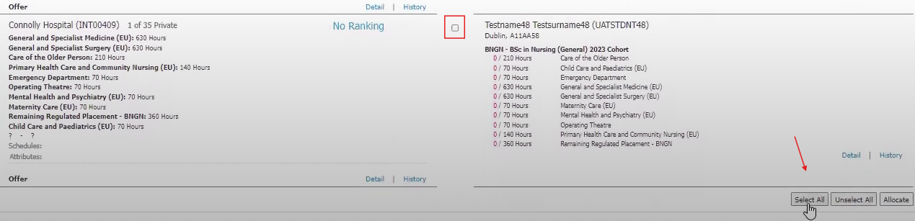
Allocate your students to the relevant parent service by clicking on each box individually or click select all at the bottom and unclick boxes. Then click Allocate. Click ok to confirm these. Note the number of placements shown. View and x out of the allocation summary dialog box. It sends this as a list to the parent service who can see it under placements and export to excel using the download icon on the right.
The parent service will use the student name and student code from the export, to further allocate within sites using a variation of this file (e.g. import file or calendar view file).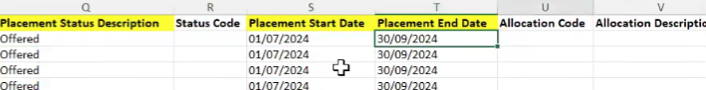
When the SALO has completed this import file they click the down arrow by their name and agency details. They upload their allocation (import file) in the area shown below:
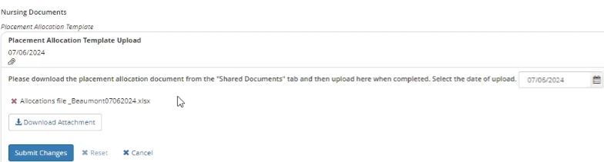
This creates an alert for DCU staff to action under Home/urgent notifications or under alerts on the main menu. To view submitted allocations from partner services display the Placement Allocation Template Upload section under Nursing documents.
Below you can see the submission and date from this particular service:
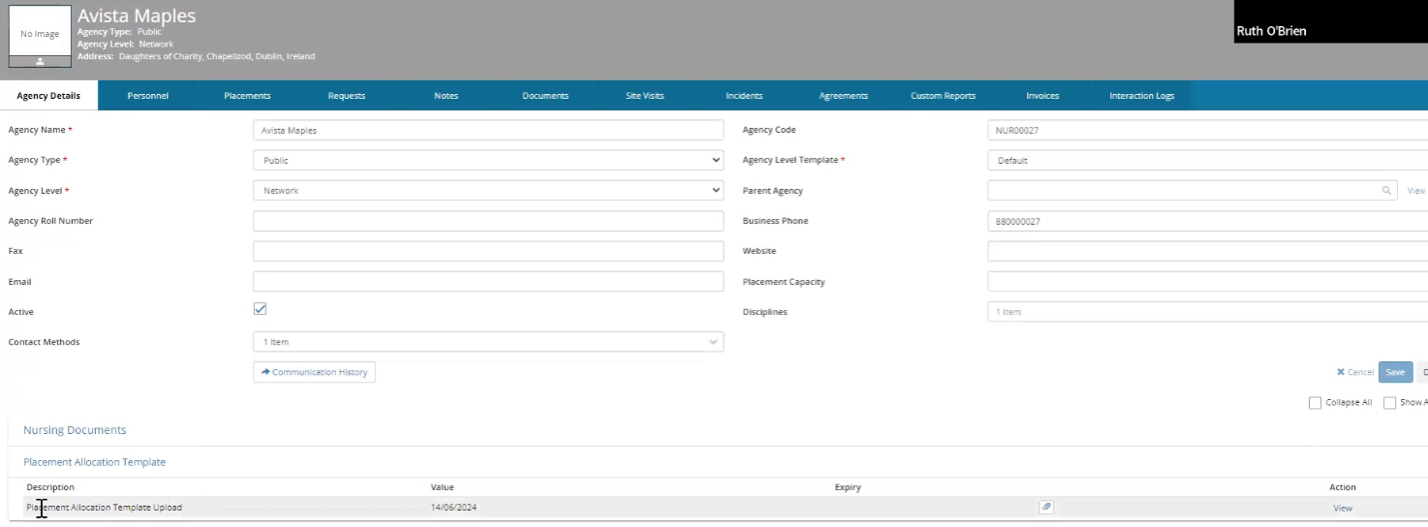
Download the submitted file using the attachment icon to the right, shown above. Review the file for formatting and spacing issues and check that data is in the correct columns. When it's ready to load to InPlace, click into Admin from the main menu and date migration from the drop-down list. Click on + add a new item. Under import file ensure placement import is selected and that import type is placement. Click choose file and find the import file on your device, click open and click upload to load the data into the system.
You’ll see the newly loaded date here. Click detail as shown below:
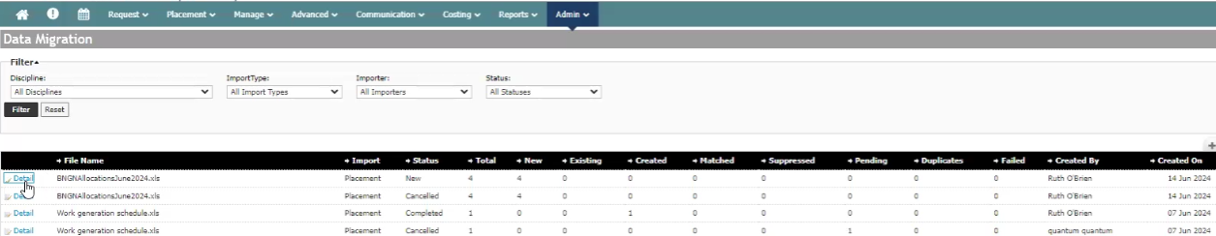
On the next screen click process all. If the list shows file(s) as failed click into edit on the left to see which field(s) has an error. Correct this error in your import file and repeat the import process as above starting with +add a new item. This time by clicking process all, the status will be pending. Then click “Create all pending placements as new” as shown below:
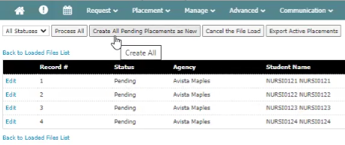
The status of your files will change to completed.
Step 5
To generate the schedule and trigger student timesheets
From the main menu go to placement and click placements under Lists. Search under the relevant partner service and when you find it click on filter. The placements you’ve created will be shown under Allocation Groups with the status of offered. Click on bulk action on the bottom right.
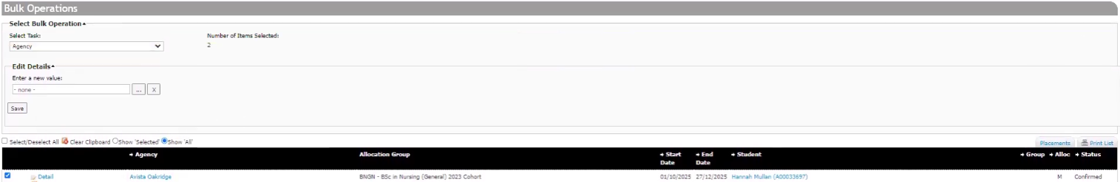
Under Bulk operations select the task placement times and click select placement times to choose the times from the calendar which appears and click ok.
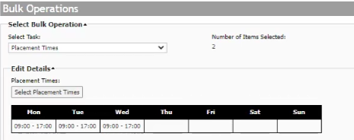
Complete the shifts as shown above and click select placement times. Clicking yes on the warning box and ok in the action summary triggers the timesheets for students. You can achieve the same outcome by clicking placement manager > schedules. Select a particular allocation group as shown below and populate the schedule (if this is not already done via the import file). Click refresh. In the confirmation tab, you can then click “Generate schedule”.
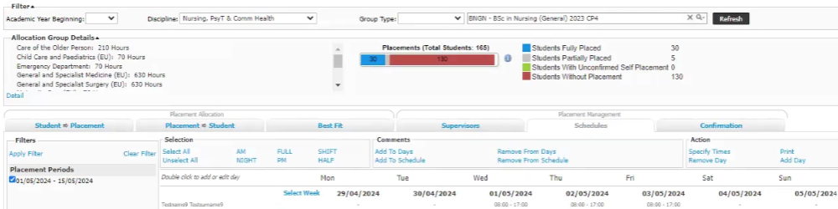

To update the placement status click on Placement/Placement Manager from the main menu. Use the filters to find your cohort and click on confirmation to the right. You can filter for specific agencies and time periods (blocks) on the left-hand side panel and when finished click where the red circle is as below:
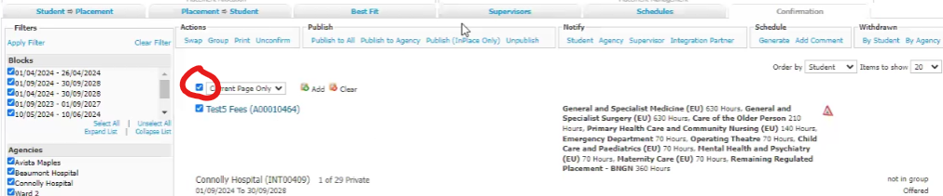
This shows all of the students for which the placements have been setup. Under Confirmation tab again, the publish to all option publishes the placement to students and the agency. You can unclick boxes to remove any student that you do not wish to confirm. Click ok on both warning boxes if happy to proceed with publication.

To manage late changes, DCU staff go to placement and placements from the drop-down menu. Search for the placement using the filter. Click into detail to view the confirmed placement. Change the status back to offered and save to edit the record, make your edit(s) and click ok on the warning boxes to confirm to the student and the SALO that the change has been made. This generates a notice in the student’s dashboard. If it’s a placeholder placement, select the parent service (e.g. Public health nursing) and when their exact placement site is known you can update the agency record and their placement status to confirmed.
Note the practice module coordinator (PMC) and SALO shown here:
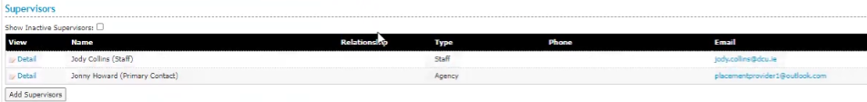
The SALO can approve timesheets once they are assigned and the PMC can view placement records and NCADs.
Regarding SALO submissions for late changes:
Note: If there are any late changes (e.g.placement provider or location change) the SALO should highlight these in the import file or calendar view file with the original placement start and end date. The file should be submitted via the standard SALO upload functionality in their “agency details” screen.

Extract from partner services handbook:

To ensure that DCU staff receive the alert that the file has been updated, remove the previous file by clicking the red “X” and deleting the date. Click “Submit changes”.
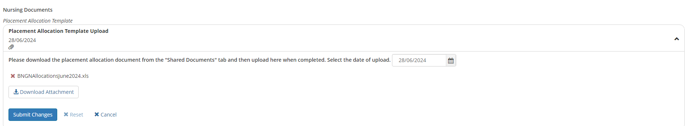
This resets the file upload task and ensures that DCU staff are notified if a late changes file is loaded.
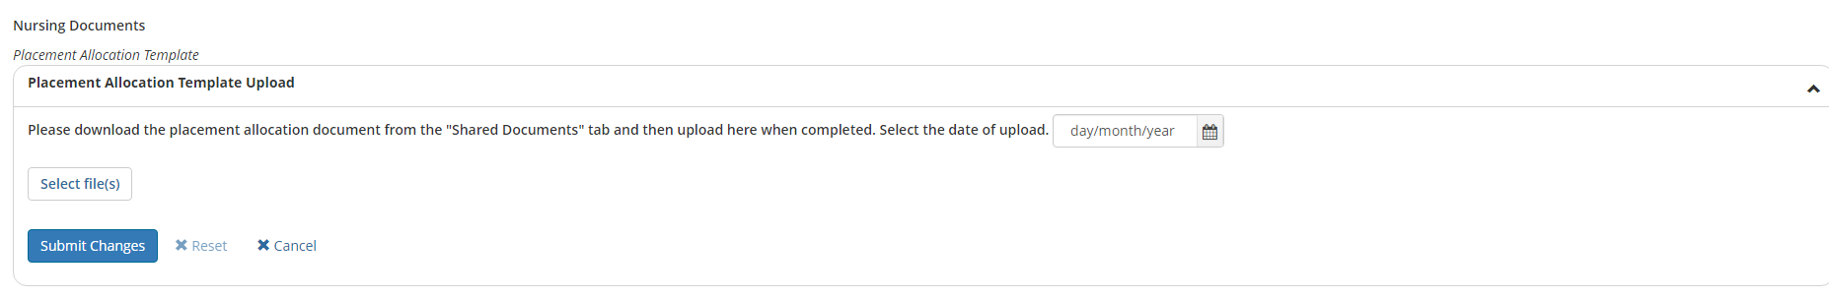

The SALO should then populate the new date and new file and click submit.

Placement visits
Objective - At the end of this guide, you will be able to log, archive and report on site visit(s) to an agency.

Step 1
To store a placement visit in InPlace you need to click on Manage, and under List, you click on Agency. Scroll down the page below to find the agency you want.
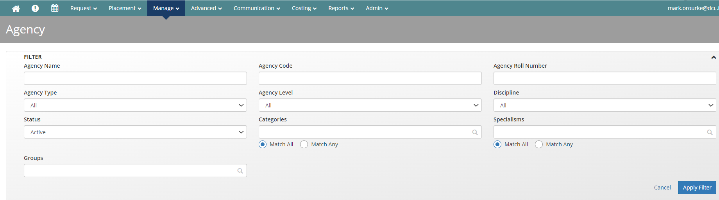

Step 2
Open up the Agency records and find Site Visits on the right-hand side as below.
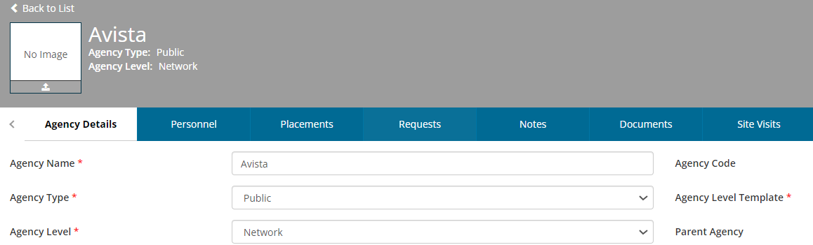
Click site visits and then click on the button + add new site visits to the right.
Step 3
In the dialog box you can enter a DCU visit or a nursing CPC visit in site categorisation. Complete the purpose of visit and notes section with your own free text. Save as a draft or if happy, click submit. The site visit will then be logged against that agency as below:
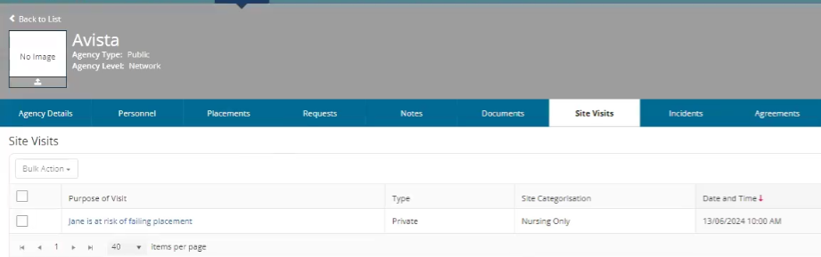
On this screen you can archive the visits and with a full list of visits against an agency you have the option to export it to excel by clicking export on the right-hand side.
Under Reports/Query tool you can configure a report to include date on all visits and visit types for an agency.

Clinical Audits
Objective - At the end of this guide, you will be able to manage clinical audits such as NCADS with digital or paper formats. You will also see how to set expiry dates for these and run reports on auditing documents.

Option 1- Digital option
Step 1
From your main menu, click manage and choose agency under lists. Filter under agency name or agency code. When you have the agency you want, click on it as shown here:
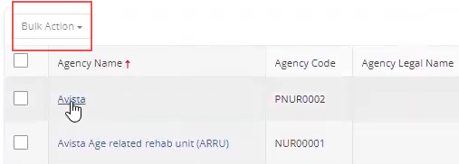
Step 2
Note: PNUR in the agency code indicates the Parent Agency. Scroll down the page and focus on the Clinical Placement details section. These fields are visible to both DCU staff and partner services.
Edit each section by clicking edit on the right hand side, complete details in the dialog box and click save. Expiry must be filled with a date to enable identification of expired audits. 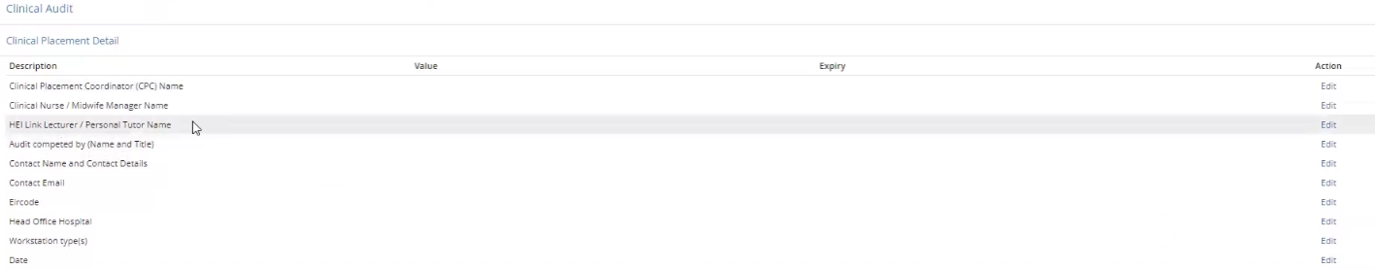
Step 3
Scroll further down the page to view the 6 standards of the NCAD Requirements as per NMBI requirements. Click edit on the right-hand side as you did in Step 2 and you are presented with a yes (Y) or no (N) option to approve or not approve each standard (requirement).
Click into the space, enter Y if satisfied that the standard has been met.
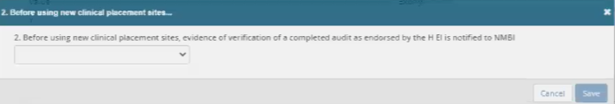

Option 2 - Scanned Paper NCAD
Step 1
Within the agency record click on documents from your top screen menu and add your scanned clinical audit using + add new document as shown below right:
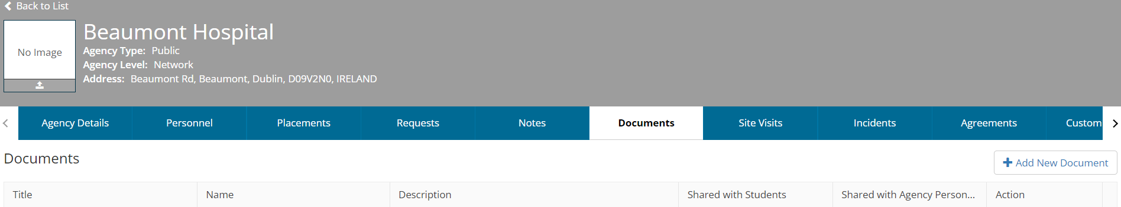

Step 2
In the Add Document box that appears add the document title and description upload your document (file) using the + symbol and click the box to share it with agency personnel. Then click Save. Agency staff can now view this document under documents.
Step 3
You will need to set a date in the expiry date section as per step 2 of the digital option above. This enables reports to be run to identify expiry dates.
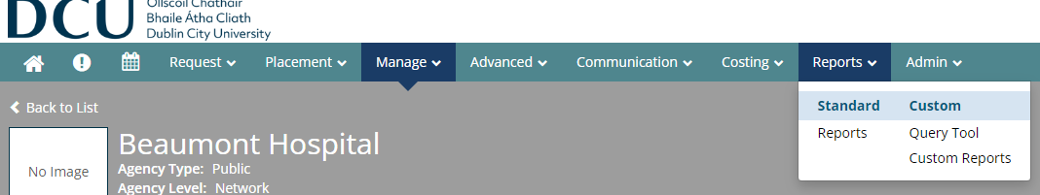
To run reports on these audits you add the fields that you want to include in your report by adding them from the available columns box on the left to the selected columns box on the right i.e. agency code, agency name, expiry date. Click run on the top right.

Reports
Objective - At the end of this guide, you will be able to create, edit, filter and share reports in a number of different ways.

Step 1
Click into Reports and Query Tool. See your list of pre-configured reports here and filter as required i.e. for reports that you have created indicated by the red circle
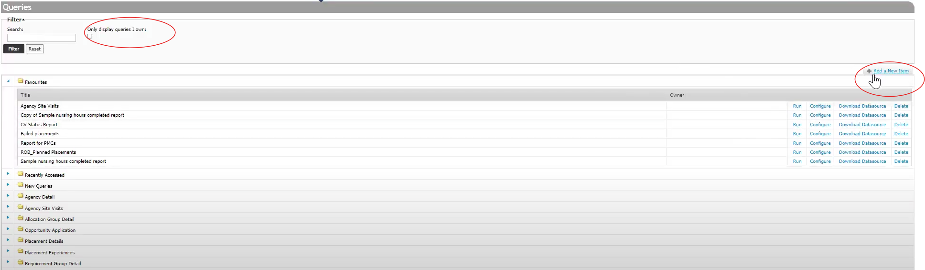

You can run, configure and delete reports as shown above and if you click download datasource you can use this for a mail merge. Click add a new item as shown in the blue circle above to create a new report. Under query configuration choose a title, subject and base query for your report.
Scroll down to the Columns section to choose the data you want in your report. Select under available columns and click add on the right-hand side.
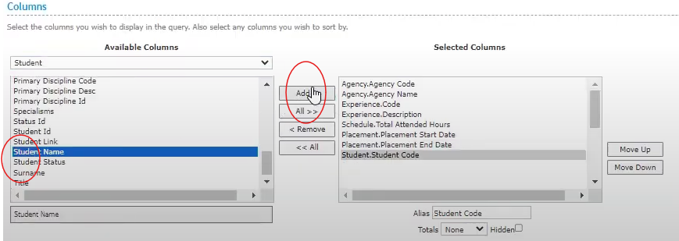
You can reorder the columns using the move up and move down buttons.

Step 2
Scroll down to the filter sections and click on any filters you find useful from the list on the left-hand side. Then click add logical group and save. The click add expression to include a particular column type i.e. agency. When happy with the column and column type click save. Note below the publish for staff section to decide who you wish to use your query (report) and the mail merge option that is available under mail merge template. When complete, click save or run to run your new report.

If you see data that is missing from your report i.e student code you can return to the set up by clicking configure query shown in the red circle above and repeat Step 2, this time finding your missing criteria i.e. attended hours are not blank and adding this filter. Continue editing and adding more detail to the report by repeating this process as required.
Step 3
To filter within your report, enter y in the column in value in which you are interested and press enter. (The true values = yes. False = no).
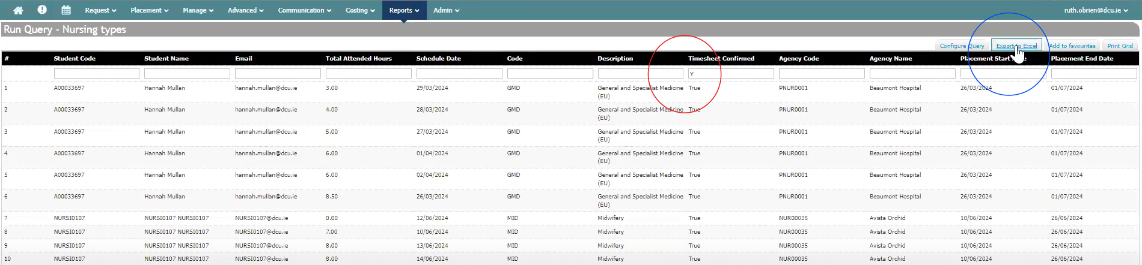
Do this in any of the blank space boxes for any of the column values in which you want to filter. You can use the export to excel button as shown in the blue circle above. Download the file to your device and send it to colleagues as required.
Step 4
You can also share your report within InPlace with all partner services or specific ones. Click into manage and under lists select agency. Select the specific agencies by clicking the blank box under Agency name as shown below or click on bulk action to share the report with all of them.
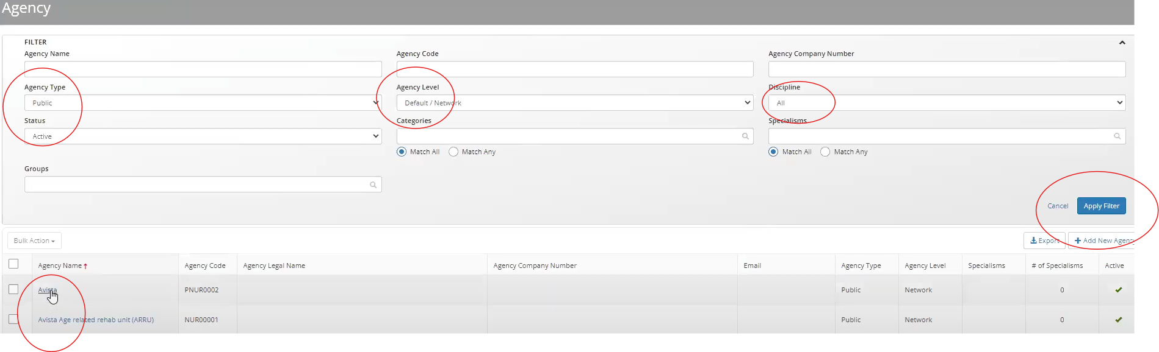
If you select a specific agency, click documents on the top menu, click + add new document to add your report which you will have already downloaded to your device. Give it a title, description and choose the recipients under select disciplines to share documents with. Click save.

Step 5
Alternatively, you can share your report by emailing it from InPlace. Click on communications from the main menu and communication templates from the drop down menu. Click + add a new item on the right hand side.
Complete the mandatory fields as shown below. Note the discipline will always be Nursing.
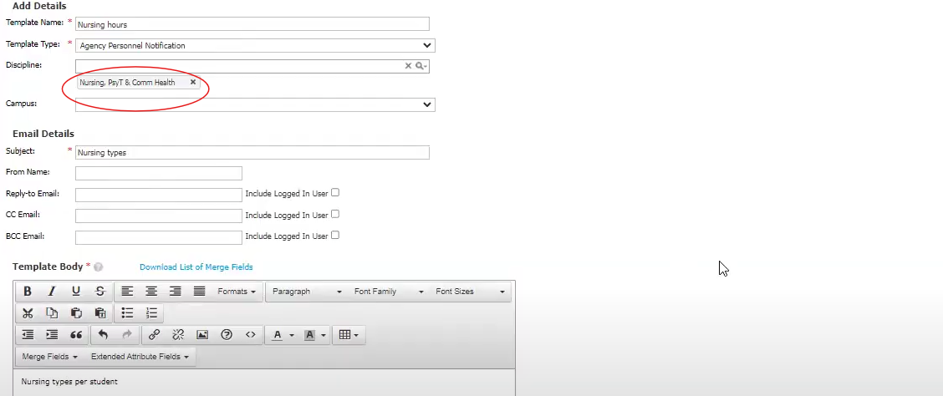
Scroll down the page and click save.
Navigate to manage and agency personnel. Select the recipients by clicking the empty boxes beside each name or use bulk action to email your report to all. The dialog box tells you the number of people (recipients) who will get your emailed report. Click yes. Choose your template. Click preview message and preview document for one final check and then click send.
Feedback
Objective - At the end of this guide, you will be able to manage student-generated feedback forms within InPlace and generate reports.

Step 1
On the home screen click advanced and survey/assessments. Scroll down and on the left hand side you may see pre-configured surveys
Click into the feedback form of interest to you as shown above. On the tab build, click into the survey. You will see the questions students were asked when they were assigned the feedback task in InPlace.
Step 2
Scroll down through the questions. You can uncheck the required button, if you don’t want a question to be mandatory, by clicking on it. Click into the stage tab and you will see the due date of the feedback under student feedback. The security tab will show you who has access to manage the feedback.
Step 3
Click into the campaigns tab as shown below and note the details indicated in red. Click on the published campaign to view it.
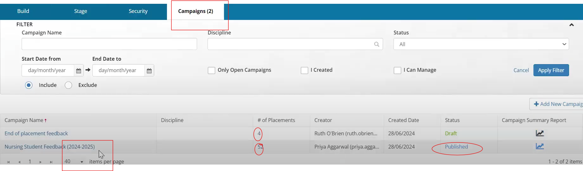
Scroll through the details tab to see campaign, communications and report settings. Under campaign stages and student feedback, navigate to the right of your screen and click edit. Update or confirm the deadline dates for feedback submission in the dialog box that appears.

Step 4
Under the tab placements, you can view each placement attached to the campaign and if required, add additional placements by clicking + add placement. The grading section is not relevant here. The security tab indicates who can manage the campaign.
Step 5
To view the feedback from a student viewpoint, click into placements and select a campaign with a previous end date by clicking on the blue underlined name, on the left-hand side.
Click as shown below, scroll down and click login as student.
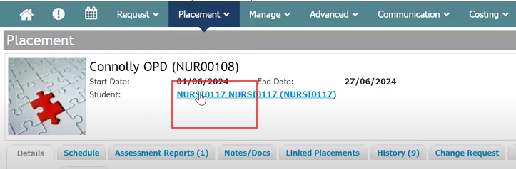
You will see an item requiring a response on the student’s to-do list. Click into the campaign(task) you require. On the top left you will see placement, agency and student details. There will be just one stage, student feedback with the deadline and status indicated. The student will complete the form, ensuring mandatory fields are filled and click submit which removes the task from their to-do list.
Step 6
Back in staff view under placements/advanced you can track completed and pending feedback and export the feedback to excel. To report you can click back to list and scroll to the campaign of interest to you. Click on the icon for the report type you want to use i.e. Feedback report. Click run. Select your criteria under report type and criteria and click the button view below. A pdf version of the report is now available for you to view and download.

Checklist for creating placements

- Ensure the SALO is assigned as the Agency supervisor. Otherwise, the timesheets cannot be confirmed by them
- Ensure the PMC is assigned as the Staff supervisor. Otherwise, they will not be able to grade the NCAD
- Ensure the schedule is populated for the student. This can be done via populating the shifts field in the import file, via bulk action in “Placements” or clicking on the schedule tab of placement manager. Ensure “Generate schedule” is clicked regardless of the method used. Failure to do this will result in the timesheet not being triggered for the student. Note that only the days populated will appear to the student and therefore, they can only submit timesheets for these days. Example: if Monday to Friday is populated in the schedule, the student won’t be able to submit a Saturday timesheet
- Ensure the placement status is “Confirmed”. Otherwise, the student won’t be able to see their placement details.

END.

