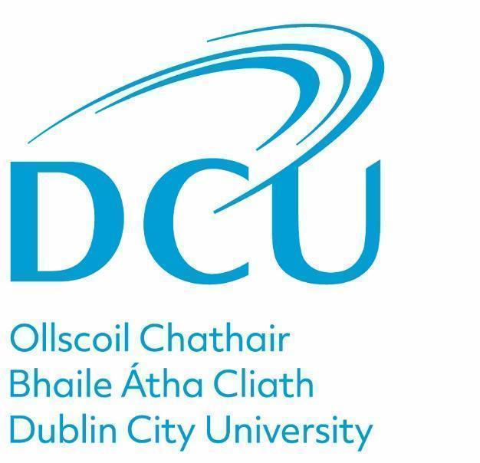

**Admissions**

**Disclosure of Offence Protocol**

**Purpose**

Dublin City University (the “university”) actively promotes equity of access and strives to achieve a diverse student population with a wide range of talents, backgrounds and experiences. Having a criminal conviction or pending prosecution (hereafter a criminal conviction or pending prosecution will be referred to as an “Offence”), may not necessarily prevent an applicant from gaining admission to the University. In making an admission decision, the university will balance the interests of the applicant, with the University’s reputation and responsibilities to provide a safe and secure environment for its staff, students, visitors and others.

This protocol should be read in conjunction with the DCU Student Vetting Policy [link](https://www.dcu.ie/policies/garda-vetting-police-clearance-policy-students-1). Mandatory garda vetting of applicants is automatically conducted for programmes listed [here](https://www.dcu.ie/registry/garda-vetting-programmes), that involve access to vulnerable groups as part of the programme of study. If the programme you are applying for is listed, you should engage with the university garda vetting process.

Applicants that are applying for a programme that is not listed as a mandatory garda vetting programme, must inform Dublin City University of any Offence by 1st May for programmes that commence in September and by 1st September for programmes that commence in January. In the case of postgraduate research applicants, they must inform Dublin City University of any office within 30 days of making an application.

Should an offence occur in the period thereafter, the applicant must inform Dublin City University at the earliest opportunity. Upon declaration of an Offence, DCU will initiate the risk assessment process detailed below.

The provision of false, inaccurate or misleading information will disqualify applicants from the admission process. In the event that an applicant has not disclosed the information at the point of entry, this may result in disciplinary action (up to withdrawal of an offer and/or withdrawal of registration and exit from a programme).

The purpose of this protocol is to advise that:

* all applicants must disclose criminal convictions or pending prosecutions to DCU at the point of entry
* a disclosure of offence must be received by email to admissionsdisclosure@dcu.ie:
  + By 1st May for a programme that commences in September and by 1st September for a programme that commences in January.
  + Within 30 days of an application for a postgraduate research programme
* a DCU risk assessment process will commence on receipt of a disclosure.

**Scope**

This Protocol applies to all applicants who submit an application to a DCU programme that is not on the [DCU Garda Vetting Programme list](https://www.dcu.ie/registry/garda-vetting-programmes). An Offence as referenced in this Protocol includes Offences in Ireland or abroad.

**Risk Assessment Process**

Where an applicant has disclosed an offence to the University, the individuals’ disclosure will be reviewed initially by the Admissions Manager in The Registry. The offence will subsequently be categorised as ‘No Risk Assessment required‘ or ‘Risk Assessment required’ where the Offence is deemed to be a Relevant Offence.

A Relevant Offence includes Offences in Ireland or abroad and includes:

* crimes against a person of a violent or sexual nature or
* an offence involving firearms, arson terrorism, cybersecurity or
* offences that involve the unlawful supply of controlled drugs or substances, where the offence concerns drug dealing or trafficking
* any other offence that the University deems relevant.

In the case where a risk assessment is deemed to be required, the university may seek additional information from the applicant. All documentation relating to the risk assessment will be shared with the Chief Operating Officer (COO) and the Director of Registry. The COO will complete a risk assessment and make a recommendation to the Director of Registry. The Director of Registry will make the admission decision based on the risk assessment conducted by the COO.

When completing the risk assessment and making a decision about admission, consideration will be given to any or all of the following:

* whether the admissions disclosure protocol was followed;
* whether the offence or other matter revealed is relevant to the programme on offer (including any secondments or placements);
* the seriousness of any offence(s);
* the number of any offence(s);
* the time elapsed since the offence(s);
* whether the offence(s) shows a pattern of behaviour that seems to be recurrent and ongoing;
* whether the offence(s) involves violence, threats of violence or is a sex related crime;
* whether the circumstances surrounding the offence(s) are a threat to the safety of students, staff, visitors and others;
* whether the applicant or student's circumstances have now changed; and
* evidence provided to support the view that the applicant or student is unlikely to offend again.

The COO may consult with DCU Units and or external parties in carrying out the risk assessment. These parties may include persons such as a relevant probation officer, the Gardaí, prison or court officials, and others who are professionally or personally involved in the rehabilitation/personal life of the applicant.The applicant may be required to provide additional information and may be required to attend a meeting. Any information received will be treated confidentially and in accordance with DCU’s Data Privacy Statement.

**University Response to Relevant Offence**

Based on the risk assessment, potential outcome admission decisions are as follows:

* an offer of a place to an applicant is made without conditions;
* an offer of a place to an applicant will be subject to certain conditions;
* an application for admission is rejected.

The applicant will be notified of the outcome of the decision as soon as practicable. Such notification shall be in writing.

**Appeal Process**

An appeal may be made to the Vice President for Academic Affairs / Registrar within 10 working days from the date of issue of the Risk Assessment/Admission decision. Appeals may be made on the following grounds.

* New evidence: Information directly relevant to the decision, which for good reason was not available at the time of the risk assessment.
* Procedural irregularity: There is evidence that the protocols relating to a decision were not followed properly, which may have impacted on the risk assessment.

The Vice President for Academic Affairs / Registrar can:

* Uphold the Appeal
* Reject the Appeal

**Roles & Responsibilities**

**Disclosure of an offense** Applicant emails admissionsdisclosure@dcu.ie

**Initial Assessment of Risk** Admissions Manager

**Preparation of Risk Assessment Form** Admissions Manager

**Provision of supporting information,**

**documentation or attendance at a meeting** Applicant

**Risk Assessment** Chief Operating Officer

**Admission Decision based on Risk**

**Assessment**  Director of Registry

**Communication of Decision**  Admissions Manager

**Risk Assessment/ Admission Decision**

**Appeal** Vice President for Academic Affairs /

Registrar

**Communication of Appeal Decision** Vice President for Academic Affairs /

Registrar

**Any information received will be treated confidentially and in line with DCU’s Data Privacy Statement.**

*Note: If an applicant feels that they have been unfairly treated or are not satisfied with the decision, it is open to applicants to contact the Office of the Ombudsman. By law the Ombudsman can investigate complaints about any administrative actions or protocol, as well as delays or inaction in your dealings with the institution. Further information can be accessed on the website –* [Office of the Ombudsman](https://www.ombudsman.ie/).

**Related Documentation**

|  |  |
| --- | --- |
| DCU Garda Vetting Process | https://www.dcu.ie/registry/garda-vetting |
| DCU Garda Vetting Programmes | https://www.dcu.ie/registry/garda-vetting-programmes |

**Version Control**

|  |  |  |  |
| --- | --- | --- | --- |
| **Protocol Name** | DCU Disclosures Protocol | |  |
| **Unit Owner** | Vice President for Academic Affairs / Registrar | |
| **Version Reference** | **Original Protocol V1.0** |  |
| **Approved by** | Registrar |  |
| **Effective Date** | January 2025 |  |

**End.**