Dignity and Respect
Student Procedures

Table of Contents

1. Purpose 2
2. Scope 2
3. What does not constitute harassment or bullying 3
4. Procedure 4
4.1 The Informal Resolution Process 4
4.1.1 Step 1 - Assessment of the behaviour 4
4.1.2 Step 2 - Request that the Behaviour Stop 4
4.1.3 Step 3 - Facilitated Resolution 5
4.1.4 Step 4 - Formal Complaint 5
4.2 Submitting a Formal Complaint 5
4.2.1 Submitting a Formal Complaint (Involving a student) 5
4.2.2 Submitting a Formal Complaint (Involving a staff member) 6
4.2.3 Investigating a Complaint 6
4.2.4 The Findings of Disciplinary Committee 6
4.2.5 Withdrawing a Complaint 6
4.2.6 Potential Outcomes of a Formal Complaint Process 7
4.3 Right to Appeal 7
4.4 Malicious Complaints 7
4.5 Anonymous Reporting/ Reluctant Reporting Party / Third Party Reports 8
4.6 Speak Out Tool 8
5. Roles and Responsibilities 8
5.1 Confidentiality 9
6. Definitions 9
7. Related Documentation 9
Additional Sources of Support 10
Contact 10
Procedure Review 10
Version Control 10
Appendix 1: Self-Audit: Checklist for Complainant 11
Appendix 2: Self-Audit: Checklist for Respondent(s) 14
Appendix 3: Student Flowchart for dealing with an incident(s) of bullying, harassment, or discrimination 17

Purpose
The purpose of this Procedures Document is:
● To have adequate and accessible mechanisms to handle bullying, discrimination or harassment effectively.
● To support provisions to enable complaints of alleged bullying and harassment to be thoroughly investigated in a manner that recognises the sensitivity of the issues raised, maintains appropriate confidentiality and protects the rights of the parties involved.
● To assist in upholding a safe environment where bullying, discrimination and harassment are considered unacceptable and not tolerated.
● To develop a culture whereby individuals can raise concerns about bullying, discrimination, and harassment, confident that their issues will be dealt with appropriately, consistently, fairly and without fear of ridicule or victimisation.
● To foster an environment where individuals and groups treat one another with dignity and respect.
- To ensure that all members of the University community are aware of behaviour that may constitute discrimination, bullying and harassment and their responsibilities for avoiding and/or preventing such behaviour.
● To encourage, where safe and appropriate, the internal and informal resolution of issues.

Scope
This procedure applies to all students of the University, including undergraduate, postgraduate taught, postgraduate research, online and on campus. These are hereinafter collectively referred to as ‘Members of the University Community’. A separate Staff Procedures Document is available from the HR EDI unit.
These procedures apply to all areas of the University’s operations and programmes. It applies to conduct which takes place:
- on any University campus;
- at any other university or another place (including abroad) where students are representing the University or are engaged in a University-related activity;
- any virtual setting in relation to any University-related activity e.g. zoom meetings, Blackboard, Microsoft teams, etc.
- at events such as social functions, conferences, sporting events, field trips or work assignments which are related to the University or are a University-related activity;
- in person, in writing, on the telephone, by email or online, including social media, regarding any University-related activity.

What does not constitute harassment or bullying
It is essential to differentiate between the exercise of a person’s legitimate authority and harassment or bullying. Lecturers, supervisors, coaches, or administrators have the right to manage, direct and govern how work is done, and have a responsibility to monitor workflow and manage performance. The exercise of this right is not harassment or bullying. Communication or direction by staff or students does not constitute harassment or bullying where the appropriate processes have been applied and communicated in a professional manner, examples of which follow: -
- Constructive feedback within a study group that is communicated appropriately with a view to improving performance.
- Critical comments indicating performance deficiencies do not constitute harassment or bullying where the comments are objective and communicated appropriately.
- Feedback delivered constructively and appropriately intending to assist students participating in an extracurricular activity to improve their performance or the standard of their behaviour.
- Academic feedback delivered constructively and appropriately to students. Any such feedback should be in keeping with the university regulations.
Sexual Harassment and sexual misconduct are covered by the separate ‘Sexual Misconduct at Work and Study Policy’ and ‘Sexual Misconduct Student Procedures’.

Procedure
The procedure for the resolution of an incident of bullying, harassment, or discrimination to a student or by a student is as follows:

4.1 The Informal Resolution Process

4.1.1 Step 1 - Assessment of the behaviour
- Students who feel that they are being harassed or bullied should consider if the conduct in question constitutes harassment/bullying as defined in the Dignity and Respect at Work and Study Policy or Section 6 of this document. Individuals may complete the self-audit checklist to aid their assessment of the behaviour as bullying or harassment (see Appendix 1).
- Harassment or bullying can sometimes be difficult to prove. If they feel able, a complainant needs to keep an accurate record of any incident. Think about what behaviour is happening, how does it make them feel, dates, times, places, and people involved.
- For concerns relating to sexual harassment and sexual misconduct, please refer to the specific Sexual Misconduct Policy for Staff and Students and accompanying procedures document.

4.1.2 Step 2 - Request that the Behaviour Stop
- Unless a student feels that they are unable to, or where they feel it may be dangerous, uncomfortable, or stressful, they should initially discuss the matter with the person/people concerned and request that the unwanted behaviour stop. It is important to stick to the facts. In this situation, individuals should talk about the impact of the behaviour on them, using examples where necessary, and ask the person responsible to stop the unwanted behaviour. To get advice on how to manage a conversation regarding unwanted behaviour, contact a Dignity and Respect Ally by emailing studentreport@dcu.ie.
- If they feel able, the person who feels they have been bullied or harassed, should raise the issue as soon as possible after it has happened. It is important that any meeting should be an open, two-way frank discussion. The meeting should be held in a private but safe space away from distractions. Raising the issue with the individual(s) allows them to be made aware of the problem and to desist from the specific behaviour.
- A person who feels they have been bullied or harassed may decide to go to Step 3: Facilitated Resolution or to Step 4: Formal Complaint process.
Note: Students accused of bullying or harassment should refer to Appendix 2- ‘What do I do if I have been accused of bullying, harassment or discrimination - Self Assessment’ of this document.

4.1.3 Step 3 - Facilitated Resolution

a) Raise the matter with one of the Dignity and Respect Ally or a person of Authority
If the person engaging in unwanted behaviour is a student and the complainant is uncomfortable asking for the behaviour to stop themselves, the complainant should report the matter to a Dignity and Respect Ally or the Student Policy Officer. This should be done in writing by email with as much detail as possible to studentreport@dcu.ie or student.support@dcu.ie and include the self-audit checklist in Appendix 1. The staff member will arrange an initial meeting to discuss the complaint and complete a Bullying, Harassment and Discrimination Report Form. If the complainant is in agreement, the Dignity and Respect Ally will contact the respondent and request a meeting between all parties involved (see facilitated meeting below). Details provided in the report template will be used as evidence when the respondent is contacted. If it is a staff member, the line manager of a member of staff engaging in the unwanted behaviour can be contacted. See the Dignity and Respect Staff Procedures for more information.

b) Facilitated Meeting
The facilitated meeting is convened by a Dignity and Respect Ally. Through mediation, a solution may be found at which point the issue will be deemed to have been resolved. Where mediation does not provide a solution, the complainant may proceed to Step 4, the formal complaint procedure.

As part of a facilitated meeting the complainant is asked to provide a written statement outlining the situation. This is provided to the respondent prior to the facilitated meeting, to allow all parties time to understand the reason for the meeting. A Dignity and Respect Ally will be allocated to the respondent who can provide support to the respondent prior to a facilitated meeting. A brief written record of the meeting will be kept, in line with relevant data protection legislation, and agreed outcomes and dates will be noted by the relevant person responsible for managing the resolution.

4.1.4 Step 4 - Formal Complaint
In cases where the informal procedure has not been successful, it may be necessary to invoke formal procedures. See section ‘4.2 Submitting a Formal Complaint’ for detailed information on the formal complaint procedure. Escalating a complaint to a formal process should only be done after reviewing all aspects of the circumstances surrounding the complaint. Being able to evidence a reasonable decision-making process is important.

4.2 Submitting a Formal Complaint
If the informal processes have proven unsuccessful, the complainant may wish to lodge a formal complaint. The following sections outline the procedures for lodging a formal complaint, the outcomes, potential consequences, and appeals process.

4.2.1 Submitting a Formal Complaint (Involving a student)
The student must write to the Secretary of the Disciplinary Committee with full details of the complaint (see Disciplinary Committee - Section ‘Complaints under the Code’ ) including copies of all or any relevant notes of the alleged behaviours, for example, a copy of their Bullying, Harassment or Discrimination Report Form. Although a complainant may decide to access the formal complaint process at any time, where an allegation of harassment, bullying or discrimination is made, and informal resolution has not been attempted, the Chairperson of Disciplinary Committee may ask the Student Policy Officer, or their nominee, to explore other options before proceeding to the investigation stage.
Upon receipt of the complaint, the Chairperson of Disciplinary Committee will provide the complaint to the person named by the complainant who for these purposes will be called the respondent(s). Details of the Disciplinary process can be found in Section 6 of the Student Code of Conduct and Discipline.
Being the subject of a complaint can be upsetting and may leave you feeling vulnerable and alone. It can be helpful to talk to someone about what is happening. Emotional support is available through the DCU Student Advice Centre or the DCU Counselling & Personal Development Service for Students.

4.2.2 Submitting a Formal Complaint (Involving a staff member)
If a complaint is made against a staff member, the incident will be dealt with through the Staff Procedures for Dignity and Respect. If a member of Senior Management is the subject of the complaint, the DCU President should be contacted directly. Where the President is the subject of a formal complaint, it should be made directly to the Chancellor of the University.

4.2.3 Investigating a Complaint
The Student Code of Conduct and Discipline Sections 7 and 8 contain procedures concerning the University Disciplinary Committee (UDC). The objective of an investigation by the UDC is to ascertain whether, on the balance of probabilities, the behaviours complained about occurred. It will have already been established that the behaviours align with definitions of bullying or harassment. The complainant and respondent can access advice and guidance regarding the disciplinary process from Student Support & Development via a Dignity and Respect Ally.

4.2.4 The Findings of Disciplinary Committee
The decision of the Disciplinary Committee will be verbally communicated to the student on the day of the hearing and in writing by email or post following the hearing.

4.2.5 Withdrawing a Complaint
Should the complainant decide to withdraw the complaint, it will not be possible to reactivate it or the resolution process for the same issue.
Should the complainant withdraw from the process, the respondent(s) or the investigating committee may request that the investigation continue to provide a finding about the complaint. This is to ensure that any member of the DCU community accused of behaviour which breaches the terms of the Dignity and Respect at Work and Study Policy has the opportunity to answer the charge and receive a formal determination from the investigating committee.

4.2.6 Potential Outcomes of a Formal Complaint Process
The role of the Disciplinary Committee is to consider the case put forward by the complainant and the respondent.
The panel may find in its view.
● Harassment, bullying or discrimination did take place
● Harassment, bullying or discrimination did not take place
● The behaviour of one or other or both parties contributed to the breakdown in relations
● No harassment, bullying or discrimination was evident, and the claim appears to be malicious or vexatious.
Penalties may be applied in accordance with the disciplinary procedure under Section 9 of the Student Code of Conduct.

4.3 Right to Appeal
A student has the right to appeal a decision of the Disciplinary Committee on the following
grounds:
1. there is new evidence or evidence which was, for good cause, not presented to the Disciplinary Committee which might reasonably have resulted in a different decision;
2. there were procedural irregularities (including administrative errors) that give rise to reasonable doubt as to whether the Disciplinary Committee would have reached the same decision had they not occurred;
3. the evidence considered by the Disciplinary Committee did not support the findings made by the Disciplinary Committee;
4. the penalty imposed by the Disciplinary Committee was unreasonable or disproportionate having regard to all the circumstances of the case. See Section 10 of the Student Code of Conduct for more information.

An appeal can be lodged by following the steps outlined here.

4.4 Malicious Complaints
A malicious complaint can be described as an allegation made without foundation, and with malicious intent, where a person knowingly or without regard to whether it is true or not, accuses another person of allegedly bullying or harassing them. This could also apply to where one person maliciously complains of someone allegedly bullying or harassing a third party, without fully exploring the veracity of the claim.
If proven to be malicious, the person making such a complaint may face disciplinary action up to and including expulsion in serious cases, particularly in cases where the good name and reputation of another member of the university community has been unjustifiably brought into question.

4.5 Anonymous Reporting/ Reluctant Reporting Party / Third Party Reports
It would be exceptional for the University to pursue a formal investigation where the reporting party is a third-party, the reporting party is reluctant to pursue a formal report, or where the reporting party has chosen to remain anonymous. There are limitations in responding to these types of reports, such as the lack of detail provided, that could impact on the rights of respondents as per the rules of natural justice. In these situations, the University will examine reports on a case-by-case basis. However, if a reporting party wishes to make an anonymous report to note that an incident happened, they can do so through ‘SPEAK OUT’. Here they will have access to information and support should they wish to pursue a report or support in the future.

4.6 Speak Out Tool

Speak Out, is an anonymous-reporting tool for DCU staff and students. The tool allows any member of staff or student to submit a report of bullying, harassment or discrimination in a way that protects their identity and the identity of the alleged perpetrator. The tool is completely confidential and no identifying information is collected.
The anonymous reporting tool will assist the University to monitor data related to experiences of sexual misconduct within the University to identify trends and patterns. The University will then use these findings to inform future work: for example, to identify training and information needs and any gaps in current policies and procedures or to address areas of risk which had not previously been identified. To anonymously report an incident, go to SPEAK OUT.

Roles and Responsibilities
The University, through developing these procedures, seeks to address bullying, harassment, and discrimination across the institution as it has a duty of care to its staff and students and to protect itself from reputational damage. The Dignity and Respect at Work and Study Policy contains the roles and responsibilities of units/departments within the university that engage with this procedure.

5.1 Confidentiality
Confidentiality will be maintained throughout the investigation to the greatest extent possible, consistent with the requirements of a fair investigation. All individuals involved in the informal and formal complaints procedures are expected to maintain the utmost confidentiality on the subject. However, DCU may be obliged to disclose the details of any complaint to such persons or authorities and to such an extent as is necessary to investigate the complaint properly and fairly. All individuals are required to give due regard to GDPR legislation in the collection and storage of any personal information.
5.2 Data Collection
The personal data provided as part of a report is obtained, processed and retained by Dublin City University ‘Data Controller') for the purposes that are directly connected with the administration and operation of the Dignity and Respect Policy and Procedures and will be treated in accordance with the DCU Data Privacy Policy which can be accessed on the Chief Operating Officers website.
Some data will be shared with the HEA or Department of Further and Higher Education, Research, Innovation and Science for statistical purposes only. No identifying, personal or sensitive data will be shared.

Definitions
Harassment and discrimination are covered in legislation by the Equal Status Acts 2000 – 2018 . Please see the Dignity and Respect at Work and Study Policy document related to these procedures for more information on bullying, harassment and discrimination as well as further related definitions.

7. Related Documentation
This procedure should be read in conjunction with:
- Student Code of Conduct and Discipline
- Equal Status Act 2000-2018
- Sexual Misconduct for Students and Staff Policy
- Dignity and Respect at Work and Study Policy
- Sexual Misconduct Student Procedures
- Dignity and Respect Staff Procedures
- Sexual Misconduct Staff Procedures
- Student Gender Identity and Gender Expression Policy
- Social Media policy

Additional Sources of Support
DCU Student Counselling Service | https://www.dcu.ie/counselling
DCU Student Advice Centre | https://www.dcu.ie/advice
Student Policy Officer, Student Support & Development | https://www.dcu.ie/students

Contact

Name | Title | Contact Details | Phone
Deirdre Moloney | Student Policy Officer | deirdre.moloney@dcu.ie | 01 700 6157

Procedure Review
This procedure will be reviewed annually unless amendments are necessary throughout the academic year.

Version Control

Document Name | Student Sexual Misconduct Procedure
Version Reference | V2.0
Document Owner | Deirdre Moloney, Student Policy Officer, Student Support and Development
Approved by | None Required
Date | 18th April 2023
End.

Appendix 1: Self-Audit: Checklist for Complainant
In considering options to resolve your current situation, you should consider the following, or discuss these points with an appropriate contact person or manager.
Section A: Defining the behaviour
- Would a third person objectively consider the behaviour to be offensive, humiliating, intimidating or threatening?
- Does the behaviour result in my isolation or exclusion?
- Does the behaviour fit the examples described in Section 3 of the Dignity and Respect Student Procedures?
- Has the behaviour I am concerned about been repeated?
- Was the behaviour I am concerned about part of a normal feedback process?
- If the answer to the above question was yes, was the feedback given in an appropriate and respectful manner?
- What is the impact of the behaviour on me?
- If I do not believe my experience can be defined as bullying or harassment, could the behaviour be seen as personal conflict? If so, have I explored the options available to me for resolution of these issues?

Section B: Resolving the Issue
- Have I recorded the behaviour I am concerned about using the DIgnity and Respect Report Form?
- Were there witnesses to the behaviour?
- Have I informed the other person that the behaviour is unacceptable in terms of the University’s policies and procedures and must stop?
- Did approaching the person to ask them to stop the unwanted behaviour resolve the situation?
- If I am unable to discuss the matter directly with the person, could I discuss the matter with their supervisor/manager or other member of university staff?
- Have I followed the informal process fully, as outlined in Section 4 of the Dignity and Respect at Work Procedures?
Section C: Making a Formal Complaint
- Have you explored informal resolution opportunities?
- What are the possible consequences, if any, of making a complaint?
- What do I want to achieve from making a complaint?
- How do I cope with the behaviour if I decide not to make a complaint?

Appendix 2: Self-Audit: Checklist for Respondent(s)

Item to Consider | Notes
- Have I read the Dignity and Respect at Work and Study Policy as a basis for defining harassment and/or bullying and have I understood the policy and related procedures?
- Could an objective person consider any of my behaviour, communication or management style to be perceived as offensive, humiliating, intimidating or threatening?
- Was the behaviour perceived as harassment and/or bullying part of the normal disciplinary or performance feedback procedure?
- Could how I provide feedback on people’s work, or monitor their performance, ever be perceived as overly critical or excessive by someone else?
- Have I excluded a particular student from essential information or meetings?
- Could targets or deadlines I have set be perceived by others as impossible?
- Could my behaviour towards the complainant have been repeated?
- Having read the policy, could my behaviour be perceived as fitting with the definition of bullying and/or harassment?
- Do I have any records of previous interactions I have had with the complainant?

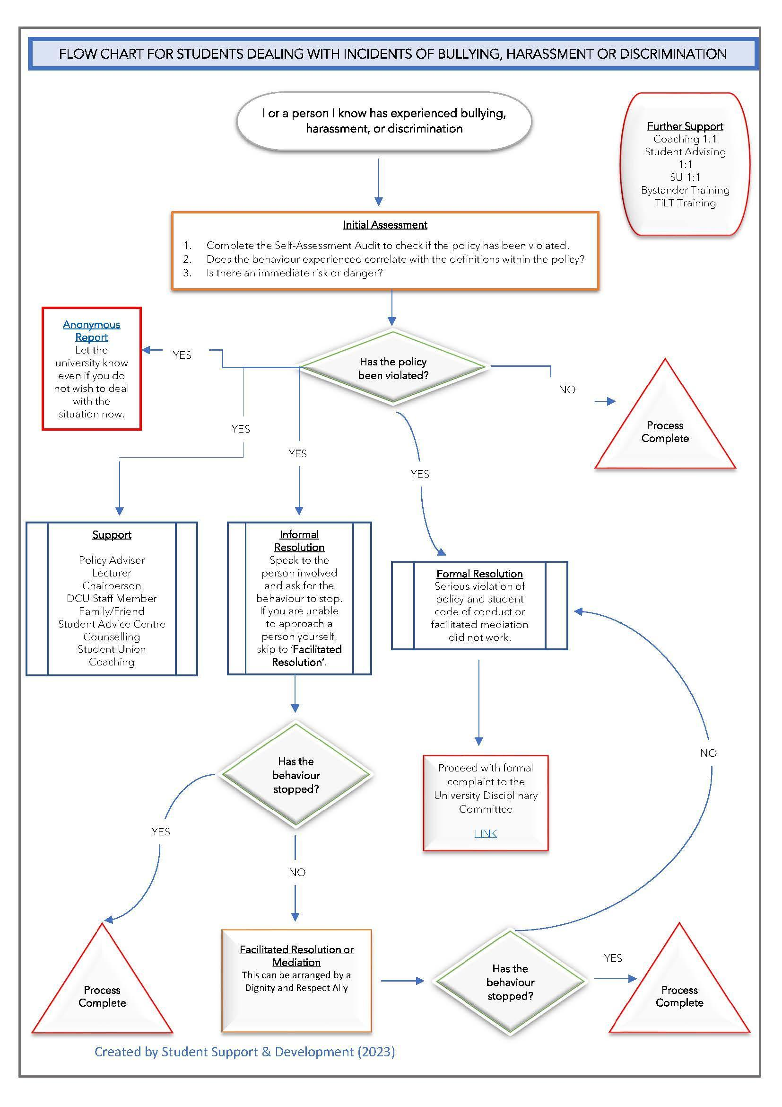
Appendix 3: Student Flowchart for dealing with an incident(s) of bullying, harassment, or discrimination

