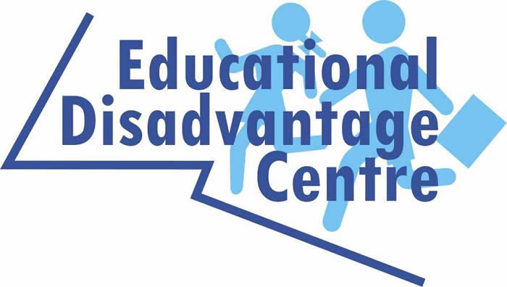

Submission from Dr. Paul Downes, Director, Educational Disadvantage Centre, Associate Professor of Psychology of Education, DCU Institute of Education
Recommendation 1. Expand the Successful University Outreach Hubs in Darndale and Kilbarrack for Promoting Access to the Teaching Profession to Other Universities and Local Areas in Ireland
Recommendation 2. Expand the Faculty Targeting Approach to Other Key Areas Building on this Approach in the Previous HEA National Action Plan which Promoted Access to the Teaching Profession – Areas such as Law, Psychology, Social Work, Social Care, Youth Work, Medicine, Social Policy, Community Development, Health Promotion
Recommendation 3. Develop a Distinct Access to Higher Education Strategic Focus for Children and Young People in Care
Recommendation 4. Target Member of the Traveller and Roma Communities for Additional Afterschool Projects in Late Primary and to Identify Potential Students for Supports for Higher Education Access Routes
Recommendation 5. Develop Flexible Entry Routes Based on Parental Education Attainment and Being First Generation in Immediate Family to Access Higher Education.
Recommendation 6. Increase the Income Eligibility Threshold for the HEAR scheme and Student Grants
Recommendation 7. Develop Peer Support and Mentoring Networks between Existing Access Students and Younger Students in DEIS Schools to Promote Access to Higher Education through Informal Word of Mouth and Relational Supports, building on UCD’s Future You Projection Evaluation (McNally & Downes 2016)

Recommendation 1. Expand the Successful University Outreach Hubs in Darndale and Kilbarrack for Promoting Access to the Teaching Profession to Other Universities and Local Areas in Ireland
From a baseline of extremely rare entry to primary teaching across these areas in previous two decades, a total of 16 Darndale/Coolock and Kilbarrack hubs’ students have now gained entry over the 3 years (2017-20): 11 BEd and 5 PME (primary) in DCU Institute of Education. Since the launch of these hubs by the then Minister for Education and Skills, Richard Bruton T.D., in 2017, there is evidence of a cohort effect where a culture of aspiration and expectation of doing primary teaching is being developed in at least some of the participating schools. Whereas initially in autumn 2017 only 2 students across the 6 local DEIS schools with service level agreements for the hubs indicated a possible interest in primary teaching this has radically changed with large numbers attending sessions at the hubs since then. A large majority of the hub attendees are successful in obtaining honours Irish due to the hub sessions and it is their other Leaving Cert scores that are hindering their entry to primary teaching. This has brought an increased emphasis on hub sessions on maths and academic writings skills that will be continued in Phase 2. There is a need to give hope to aspiring candidates from the local areas and to ensure there is visible success so that some students are gaining entry.
Building on the real and tangible success of these two local community university outreach hubs initiatives in the Darndale/Coolock and Kilbarrack areas – both in motivating students to aspire to and apply to teaching, and to gain entry to teaching in DCU Institute of Education – there is a need to expand this successful initiative for Promoting Access to the Teaching Profession to Other Universities and Other Local Areas across Ireland. A key success factor has also been to have a Local Darndale-Coolock-Kilbarrack Taskforce as Advisory Group for the Hubs, involving local key stakeholders and schools, in conjunction with DCU Educational Disadvantage Centre and Northside Area Partnership.

Recommendation 2. Expand the Faculty Targeting Approach to Other Key Areas Building on this Approach in the Previous HEA National Action Plan which Promoted Access to the Teaching Profession – Areas such as Law, Psychology, Social Work, Social Care, Youth Work, Medicine, Social Policy, Community Development, Health Promotion
A European study of 12 countries national strategic approaches to access to higher education for socio-economically and socio-culturally excluded groups highlights the need for access strategies linked with specific university faculties which are particularly relevant to the needs of the local community in traditionally working class areas —faculties and departments such as law, psychology, social work, youth work, medicine, education, social policy, community development, health promotion, etc (Downes 2014). One such example of this targeted, differentiated approach was for entry to the teaching profession in the last HEA Action Plan. There is a need to build on this targeted by Faculty and heightened social need in the last Action Plan to extend this specific access targeting to these key domains: law, psychology, social work, social care, youth work, medicine, social policy, community development, health promotion, as well as to expand these initiatives to access to the teaching profession.
Recommendation 3. Develop a Distinct Access to Higher Education Strategic Focus for Children and Young People in Care
The Educational Disadvantage Centre established a National Working Group on Children in Care composed of key stakeholders https://www.dcu.ie/edc/national-children-care-state-and-education-system-working-group#overlay-context=edc/Children-Care-and-Education-System-National-Working-Group.shtml. The Working Group’s Letter to Irish Times, September 20, 2020 has raised a range of issues for third level and Children in Care that we hope will be addressed in the new HEA Access Action Plan:
“Children in care need recognition as a distinct group as part of a higher education access strategy… If a care-leaver takes a gap year, they need to be supported in retaining supports and entitlements, with such aftercare support continuing until age 25. Better supports for their obtaining the Back to Education Allowance Scheme are also required for those over 25. Financial supports for access to third level, including through a national scholarship scheme for care-leavers as mature students, are required. A Department of Education and Skills circular to all third-level education providers is required to explain the needs of this vulnerable group to staff. The Scottish government has recently announced the removal of the age cap of 26 on the care-experienced student bursary in time for the start of the 2020-21 academic year. People with experience of care often do not feel ready to start further or higher education immediately after leaving school – this will support them into either further or higher education at whatever point in life they feel they are ready, regardless of their age.” https://www.irishtimes.com/opinion/letters/educational-needs-of-children-in-care-1.4360745

Recommendation 4. Target Member of the Traveller and Roma Communities for Additional Afterschool Projects in Late Primary and to Identify Potential Students for Supports for Higher Education Access Routes
Feedback from our Darndale/Coolock and Kilbarrack Outreach Hubs is that late primary school is the optimal time for targeting supports for local Traveller and Roma students as part of a long-term access initiative to higher education. This needs to include afterschool supports that would include Traveller and Roma students as part of wider groups of students. These afterschool supports need to combine some academic work with arts, sport or other meaningful and enjoyable activities, including for example, working with nature, animals etc. A lifelong learning focus on meaningful outreach classes and supports for Traveller and Roma adults, including parents is also an important aspect for a multidimensional response.

Recommendation 5. Develop Flexible Entry Routes Based on Parental Education Attainment and Being First Generation in Immediate Family to Access Higher Education. This recognises that there is a need to go beyond simply economic barriers to higher education but also socio-cultural barriers. The need to overcome these socio-cultural barriers may be especially important in targeting specific professions for developing access initiatives (see Recommendation 2 above). This may also be important in targeting specific ethnic minority groups who are above income thresholds but significantly underrepresented in higher education and specific professions involved in supporting the needs of their minority groups.
Recommendation 6. Increase the Income Eligibility Threshold for the HEAR scheme and Student Grants. Feedback from our Darndale/Coolock and Kilbarrack Outreach Hubs is that the eligibility threshold for the HEAR scheme excludes many of our target group of students living in areas of higher poverty and socio-economic exclusion, attending DEIS schools and with parents who have either left school early or not attended higher education.
Recommendation 7. Develop Peer Support and Mentoring Networks between Existing Access Students and Younger Students in DEIS Schools to Promote Access to Higher Education through Informal Word of Mouth and Relational Supports, building on UCD’s Future You Projection Evaluation (McNally & Downes 2016) https://www.dcu.ie/sites/default/files/edc/pdf/evaluation_of_ucds_future_you_psa_initiative.pdf
References
Downes, P. (2014). Access to Education in Europe: A Framework and Agenda for System Change. Dordrecht, Springer Verlag. Foreword by Sue Waddington, President, European Adult Education Association (EAEA) (2008-2013).
McNally, S. & Downes, P. (2016). Evaluation of University College Dublin’s ‘Future You’ Peer Support Access Initiative: A Relational, Community Development Systemic Outreach Approach. Dublin: University College Dublin

