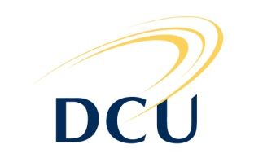
Individual Competitor
Funding Form

Applicants Personal Details
Student Name: | Student ID Number:
Course: | Year (1st, 2nd, 3rd, 4th):
Address :

Sport: | E-mail:
Name of DCU Clubs which you are a member:

Sporting Details
What is the highest level of competition in which you have competed:

Give details of your performance at this level and major sporting achievements for the last 3
years:

Competition Details & Costs
Name of Competition:

Date: | Location:
Is this competition invitational or have you qualified to compete in this competition (please
give details):

Please give a breakdown of the cost of this competition: (include travel, accommodation, entry
fee etc)

In accepting funding from the Club Life Committee (CLC) I will:
- Acknowledge the support of the CLC in all promotional articles regarding the event
- Produce a brief report on my performance and achievements in the event. This must be submitted to Yvonne McGowan, Senior Sports Development Officer, e-mail yvonne.mcgowan@dcu.ie
Signature of Athlete:________________________ Date:_____________________________

Please return completed form to:
Siobhan Byrne
Club & Society Finance & development Officer
Dublin City University
The Hub, Dublin 9
Tel: (01) 700 5585
Email: clubssocietiesfinance@dcu.ie
For Office Use only:
Funding Allocated:__________________________
Source:___________________________________
Amount:__________________________________
Signed:___________________________________
Date:____________________________________

