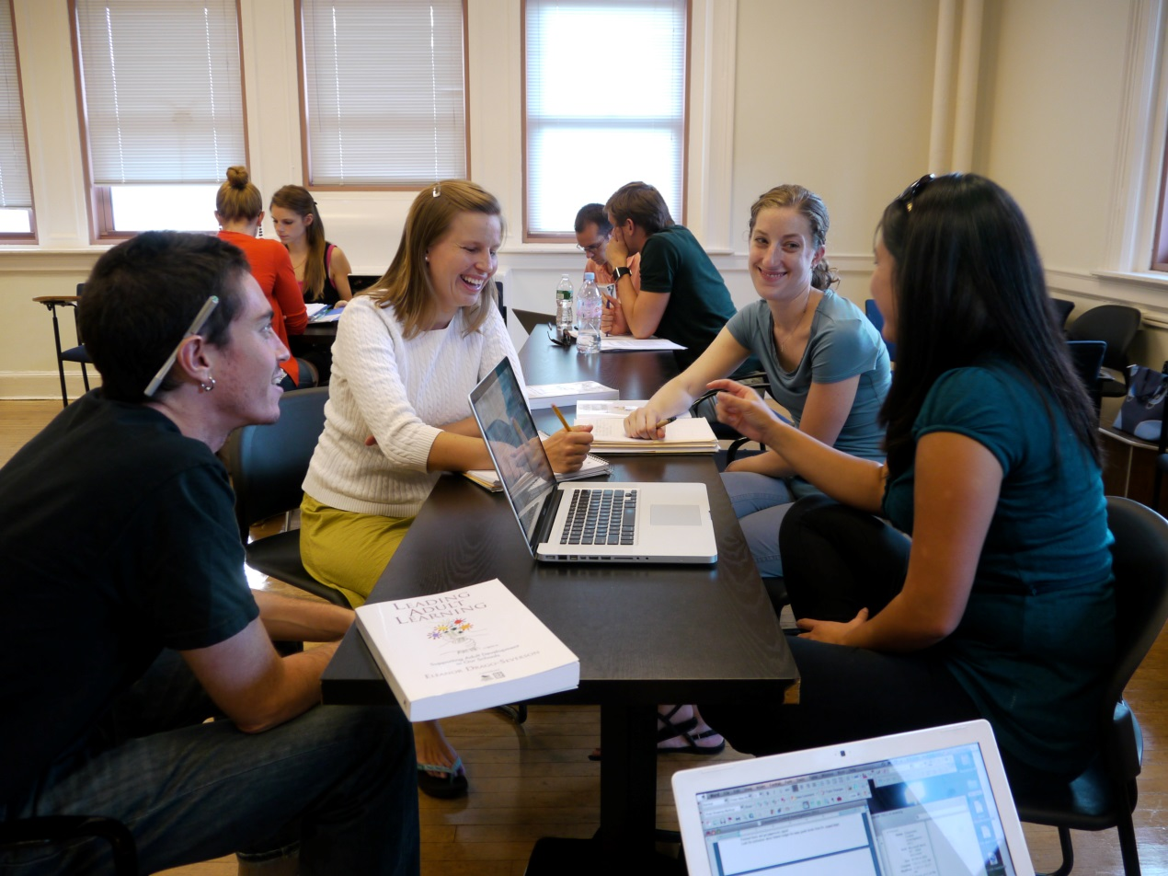

GROUPWORK
- These hand-outs are based on materials from the TCD Student Learning Development website accessible at http://www.tcd.ie/Student_Counselling/student-learning/

Hand-out 1: Group Contact List

Name | Contact Details | Preferred time(s) for meetings
Email:
Mobile:
Other:

Email:
Mobile:
Other:

Email:
Mobile:
Other:

Email:
Mobile:
Other:

Email:
Mobile:
Other:

Email:
Mobile:
Other:

Email:
Mobile:
Other:

Email:
Mobile:
Other:

Email:
Mobile:
Other:

Email:
Mobile:
Other:

Email:
Mobile:
Other:

Hand-out 2: Group Ground Rules

Ground Rules for Working Practice
Ground Rules for Personal Conduct

Signed____________

Hand-out 3: Sample Agenda for Meetings

- Date of meeting:________________

- 1. Attendance and apologies (from members who cannot attend)

- 2. Progress report on actions from last meeting.

- 3. Items for discussion (e.g., tasks, problems, time allocation, deadlines, task allocation etc. in priority order if possible)

- 4. Any other business

- 5.Summary of agreed actions

- 6. Time and place of next meeting.

Hand-out 4: Sample Meeting Notes

Group Meeting 1: 18th October 2014

In attendance: Mary, Catherine, Gareth, Kevin, Edel, John, Orla, Jessica, Tom, Fidelma, Niamh.

Task Analysis
We agreed that completing the assignment (due 24th November) will involve:
- Conducting a review of empirical research (journal articles, book chapter, reports) on challenges to inclusive education in Ireland.
- Interviewing teachers on their personal experience of constraints to inclusive practices in the Irish education system.
- Writing one group essay outlining why we believe that inclusive education is not possible (5000 words).
- Devising a power-point presentation to be used as the basis for the debate.
- Practising for, and participating in the debate (three group members self-nominated as speakers)

Group discussion
We decided that we would use Bronfenbrenner’s Sociological Systems Theory (1979) as a framework for our discussion of the challenges to inclusive education. That is, we decided to explore the constraints to inclusion that operate at micro (e.g., the teacher, the pupil), meso (the school), and macro (e.g., primary and secondary curriculum, Department of Education, government) levels of education. We decided to conduct a semi-structured interview with two teachers (one primary and one secondary) to gather information on constraints to inclusive practices in action.

Time Scale
We agreed on the following timescale for the project:
- First draft of group essay to be completed by 4th November.
- Second draft of group essay to be completed by 11th November.
- Powerpoint presentation to be completed by 18th November allowing one day (19th November) for the designated speakers to practice for the debate (with feedback from other group members).
- Presentation delivered on 22nd November.
- Final proofreading of group essay to be completed on 23rd November.
- Final essay to be submitted on 24th November.

Agreed actions:
- Source, read, and summarise in rough form previous research on:
  - micro level constraints (Mary, Catherine, Gareth)
  - meso level constraints (Kevin, Edel, John)
  - macro level constraints (Orla, Jessica)
- Prepare semi-structured interview schedules (Tom, Fidelma, Niamh)

Next meeting
We agreed that the next meeting would be on 18th October in the departmental seminar room from 5-7pm.

Signed and dated:_____________________________________________

