Sport Scholarship
Application Form
2017-2018
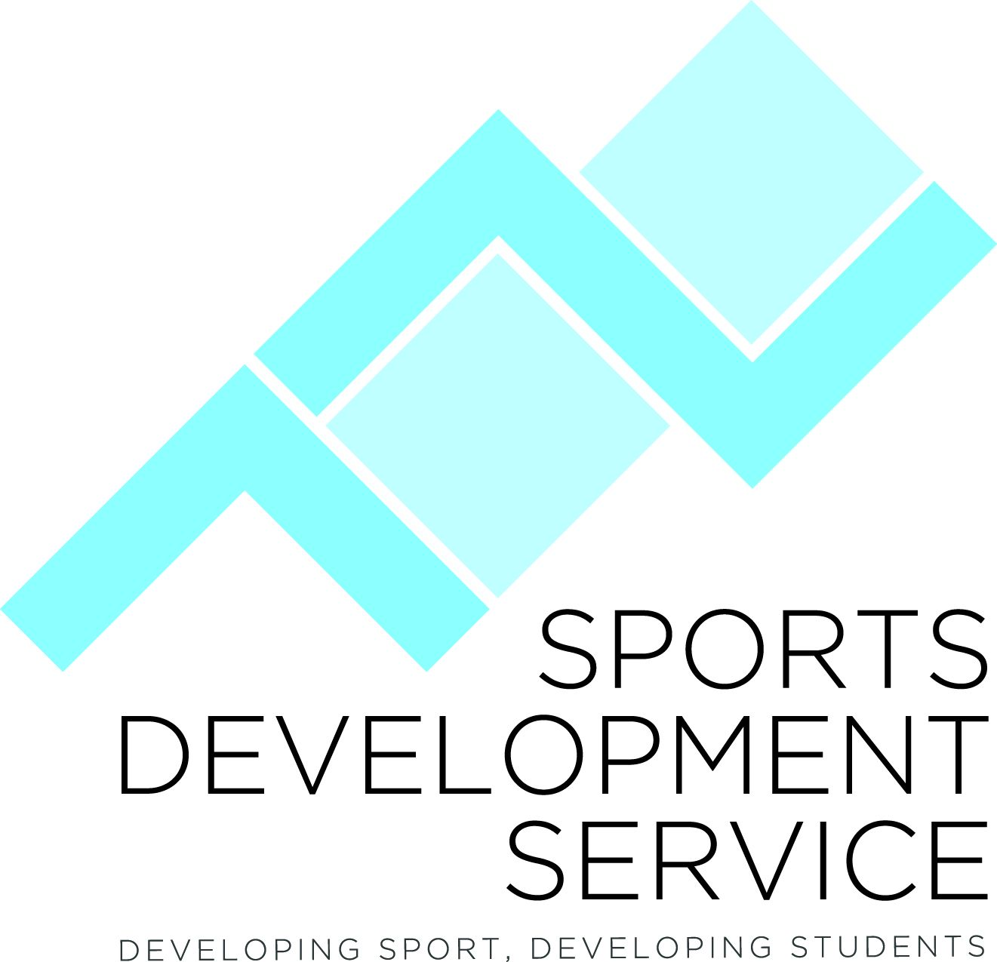
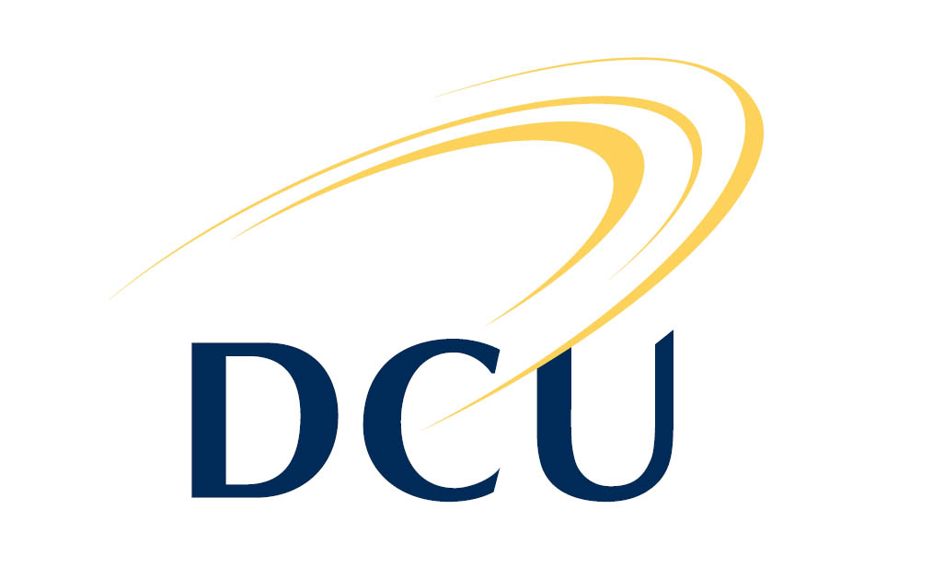

Personal Details
Name: | Date of Birth:
Home Address:

Tel: | E-mail:
Height: | Current Weight:

Academic Details: Complete either 2.1 or 2.2 as appropriate
2.1 Current DCU Student
Course & Year: | Student Number:

2.2 Prospective DCU Student
CAO Number:

List the DCU Courses on your CAO application form and the CAO Preference e.g. 1st, 2nd choice:

Please indicate if you have applied for the DCU Elite Sportspersons Academic Entry Scheme (for details go to Form R-13 at http://www.dcu.ie/registry/application_forms.shtml
Yes No

Sport details

Sport: If you wish to be considered in more than one sport please complete a separate application form for each sport.
Current Club:
Highest level of Representation: (include competition, team, dates, result/personal best)
Team Sport Playing Position:
Provide details of other Financial support you are receiving e.g. Irish Sports Council carding etc

4. Sports Achievements
List your sporting achievements in the last 3 years: (continue on a separate sheet if necessary)
Date Achievement Competition/Result Event/Age
Example  International | May 2014 | Irish Senior Men’s Hockey Team | European qualifiers, team placed 7th | Irish Senior Men’s Team

National & Provincial

County & Club

5. Supporting Information
Provide a brief explanation in support of your suitability for the DCU Sports Scholarship Programme. Please provide this on a separate document and include:
- Your Sporting aims for the next year
- Your Sporting aims for the next 1-3 years
- Your academic aims
- How a DCU Sport Scholarship would benefit you
- Any other information which you may feel is relevant to your application
- Two References (from a coach/teacher/national governing body)

The completed application form and all supporting information should be sent to the address below. Please note applications by e-mail will not be accepted.
DCU Sports Development Service
CG25 Henry Grattan Building,
Dublin City University,
Dublin 9

CLOSING DATE: Saturday 1st of July 2017 at 5pm

CLOSING DATE FOR GAA Sports (Football, Handball, Camogie & Hurling):
Friday the 1st of December 2017 at 5pm

Please note applications received after the closing date will not be processed.
The purpose of collecting the above information is for assessing an applicant’s suitability for the DCU Sport Scholarship programme only.

