How to set up a New Customer
Modified on: Thu, 3 Aug, 2017 at 2:19 PM

New Customer Set Up

Go to Customer/Sales Menu:
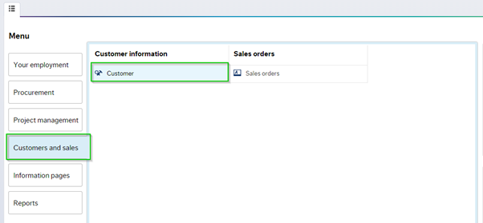
Click on Customer, a new window will open see below:
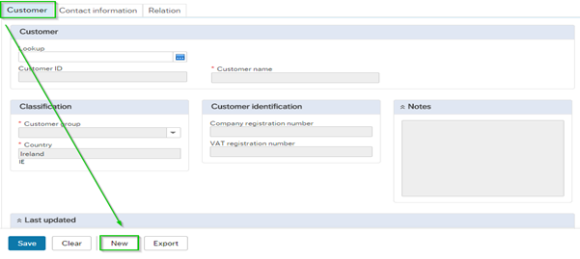
To enter a new Customer click on the 'New' button:

1. Customer Details

1.1a Customer Tab

To enter a Customer name, please select or click on the *Customer Name window. All sections marked * are mandatory fields:
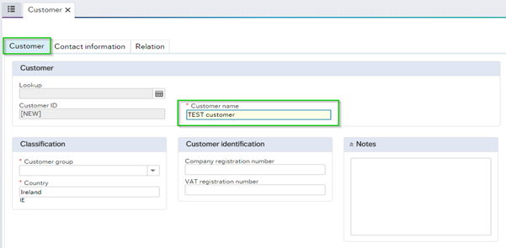

To move to the next section, use the tab key on your pc/keyboard: 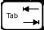

1.1b Customer Group

Click on the drop down menu and choose only one of the following:

Domestic Euro Irish Customers only
EU Euro Customers in EU - Euro only
EU Non Euro Customers in EU - Non Euro
International Customers outside of EU zone
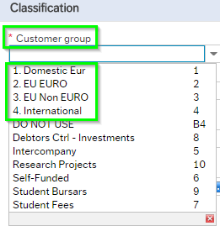
1.1c Customer Country

If it's domestic euro, the country will default in as Ireland, if you chose a different group you will need to fill in the correct country details. Simply use type ahead search and enter the country details, the results will populate:
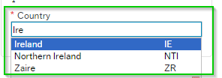

1.1d VAT Registration Number – (value added tax)

Enter the VAT registration number if the customer is registered for Vat:
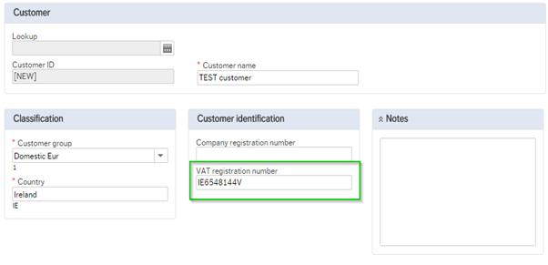

2. Customer information tab

Within the 'Contact Information' section the user must enter customer address details, Click on the ‘ADD’ button:
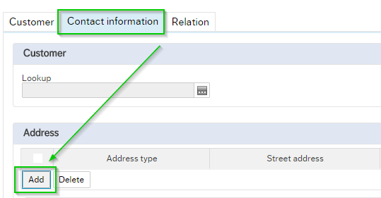

Please ensure the customer's full address, country, email address, and contact person, are submitted*, cc email is optional:
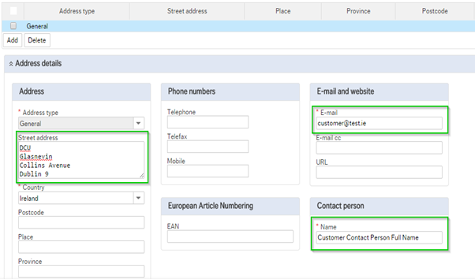

3. Relation tab

Please note two first rows, Invoice Rule, and Vat 13B are left out blank, as the information will be input by Account Receivable:

Go to next tab.

3.3a VATSTAT

To open the line, click on the title of the relation (e.g. VATSTAT) and then enter the relevant value for that relation, the User can enter the Vat Stat details manually, or run an enquiry by clicking on the icon search, details will populate see below:
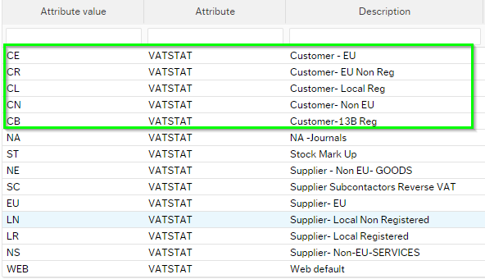

Please only choose the relevant VATSTAT for Customers:

CE – Customer EU – Customer located outside of Ireland but in Europe, registered for Vat.

CR - Customer EU – Customer located outside of Ireland but in Europe, but not registered for Vat.

CL - Customer Local Registered – Customer located in Republic of Ireland, registered for Vat.

CN - Customer Non- EU – International Customer located outside of Europe.

CB – Customer – 13BReg – Exempts certain exporting companies from charging or being charged vat provided they have a valid VAT 13B authorisation certificate.

3.3b User

To open the line, click on the title of the relation user, and then enter the relevant value for that relation,

Please enter your name to retrieve your own USER ID:

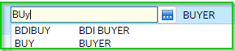

The system requires this information so it can distribute an email to you with confirmation of the New Customer set up, Click save:

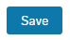
The System will create a message below, click OK:

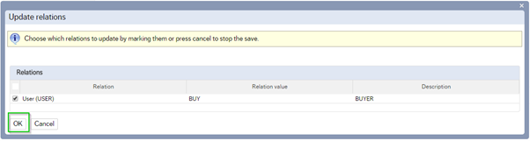

4. Update information on Customer

The customer approval task is then work flowed to the accounts receivable administrator to approve and activate the customer on the Agresso system.

The user who submitted the new customer will receive an email notification to confirm that the customer is active or closed if it is a duplicate.

If this is a duplicate customer, the approval group will close the customer and give a detailed comment which will appear on the email notification.

Please note sales orders cannot be submitted until the customer is active on the Agresso system.

