How to add/attach a document to a Sales Order

HOW TO ADD/ATTACH A DOCUMENT TO A SALES ORDER

Go to 'Customers and Sales' then 'Sales Orders':

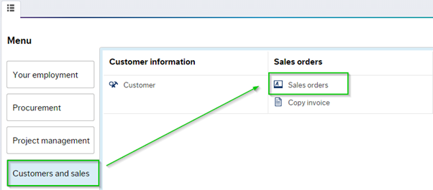

Click on the 'Sales orders' folder, the sales order template will open in a new window, click on the Open tab:

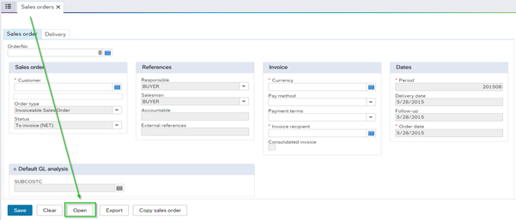
Type in the sale order number, e.g. 420074331 in the search criteria box, hit search:
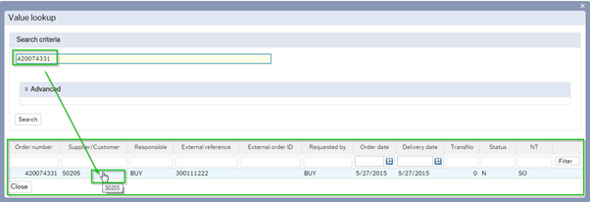
Then click on the relevant line, the sales order details will populate. The User can add documents by using the paper clip icon button. To add a document click on the paper clip button: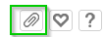

A new window will open, the user can use the top icon or tab to 'Add Documents':

The upload option will open in a new window, click on the Upload button: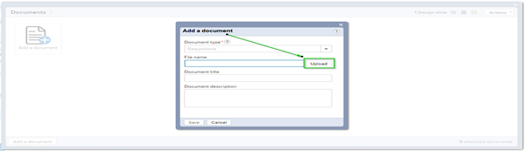

Go to the relevant documents folder saved on your PC/desktop/library:

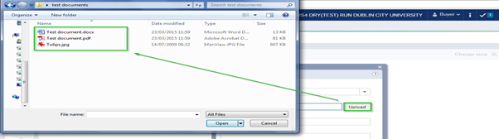

Choose the relevant document, click 'Save':
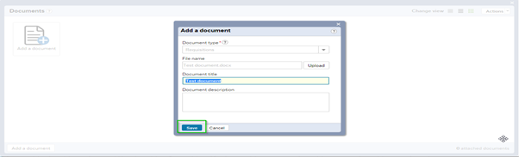

The document will show see screen shot below:

To add more documents simply repeat this process. Users can attach word, pdf, jpg files: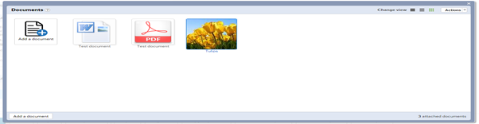

To close the application simply click on ‘x’ in right top corner of the page, documents will be kept under sales order: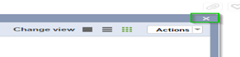

To check if any documents are attached to a sales order, simply click on the paperclip icon, results will populate: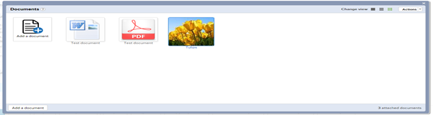

To delete/remove an attachment, the user can delete the document by clicking the right mouse button and choosing the 'Delete' option, or using the actions drop-down section.

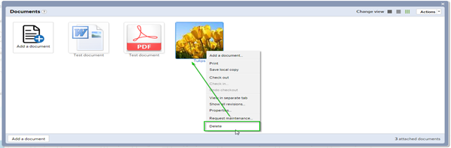

The user will be asked to confirm the action see screen shot below, click on 'Delete' to confirm:

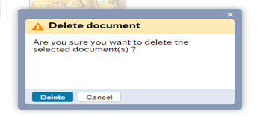
The file is now removed and will not show under the Sales Order details:

All sales orders raised correctly will be converted to a Sales Invoice

